
Advanced Users Guide
Version 1.2.7

Revision History
Date | Version | Author | Changes
28/02/00 | 1.0 | CD | Initial version prepared
16/09/08 | 1.1 | CD | Added:  - Automatically Calculate Savings based on an RRP  - Creating a Mutually-Exclusive Set of Choices  - Using Out of Stock Images in the Push Button Grid  Amended  - Adding Extra Fields into the Customer Email (added Payment Method)  - Single Product Per Page – Using Subsections (changed ProductReference to ProductID)  - Having a larger box for the 'Other Info' Prompt (changed ProductReference to ProductID)  - Displaying Store Prices In Three Currencies (doesn't work with quantity-dependent prices)
10/03/10 | 1.2 | BT | Removed articles not relevant to v10
22/04/10 | 1.2.1 | BT | Additional articles for v10
13/09/10 | 1.2.2 | BT | Corrections and additions, v10.0.3
24/6/11 | 1.2.3 | BT | Updated for v11, removed articles no longer relevant.
13/12/11 | 1.2.4 | BT | Corrections to ‘Email a friend’ and ‘Automatically Rescale Your Product Images to a Certain Size’ articles
16/6/12 | 1.2.4 | BT | Rebranding to ‘SellerDeck’
01/03/13 | 1.2.5 | BT | Deleted obsolete articles; added ‘Creating A Customer Reviews Page’ and ‘Providing Extended Search Results’; made a few minor corrections
02/05/13 | 1.2.6 | BT | Added articles “Show Added Prices Against Product Choices” & “Changing the Checkout ‘Salutation’ Field Into a Combo Box”. Replaced “Using the 'Thumbnail' Image in the 'Mini' Item Layouts” with updated “Using the 'Thumbnail' Image in Marketing Lists”
15/01/15 | 1.2.7 | BT | Expanded new variable exercise to cover creation of the variable

Table of Contents
Read This First 8
Using the Preview to Select a Layout 8
Navigating Round the Layouts 8
Page Structure 9
Editing and Undoing 11
The Library 11
Inserting Variables 12
Exercise - Creating a New Variable and Adding It to the Design 13
Hiding Things With Conditions 15
Inserting Layouts 15
Using Stylesheets 16
Advanced: Fixed Layouts vs. Selectable Layouts 17
Advanced: Editing Lists 18
SellerDeck and CSS 20
The SellerDeck Stylesheet 20
Other Default SellerDeck Style Information 21
Including Custom Stylesheets in SellerDeck 21
Editing Your Stylesheet in Dreamweaver 21
Custom CSS Files and the Dreamweaver Integration 22
Tips on Handing Over Designs to Clients 23
Removing a Dreamweaver Design from SellerDeck 25
Section B – Layouts 26
General Advanced Tips 26
Making Sure Images in the CSS Appear Correctly 26
Hiding Code From The Preview 26
Including File Content Dynamically Online 27
Creating PHP Functions 27
Stripping Out File Paths from Variables 27
Advanced List Functionality 28
Variable Qualifiers 30
Using an Email Link that is Invisible to Spammers 30
Stopping SellerDeck from Parsing Things in Square Brackets 31
Restricting Object Display to Single-Item Pages 31
Suppressing Repeat Processing of Invariant Blocks 31
Section Pages 32
Taking People Straight to a Section 32
Optimising Page Titles For Search Engines 32
Inserting Content to Only Appear on the Store Front Page 33
Creating Links to 'Previous' and 'Next' Sections at the Same Level 34
Only Using a Single Parent Section List in a Design 34
Having Different Background Colours on Different Pages 34
Preventing Search Engines from Indexing Certain Pages 36
Section Navigation 37
Hiding Top Level Section Links from the Sitemap 37
Using a different Section Name in the Breadcrumb Trail 37
How to Only Show Certain Sections in the Top Level Section List 38
Highlighting the 'Current' Section in the Section List 40
Section List With Sub Sections In Bullets 41
Jump List Containing Every Section 42
Different Sections in Different Parts of the Page 43
Including Section Lists with Javascript 45
Creating a Jump List Containing the Top-Level Sections 48
Creating a Drop-Down List Containing the Top-Level Sections and Sub Sections 49
Creating a List Box Containing the Top-Level Sections 50
Creating a List of Hyperlinks with Sections and Sub-sections 50
Creating a List of Hyperlinks with Sections and Two Levels of Sub-sections 51
Creating a Section List (With Sub-Sections) in 2 Columns 52
Listing Sub-Sections Within Each Main Section 53
Inserting a List of Section Images With JavaScript 53
Including a SellerDeck-Generated Jump List Anywhere on the Internet 54
Marketing 55
Only Displaying Certain Products in the Marketing Lists 55
Using the 'Thumbnail' Image in Marketing Lists 55
Changing the Configuration of the ‘Recently Viewed Products’ List 58
Enable Automatic Resubmission of the Google Product Feed 59
Creating a Customer Reviews Page 59
Products 62
Taking People Straight to a Product 62
Only Displaying the First Ten Words of the Full Description 62
Different Cart Button Text for Each Product 63
Selecting Quantity From A Drop-Down 63
Including an 'Email A Friend' Link into SellerDeck 64
Displaying Store Prices In Three Currencies 64
Automatically Calculate Savings based on an RRP 65
Creating a Rollover for your Add to Cart Button 65
Reversing the Order of Years in the Date Prompt 67
Allowing Ordering of Out of Stock Products 68
Show Added Prices Against Product Choices 72
Product Images 74
Automatically Rescale Your Product Images to a Certain Size 74
Clickable Expanding Product Image Thumbnails 76
Product Options 78
Changing the Way Attributes are Laid Out 78
Displaying Images Against Radio Button Choices 79
Extended Information Windows 81
Pop-Up Windows That Automatically Resize to Fit the Images Within Them 81
Fragments and Brochure Pages 83
Displaying Fragments Separately From Products 83
Automatically Generating Hyperlinks in Fragment Text 85
Stopping Specific Brochure Pages from Appearing in the List 85
Including Brochure Pages in the Site Map 87
Shopping Cart and Checkout 89
Viewing the Shopping Cart from Anywhere on the Internet 89
Adding to Cart from Anywhere on the Internet 89
Inserting Links to Save and Retrieve Shopping Carts 90
Displaying a Message that Counts Down to Free Shipping 90
Multiple Currency Conversion 91
Going Straight to the Checkout after Adding to Cart 91
Making ‘Hide Cart Details’ the Default in the Checkout 93
Stopping People from Checking Out with Less Than 2 Items 93
Offering Payment Methods to Customers in Different Formats 94
Adding a Giftwrap Option to the Checkout 95
Turning a Text Field into a Check Box 96
Automatically Capitalising Customer Input 97
Supporting an Affiliate Program with SellerDeck Ecommerce 98
Creating a 'When To Deliver' Drop Down List 99
Specifying a Delivery Cut-Off Time for Orders 99
Emptying The Cart When People Leave The Checkout 100
Customer Accounts 101
Hiding Elements from Retail Customers, but Showing Them to ALL Registered Customers 101
Preventing Unregistered Customers from Entering Certain Sections in your Store 101
Bouncing Unregistered Customers Out of Sections 101
Miscellaneous 103
Adding New Terms and Conditions 103
Using a Text Field for Searchable Properties 103
Providing Extended Search Results 104
Section C - Perl Script Changes 105
Products 105
Making the Other Info Box Optional 105
Having a larger box for the 'Other Info' Prompt 105
Having Two Other Info Prompts 107
Search 109
Omitting Certain Products From Search Results 109
Turning the Search Results into a Buyable List of Products 109
Editing the Search Page HTML 110
Editing the 'customsearch.fil' Files 110
Joining Search Terms Together in Different Ways 112
Matching Plurals in the Search 113
Keeping a Log of Search Terms Used at the Site 113
Understanding Relevance 114
Contact Us Form 115
Adding Extra Fields to the 'Contact Us' Form 115
Creating a Newsletter Subscription Form 116
Shopping Cart 120
Removing Product Hyperlinks from the Shopping Cart 120
Using Dual Currency Pricing in the Store Pages But Not in the Cart 120
Changing the Destination of the 'Continue Shopping' Button 120
Removing the Bounce Page when Adding to Cart 121
Checkout 122
Using Images for the Checkout Buttons 122
Changing the Order of the Shipping Methods 123
Displaying Shipping Options as Radio Buttons 124
Changing the Checkout ‘Salutation’ Field Into a Combo Box 124
Customer Accounts 127
Taking the Customer to Brochure Home Page after Login 127
Suppressing the 'Re-Enter Password' Page 127
Orders 129
Making the SellerDeck Order Number Shorter 129
Changing the Time on the Orders 129
Using The Referrer Perl Script 130
Emails 133
Adding Extra Fields into the Customer Email 133
Section D – Other Tricks 135
Importing 135
Creating a Design Import File 135
Reports 136
Adding Your Own Reports into SellerDeck's Built-in List 136
Mailing Lists 137
List All Customers Who Have Bought Product X But Not Product Y 137
Printing Packing Labels For Today's New Orders 137
Uploading 138
Uploading Without FTP Access 138
Using SellerDeck with a Firewall 139
Section E – Web Servers 140
SellerDeck Hosting Requirements 140
Specifications Required for SellerDeck to Run 140
Web Space Required by SellerDeck 141
Permissions required by SellerDeck Ecommerce 141
Miscellaneous 143
SellerDeck's Online Components 143
Section F: Installing a Standalone Demo on a PC 144
Downloading The Required Components 144
Perl Interpreter 144
Web Server 144
FTP Server 145
Installation Instructions 146
ActivePerl 146
Apache HTTP Server 146
War FTP Daemon 146
Configuration 147
Apache 147
War-FTP Configuration 147
SellerDeck Network Settings 150
Testing if it Works 150
Troubleshooting 151
Section G: IIS5 Server Setup 153
Host Headers 153
Vocabulary 153
Setup of Catalog Web Site 154
CGI-BIN Directory 157
CGI-BIN Physical Directory Creation 157
CGI-BIN Virtual Directory Creation 157
cgi-bin IIS Check 159
cgi-bin Perl Association 160
NTFS Permissions 162
Catalog Home Directory 162
Acatalog Directory Permissions 164
CGI-BIN Directory Permissions 165
Web Sharing 170
FTP Settings 171
Perl Setup 172
Perl Association 172
Perl Checks 172
SellerDeck Network Settings 174
Defining The Home Page In IIS 175
Troubleshooting 177
cgi-bin Accessed Denied 177

Section A:
Understanding Design in SellerDeck

Read This First
Designing in SellerDeck can take a little while to understand - this is just because there aren't that many programs that work in the way SellerDeck does. However, once you've learnt the basics, you will discover how flexible SellerDeck is to design with.
The important thing is to spend a bit of time trying to understand how the various features work, before ploughing ahead and trying to make a specific change.
These articles will lead you through the essential things you need to know.

Using the Preview to Select a Layout
Try clicking within the preview panel in the Design tab.
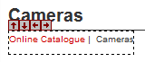
You should see a dotted line appearing round the thing you've clicked on. This means you've selected a layout (or an item within a layout).
Layouts are the building blocks of SellerDeck pages. They are pieces of HTML that SellerDeck sticks together in order to create each page in the store.
It is possible to see the HTML code of the layout you've clicked on. To do this, look at the 'Layout Code' panel. This will either be underneath the preview, or it will be on a separate tab.
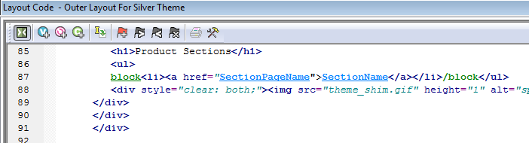
In the title bar of the Layout Code panel is the name of the layout.
Make a mental note of this, as it's useful to know what the layout is called in case you ever need to go back to it.
Note: The button on the layout code toolbar is used to toggle between an 'advanced' and 'simple' view of the layout code. You generally just leave it on the 'simple' view.

Navigating Round the Layouts
Once you have selected a layout in the Design tab, look at the layout breadcrumb trail that runs along the bottom of the Design tab.
The breadcrumb trail shows you that the layout you've clicked on is located within another layout 'above' it, and that layout in turn is located within another layout. So in the example above, the product layout is located within the product list, which in turn is located within the 'section page' layout - and so on until you reach the 'top' of the design, which is a special layout called the 'Overall Layout' (also known as the 'Outer Layout').
If you only see one layout in the breadcrumb trail, it's probably because you've already got the Overall Layout selected in the preview.
You can click on the layouts in the breadcrumb trail to select them, and this way you can move up in the design.
You can also click the button on the layout code toolbar and the icon in the preview to move up a level in the design.
The down arrows are for taking you back to the layout you were on previously.
You can see the full structure of the layouts used to build the page by viewing the 'Design Tree'. To see the tree, click on the tab at the bottom right of the screen.
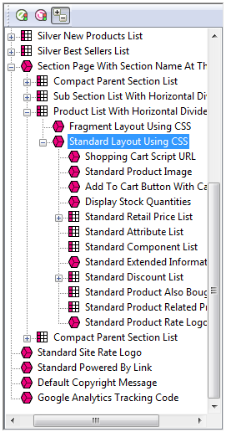

Page Structure
All SellerDeck pages are divided into two parts - the 'outer' and the 'inner'.
- The 'outer' part of the page controls the branding and navigation elements that largely stay the same as you go from page to page. They are the elements that usually go across the top and down the side of each page. The outer part of the page also contains the <head> section.
- The 'inner' part of the page controls the content for that page - so if it's a section page it will be the section links and products, and if it's a checkout page it will be the checkout fields etc.
Outer Layout
The outer part of the page is controlled by a layout called the 'Overall Layout' (also known as the 'Outer Layout'). This is the 'top' layout of each page - which every other layout is inserted within.
Outer layouts always contain a pink/purple placeholder called INNERLAYOUT, which will be replaced by the content (inner layout) for that page when the page is generated.
You can select the overall layout within the Design tab by clicking anywhere within the preview, and then clicking the first layout on the layout breadcrumb trail.
Alternatively, you can view the Design Tree and then click on the top item in the tree to select the overall layout.
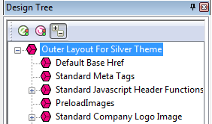
All the outer layouts are kept together in the library within a group called 'Web Page Outer Layout'.
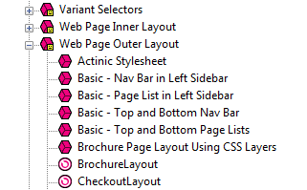
You'll find out more about the library in a moment.
Inner Layout
The inner layout is harder to talk about as it will be different depending on which page you are looking at.
For section pages, the inner layout will probably have a name that starts within 'Section Page...' and when you look in the code of it, you'll see lots of references to 'section lists' and 'product lists'.
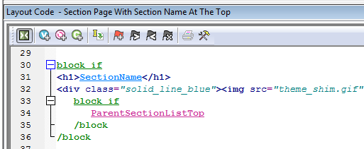
Every 'type' of page has a different inner layout that controls the layout of its content. All the inner layouts used by the store are collected together in the library in a group called 'Web Page Inner Layout'.
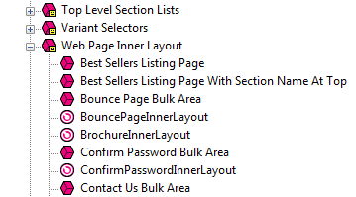

Editing and Undoing
You can make a change to the HTML of a layout and then click the 'Apply' button to see what effect this has on the store.
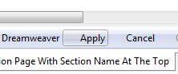
The preview will be automatically updated when you click 'Apply'.
If you are not happy with the results, click the 'Undo' button on the toolbar to undo the change - .
You can also edit layouts using Dreamweaver. This is described in the main help in a section called 'Working With Dreamweaver'.
Remember when making changes that this layout is probably going to be inserted within another layout, so be careful when making changes that you don't do anything that might distort or corrupt this 'parent' layout.
If you have made a mistake with a layout, and you cannot work out how to get the layout working again then you can always revert the layout back to its 'factory settings'. This is described in the next section.

The Library
The Design tab allows you to edit the layouts that are used within a page, but the Library allows you to search through and edit all the layouts within SellerDeck.
You can open the library by going to 'Design | Library', then change to the 'Layouts' tab.
Highlighting the layouts you've edited
If you click the 'Highlight edited library layouts (*)' checkbox at the bottom of the 'Layouts' tab, you will highlight any layouts you've customised, and new layouts you've created.
Layouts you've customised will be marked with a (*) and have a icon.
You can also highlight any new layouts you've added by selecting the 'Highlight new user layouts (+)' checkbox.
Searching for layouts
Right-click anywhere within the Layouts tab and select 'Find'.
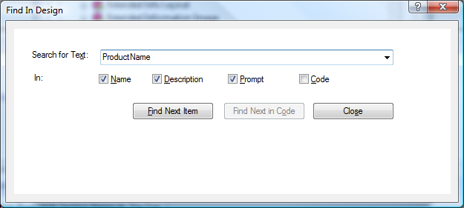
You can search for the name of a layout or some code within a layout.
Creating new layouts
Right-click on a layout and select 'New Layout'.
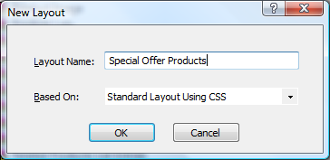
Give the layout a name and click 'OK'.
Note: You can also create new layouts within the Layouts panel of a product/section/Site Options. Simply select the '<New>' option at the bottom of the drop down lists.
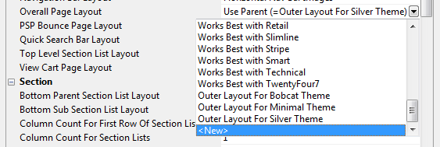
Deleting layouts
You can only delete a layout from the library if it's a custom layout that you've created, and you haven't selected it anywhere.
Reverting to Factory Settings
If you have made a mistake in a layout, and you want to put it back to how it was before you started making changes to it, then you can right-click on it in the library and select 'Revert to Factory Settings'.
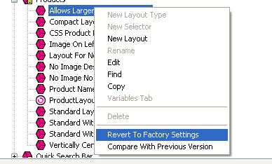
Layout selectors
Layouts are only part of the picture. There are also round things called 'Layout Selectors' - - that control how layouts are listed within the 'Layout' panels.
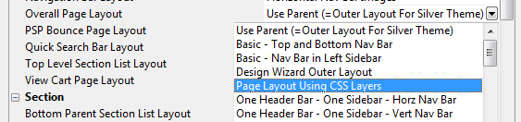
You can edit these layout selectors to change which layouts are listed within SellerDeck, and in what order.

Inserting Variables
Variables are placeholders for SellerDeck data. When the pages are generated, the variables are replaced by real data.
Variables in layouts look like this:
Inserting a new variable is simple. Let's say you wanted to add a new link to your home page. To do this, you might add the following HTML into the layouts:
You can now place your cursor between the two quote marks and click the 'Insert Variable' button -
The list of layouts is initially really long, but you can use the 'List names containing' filter the search. If you enter 'Home' into the list, the list becomes:
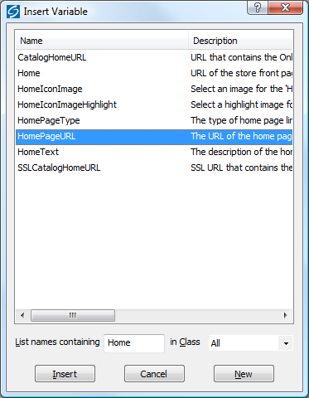
You can now highlight 'HomePageURL' and click 'Insert'.

Exercise - Creating a New Variable and Adding It to the Design
Suppose you are selling books and you want to include a field for the author and show it on the web page. First, you would create a new product-level variable as follows:
- Select ‘Library’ from the ‘Design’ menu and select the ‘Variables’ tab.
- Right-click on ‘Product’ and select ‘New Variable’ from the pop-up menu.
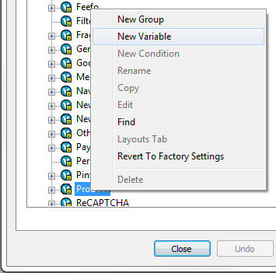
- Enter ‘Author’ for both the Name and Prompt. You can also enter a description if you wish.
- For ‘Place Of Setting’ tick Site, Section and Product.
- Click ‘OK’ and ‘Close’.
- Select the main ‘Content’ tab, click on any product and select its the ‘Properties’ tab. You will see the ‘Author’ field, and you can now enter the author’s name:
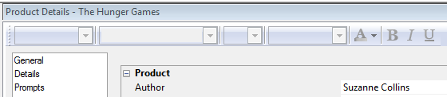
To show the name of the Author after the name of the book, do the following:
- Go to the Design tab and then make sure you are looking at the 'Books' section.
- Click on the name of one of the books on this page. This should highlight the 'ProductName' variable.
- Add in a new blank line straight after the variable.
- In the new blank line, type <br />
You might notice that SellerDeck prompts you here to complete the tag. This is a feature of SellerDeck - it will help you create the HTML within the layouts.
- Just after the <br /> right-click and select 'Insert Variable'.
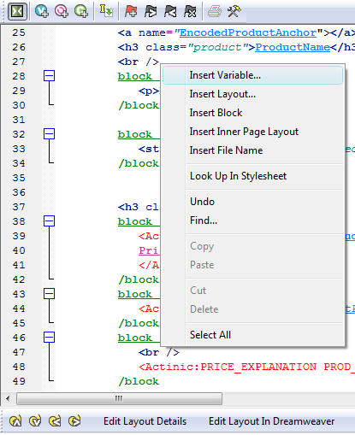
- Select 'Author' from the list of variables that appears and click 'Insert'.
- Click 'Apply' and check the preview to see if your value have appeared.
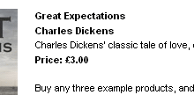
If the author value has not appeared for all your books, it may be because your books are using different layouts from each other. You may need to insert the <br />Author in more than one layout.

Hiding Things With Conditions
When you look in layouts, you see lots of green 'block if' tags.
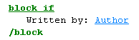
These are conditions, which will hide the text between the block tags unless a certain condition is met. You can view and edit the condition by double-clicking on the opening 'block if' tag.
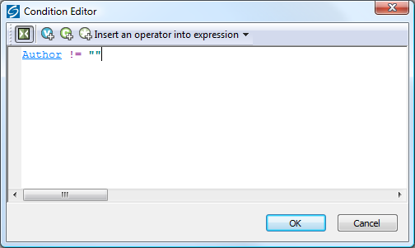
In the above example, the text shown is hidden unless the 'Author' field has a value. If the 'Author' setting doesn't have a value, then the whole thing is hidden.

Inserting Layouts
To insert a layout, use the button on the layout code toolbar.
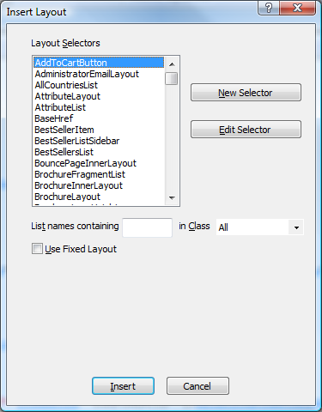
What you get presented with though is not a list of layouts - rather, you get a list of Layout Selectors (which you might have seen within the Library).
The job of a layout selector is to insert a type of layout into the design. You can see these layout types in the 'Layouts' tab of the library.
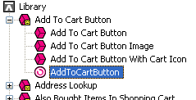
For example, inserting the 'ProductLayout' layout selector will insert a product layout into the design, and the 'AddToCartButton' layout selector will insert an add to cart button into the design. The actual layout that is used is controlled elsewhere - usually in Site Options.
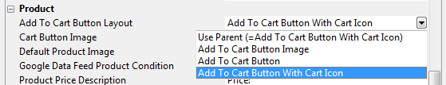
If there is a specific layout that you know you want to insert, rather than just inserting any layout of a particular type, then you can select the 'Use Fixed Layout' button and select one from the list.
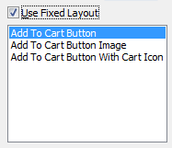
Warning - using 'Fixed Layouts' means that you will no longer be able to change the layout in Site Options or in the Layout panel of your sections/products. More details are in "Advanced: Fixed Layouts vs. Selectable Layouts" on page 17.

Using Stylesheets
SellerDeck makes use of stylesheets to control layout and fonts in the store. If you want to change the layout of items on a page, or the default appearance of text, you will probably have to think about editing the main SellerDeck stylesheet.
Note: You can edit the default font size and appearance in the 'General' panel of 'Site Options', and you can edit colours in the 'Color Schemes' tab of 'Design | Themes'.
Whenever you see a style used in a SellerDeck layout e.g.:
... you can right-click on the style and select 'Look Up In Stylesheet'.
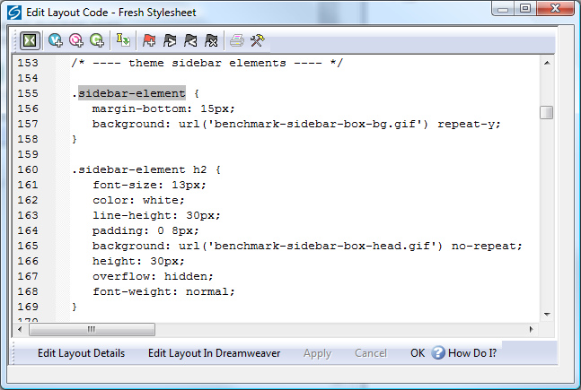
You can then edit the style as required.
You can also select the stylesheet from the 'Select Page Type' drop down list in the 'Design' tab, or click the ‘Current Stylesheet’ button on the toolbar.
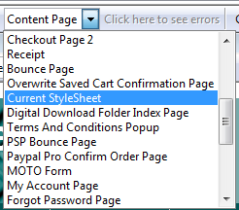
Note: In the Library, you'll find the stylesheet layout within the 'Web Page Outer Layout' group.
You can use your own styles with SellerDeck. Either just add them to the bottom of the current stylesheet layout, or save your stylesheet within the SellerDeck site folder and then use a tag similar to the following to link your stylesheet in.
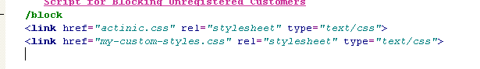
This tag needs to go in the <head> section in the overall layout used by the site.
If you right-click on an HTML tag in your layout that is using a tag from your custom stylesheet, and then select 'Look Up In Stylesheet', SellerDeck will open up your custom css file in your default CSS editor.

Advanced: Fixed Layouts vs. Selectable Layouts
In the section called "Hiding Things With Conditions" on page 14 it talks about how when you insert a layout selector, you have a choice.
- You can insert a layout selector into the design, without specifying a specific layout - this is also known as using a Layout Placeholder
- Alternatively, you can select a specific layout to insert into the design - this is known as a Fixed Layout
Using Layout Placeholders
When you insert a layout placeholder (rather than a fixed layout) it will insert a type of layout into the design. You can generally choose the layout to be inserted within the 'Layout' panel of 'Settings | Site Options'.
You can then often override this setting within the Layout panel of a section, or of a product.
Not all layout selectors have a place of setting in Site Options. If you find one that doesn't, then you need to go to the 'Layouts' tab of 'Design | Library', and edit the layout selector there.
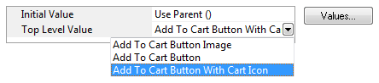
Edit the 'Top Level Value' there in order to change the layout that will be inserted.
Fixed Layouts
When you insert a fixed layout, it effectively disables the layout selection options in 'Settings | Site Options'. The choice of layouts is still there, but they will be ignored when the pages are built.
To change a fixed layout into a layout placeholder, you can right-click on the pink layout name in layout code and select 'Edit Appearance'.
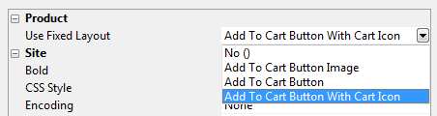
In the screen that appears, set the 'Use Fixed Layout' option to 'No()' and click 'OK'.

Advanced: Editing Lists
As well as standard layouts, you will sometimes come across things called lists. They look like this in the layout breadcrumb trail:
Lists always have an orange link across the top of the layout code that says 'Click here to edit list layout settings':
Lists work differently to other layouts. Their job is to insert a set of items into a page. Wherever you see a list of products, or a list of sub-sections, or a list of best sellers, or a list of locations, somewhere in there a list will be controlling the placement of the items.
Editing the list allows you to edit the HTML that goes at the start of a list of items, at the end of a list of items and around each individual item.
To edit a list, click the orange 'Click here to edit list layout settings' text at the top of the layout, or click the 'Edit List Layout Settings' button.
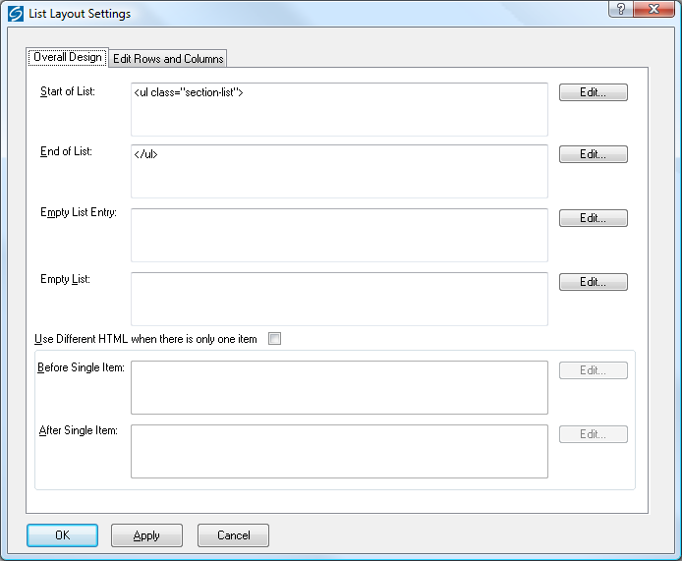
The 'Start of List' and 'End of List' fields here are self explanatory. It gets a bit trickier in the 'Edit Rows/Columns' tab:
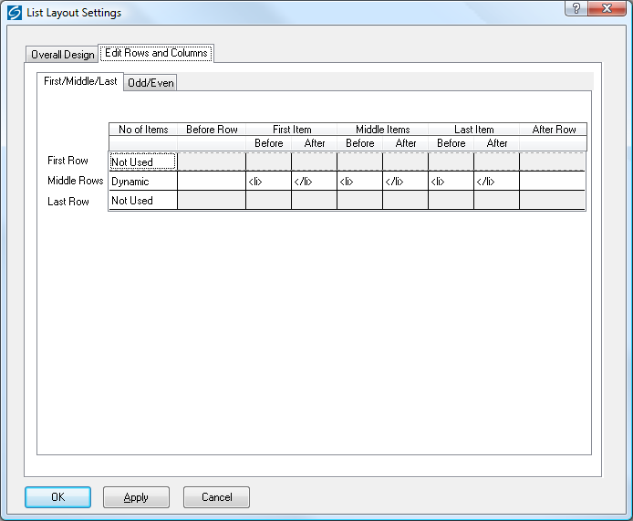
Don't panic! This screen looks more complicated than it is. This is where you can control the code that goes before and after each item in the list.
Generally, you only have to worry about the 'Middle Rows'. Only use the 'First Row' and 'Last Row' settings if you want the first or last row to be different to the other rows. The 'No of items' is where you can set the number of columns in your list - but this only works if your list is a table. Otherwise, just leave this set to 'Dynamic'. If you see a variable within this field, it means you can set the number of columns in the 'Layout' panel of the section/product you are currently editing.
Also, there are three sets of 'Before' and 'After' fields just in case you have multiple columns in your list and you want the columns to look different from each other. Most of the time you can just put the same code into each set of fields.

SellerDeck and CSS

The SellerDeck Stylesheet
When SellerDeck uploads a store to the online website, it creates a file called 'actinic.css', which is the main SellerDeck stylesheet that contains all the styles needed to support the pages.
You can view the layout that generates this file by:
- Clicking the 'Current Stylesheet' button in the 'Design' tab
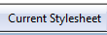
- Going to the 'Select Page Type' drop down list in the Design tab
- Within the 'Web Page Outer Layout' group in the 'Layouts' tab of 'Design | Library'.
Themes introduced prior to version 11 all rely on the ‘Main Stylesheet’ layout. Later themes each have a stylesheet layout of their own.
If you are ever editing a layout, and you see that there is a 'class=' or 'id=' value that you want to look up in the stylesheet, you can right-click on that value and select 'Lookup in Stylesheet'.
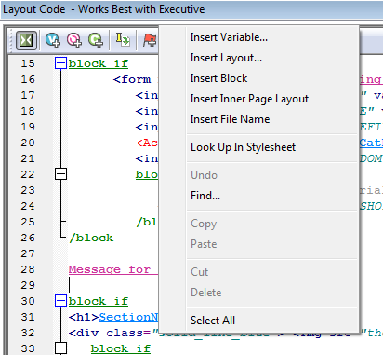
You can include your own custom styles into the stylesheet layout – just add them right at the bottom so they don't get overwritten by any of the default SellerDeck styles and classes.

Other Default SellerDeck Style Information
You will also see some outer/overall layouts contain some embedded styles within the <head> section. These are usually just a few trivial layout instructions that directly relate to code only found within that layout.
Older themes use a file called 'theme.css' located within your site folder (usually 'Site1'). It is included into the design with a '@import url("theme.css");' command at the top of the 'Main Stylesheet' layout. This file contains information that relates to the current theme that is being used. This file generally just controls the use of background images in sidebars and header areas, and also the width of any sidebars.

Including Custom Stylesheets in SellerDeck
If you have got your own custom stylesheet that you want to use within SellerDeck, the best way to include it is to save it within the site folder (usually Site1) and then include a link to it within the <head> section of the overall/outer layouts you are using within SellerDeck. E.g.
<link href="my-custom-styles.css" rel="stylesheet" type="text/css">
Make sure this line goes AFTER the line containing the reference to 'actinic.css' or else you run the risk of having your styles overwritten by the SellerDeck default ones.
Also, any custom css files MUST be saved within the site folder, you can't save them within a sub-folder in the site folder.
It is also a good idea to include the file in the 'Additional Files' list in 'Design | Additional Files' as this will make sure SellerDeck doesn't compact it when it uploads all the pages to the website.

Editing Your Stylesheet in Dreamweaver
There are two ways you can edit your stylesheet in Dreamweaver. The first is to simply click the 'Edit Layout In Dreamweaver' button on the layout code toolbar in SellerDeck when you are editing the stylesheet layout.
The second method allows you to permanently save the stylesheet layout as a *.css file on your PC that can be edited at any time. The method for this is below.
- In Dreamweaver go to 'File | New' and create a new basic 'CSS' page.
- Save this page within your SellerDeck site folder (usually 'Site1') and call it 'sellerdeck-styles.css'.
- Now go to SellerDeck and in the 'Design' tab, select 'Current Stylesheet' from the 'Select Page Type' list.
- The current stylesheet layout should appear in the layout code window at the bottom. Copy the entire contents of the layout to the clipboard.
- Now paste this content within your 'sellerdeck-styles.css' file and save your changes.
- Now in Dreamweaver go to 'SellerDeck | Register a Design with SellerDeck'.
- In the 'Register a Design with SellerDeck' window that appears, select ‘Stylesheet Layout’, which is about three-quarters of the way down the list.
- In the 'Name of the new design' field, call it something like 'SellerDeck Styles'.
- Click 'Register'.
SellerDeck will not look any different, but now the ‘Stylesheet’ page will be using 'sellerdeck-styles.css' as its source.

Custom CSS Files and the Dreamweaver Integration
If you are using the Dreamweaver integration to register a new custom design within SellerDeck, you are probably going to have a *.css file for that design. Here are some tips for success in making sure the Dreamweaver integration works correctly for you:
- It is a good idea to save your *.html file (that you want to register with SellerDeck) within the site folder (usually Site1). This will ensure that if you transfer your site via a snapshot to a different PC, that the design and all the *.css and images will all appear correctly first time.
- Your custom *.css file needs to be saved at the same level as the *.html file. You cannot have the *.css file within a sub-folder because SellerDeck has a hard time displaying all the images in at *.css correctly in the built-in preview. You can keep all the images for your design in sub-folders, but you need to make sure the *.css file is in the 'root' of your design.

Tips on Handing Over Designs to Clients
The easiest way to hand over an entire site to a client is via a standard 'Site Snapshot'. This is a single file that includes all the products, sections, Site Options and Business Settings, together with the entire Library. So when customers import this snapshot they will essentially have a clone of your installation.
There are two ways to create snapshots:
- 'File | Snapshot | Export Site' - this zips up the entire current SellerDeck site into a single *.acd file – but doesn't give you any options about controlling how this file will be imported by the client.
- 'Design | Deploy Site Snapshot' (SellerDeck Designer and SellerDeck Enterprise only) – this does the same as a standard snapshot, but gives you a few further options about how the customer imports the snapshots.
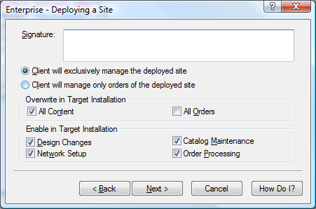
By de-selecting 'All Orders' you can avoid the possibility of the client accidentally overwriting their order history, and the options at the bottom mean you can close off access to certain areas of the software automatically.
If you don't want to overwrite any of the products and sections that the customer has, and you only want to supply a new design, then you need to use a 'Design Snapshot' via 'Design | Export Design Snapshot'.
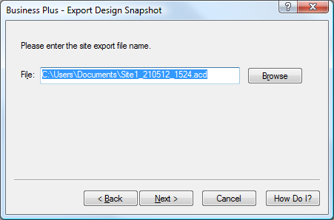
This will just take accross the design of your store (i.e. library elements, images used by the design, colour scheme, Site Options settings etc.) and will leave all the content of the store alone.
Your clients can import this data by going to 'File | Snapshot | Import Design'.
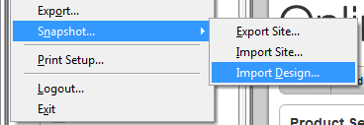
There is also an option within SellerDeck for sending the customer specific elements from your library. This is 'Design | Export Specific Design Elements...'.
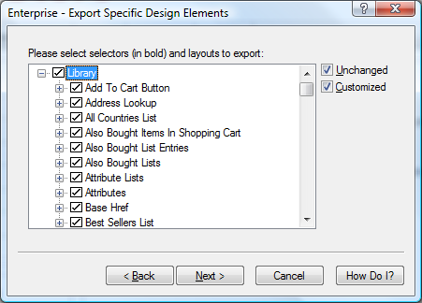
This is essentially a snapshot that will only contain library elements – it doesn't contain anything else. You can keep clicking 'Next' on the wizard to send the client the entire library. When a customer imports this, it will update their library, but leave the products and sections in place.
The thing to watch out for though is that this 'export specific elements' snapshot can contain layout selectors, and when you import a new layout selector it resets all instances of that layout selector within the Content Tree back to the 'Initial Value' - which is usually 'Use Parent'. So what it means is that any products/sections that need a setting other than the default 'Top Level Value' set in the library need to be manually set after the import.
The 'export specific elements' snapshot is most useful to send your clients the occasional layout or variable to fix or update their design. You can click the 'Select None' button on any panel of the wizard and then select just the layouts/variables/conditions etc. that you want the customer to receive.

Removing a Dreamweaver Design from SellerDeck
When you use the Dreamweaver extension to apply a new design, you have to 'register' a design with SellerDeck. Registering the design is pretty simple. Unregistering it, and deleting it, is a little tricker.
The first thing to do is make sure you are not using the registered design anywhere within SellerDeck. The quickest way to do this is to change to a default SellerDeck theme (using 'Design | Themes') or, alterntatively, register another different design with SellerDeck using Dreamweaver.
You also need to make sure that the design you want to unregister is not used by any sections in the store.
Then:
- Go to 'Settings | Site Options' and ensure that your external design is not selected within the 'Receipt Page Layout' setting (in the 'Layout' panel).
- Next you need to go to 'Design | Library | Layouts' and go to the 'Web Page Outer Layout' group.
- Double-click on the 'ReceiptPageLayout' layout selector. Set the 'Top Level Value' to 'Receipt Page Layout'.
- Double-click on the 'TermsAndConditionsPopupLayout' layout selector. Set the 'Top Level Value' to 'Terms and Conditions Popup Page'.
- Locate your externally-registered layout that you want to remove within the 'Web Page Outer Layout' group. Right-click on it and select 'Delete'.
The layout is now removed from SellerDeck.

.

Section B – Layouts

General Advanced Tips

Making Sure Images in the CSS Appear Correctly
When you include an image in a stylesheet layout, or in another custom *.css file you are using, make sure you include single quotes in the code e.g...
background-image: url(background.gif);
...will not work. But...
background-image: url('background.gif');
... will ensure the image is picked up by SellerDeck and will be uploaded and previewed correctly.

Hiding Code From The Preview
Sometimes you will have some code in your designs (e.g. an affiliate tracking scheme) that will only work online, and may actually have an adverse effect on the performance of the preview.
If this is the case, it is possible hide it from appearing in the preview with a condition. The code will then only be included in the store pages in the online store.
To do this, highlight the code you want to hide in the 'Layout Code' panel in the 'Design' tab, and then click the 'Insert Condition' button (green 'C' with a '+').
Use the following condition:
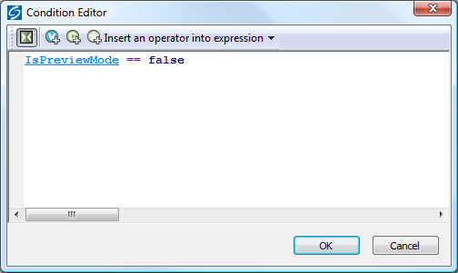
Here is some code to copy and paste to create the condition:
<actinic:variable name="IsPreviewMode" /> == false
Then click 'OK' and click 'Apply' in the 'Layout Code' panel, and the code should vanish from the preview. It will be there in the online store though.

Including File Content Dynamically Online
If you want to include the content of a text file into your web pages, and the file only exists online (not on your PC) then use a link for the following form within your SellerDeck layouts:
<a rel="fragment" href="http://your.URL/name-of-file.html">Alternate text</a>
This will only work if the user has JavaScript enabled in their web browser. If they don't then the 'alternate text' will appear instead.

Creating PHP Functions
It is possible to include PHP expressions within the layouts in SellerDeck. These are only executed on the desktop, i.e. you cannot create PHP functions to dynamically change things online, but they still allow you to do a range of advanced customisations on your store data.
There are some example PHP functions elsewhere in this guide – to find them, search this guide for: php="true"
To include a php expression into a layout, start the code with...
<actinic:block php="true">
...and finish it with...
</actinic:block>
When including a variable within a PHP function you need to right-click on it, select 'Edit Appearance' and then 'Encoding' to 'Quoted Perl' and set 'Selectable' to 'False'.
- encoding="perl" means that any line breaks, quotes etc. within the variable values that might break the PHP expression will be encoded safely.
- selectable="false" means that it cannot be selected in the 'Design' tab – this is essential as the dotted lines that get placed around selected variables will break PHP expressions.
Within the 'SellerDeck' folder there is a file called 'actinic_main.php' which contains a set of PHP functions that are referred to from within the SellerDeck default layouts. If you want to create your own php functions and then refer to them from your layouts, do the following:
- Create a new file within the 'SellerDeck' folder called 'custom.php'.
- Add your new functions within 'custom.php'
- Place the following line within 'actinic_main.php':
include_once("custom.php");

Stripping Out File Paths from Variables
Sometimes when a filename variable is used in certain contexts, the entire filepath is displayed online, instead of just the filename.
In other words, instead of:
image.gif
... what actually gets included in the code is:
C:\My Documements\SellerDeck v11\Sites\Site1\image.gif
To avoid this, replace the variable in the code e.g.:
<actinic:variable name="VariableName"/>
...with the following PHP expression:
<actinic:block php="true">echo basename('<actinic:variable name="VariableName"/>');</actinic:block>

Advanced List Functionality
A standard list of items in SellerDeck is created by inserting a 'list' layout into the design, and then inserting a layout within the list.
Here are some examples of how this appears in the Design Tree:
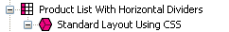
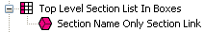
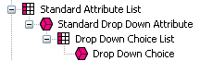
It is also possible within SellerDeck to insert layout code that you want listed, directly into a layout, and then insert 'block' tags around this layout code to 'list' it - i.e. repeat the code however many times is necessary.
Here's an example.
In the chapter called 'Including Brochure Pages in the Site Map' you are shown how to insert a list of brochure pages into the site map bulk area. To do this, you have to create a new brochure link layout, then create a new brochure page list layout, and then insert them both into the design.
With these advanced list layouts, however, that is not necessary. All you need to insert into the 'Sitemap Page Bulk Area' layout is the following code:
<actinic:block type="BrochurePagesList">
<a href="<actinic:variable name="BrochurePageURL" />"><actinic:variable name="BrochureName" /></a>
<br />
</actinic:block>
This will include a basic list of brochure pages into the sitemap.
As a further example, this code will give you a list of all the sections in your store:
<actinic:block type="EntireSectionList">
<a href="<actinic:variable Name="SectionPageName"/>">
<actinic:variable Name="SectionName"/>
</a>
<br />
</actinic:block>
The crucial element in the <actinic:block> tag is the type= value. This tells SellerDeck what type of list to draw.
The full list of 'list types' is as follows:
- BrochurePagesList – lists all the brochure pages in the store
- BrochureFragmentsList – lists all the fragments in the current brochure page
- EntireSectionList – lists all the sections in the store
- TopLevelSectionList – lists the top level sections in the store
- ChildSectionList – lists all the sub sections within the current section
- ParentSectionList – lists all the sections above the current section
- ProductList – lists all the products within the current section, or paginated page if enabled
- SectionEntireProductList – list all products within the current section regardless of pagination
- PriceList – lists all the prices for the product (when using quantity-dependent pricing)
- ComponentList – lists all the components within the current product
- AttributeList – lists all the attributes within the current product/component
- ChoiceList – lists all the choices within the current attribute
- PermutationList – lists all the permutations within the current component
- PermutationChoiceList – lists all the choices that make up the current permutation
- DayList – all the days that can be selected for a date info prompt
- MonthList – all the months that can be selected for a date info prompt
- YearList – all the years that can be selected for a date info prompt
- ProductDiscountList – lists all the discounts for the current product
- SectionDiscountsList – lists all the discounts for the current section
- BestSellersList – lists all the best sellers in the store
- NewProductsList – lists all the new products in the store
- AlsoBoughtList – lists all the 'also bought' items for the current product
- RelatedProductsList – lists all the related items for the current product
- SearchPriceBandList – lists all the price bands on a search page
- SearchPropertiesList – lists all the searchable property fields on a search page
- SearchPropertyValueList – lists all the values within a searchable property field
- CountryList – lists all the countries to choose from in the checkout
- StateList – lists all the states to choose from in the checkout
- CreditCardTypeList – lists all the different types of credit card to choose from
You can also use lists within lists, e.g. the following code will give you a basic product list containing a list of component names and a list of attribute names:
<actinic:block type="ProductList" />
<b><actinic:variable name="ProductName" /></b> <br/>
<actinic:block type="ComponentList" />
&nbsp;<actinic:variable name="ComponentName" /> <br/>
<actinic:block type="AttributeList" />
&nbsp;&nbsp;<actinic:variable name="AttributeName" /> <br/>
</actinic:block>
</actinic:block>
</actinic:block>

Variable Qualifiers
A 'Variable Qualifier' is a way of specifying exactly where you want data to come from, where there is more than one choice for the data source.
There are three variable qualifiers:
- MainBrochure - used in brochure page links to insert details about the current brochure page.
- MainSection - used in section links to insert details about the current section.
- AssociatedProduct - used in permutation layouts to insert details about the associated product.
Here is the format of a variable qualifier:
<actinic:variable name="VariableQualifier::VariableName"/>
Here are some examples of where to use them.
If you insert the following variable within a brochure page link layout, it will insert the name of the current brochure page into the layout:
<actinic:variable name="MainBrochure::BrochureName" />
For example, if the list of brochure pages was displaying on a page called 'Home', the above variable would be substituted for the text 'Home'.
The following variable will insert the ID of the current section into the section list:
<actinic:variable name="MainSection::SectionID" />
So if the section list was displaying within a section that had an ID of '5', the above variable would be substituted for the number '5'.
Finally, you can enter almost any product variable into a permutation layout with the variable qualifier of 'AssociatedProduct' and the details of the associated product will be shown in the permutation layout. For example:
<actinic:variable name="AssociatedProduct::ProductName" />
... will insert the name of the associated product into the permutation layout.

Using an Email Link that is Invisible to Spammers
When you include a link of the format:
<a href="mailto:sales@domain.co.uk">click to email us</a>
...it can be picked up by email address harvesters and used to build spam lists.
The following code will look the same to customers, but will protect your email address:
<script type=text/javascript>
var _u = "sales";
var _d = "domain.co.uk";
var _l = _u + "@" + _d;
var _m = "click to email us";
document.write("<a href='mailto:"+_l+"'>"+_m+"</a>");
</script>
Change the 'sales' and 'domain.co.uk' to your own email address.

Stopping SellerDeck from Parsing Things in Square Brackets
This is quite a tecchy issue but it can be very frustrating if you don't understand what's happening.
If you place the following expression within a full description:
<input type="hidden" name="nlbox[1]" value="97">
SellerDeck will turn it into the following:
<input name="p" id="p" value="12" type="hidden"><input name="nlbox&lt;Actinic:Variable Name = '1'/&gt;" value="97" type="hidden">
The reason for this is SellerDeck turns [1] into a variable called '1'. The square brackets tell SellerDeck to treat it like a variable.
To avoid this, just use spaces between the square brackets and the content e.g. [ 1 ]
<input type="hidden" name="nlbox[ 1 ]" value="97">

Restricting Object Display to Single-Item Pages
If you have a layout or variable that you don’t want shown on pages with multiple items, you can enclose it in a simple condition to impose that restriction. This may be useful, for example, for the tables showing Feefo product feedback, which can increase page load times significantly on pages with multiple products. To limit the display to single item pages, find the variable (eg ‘FeefoProductFeedback’) in the Product Layout and wrap it in a condition as follows:
<actinic:block if="%3cactinic%3avariable%20name%3d%22ListCount%22%20%2f%3e%20%3d%3d%201">
<actinic:variable name="FeefoProductFeedback" />
</actinic:block>
This method can be used for any layout or variable within a section layout or brochure fragment list, or in layouts that lie inside them, including product lists and product and fragment layouts.
NB. This method will prevent the item from showing on pages with more than one product, or more than one fragment, or with both a product and a fragment.

Suppressing Repeat Processing of Invariant Blocks
By default, SellerDeck’s page generation reprocesses a Block every time it encounters it. This is vital if the output of the Block varies. However, if the output of the block is always the same (for example if the block is related to a Top Level Section List), it introduces an unneccessary overhead that may extend the time taken to generate the web site.
In order to avoid this, a block can be marked as ‘Invariant’. In this case, SellerDeck will only process it once, and will remember and re-use the output for every successive instance of the same Block.
To enable this option, right-click on the Block in the Layout Code window and select ‘Edit Appearance’. Then change the ‘Invariant’ setting from ‘false’ to ‘true’ and click ‘OK’.
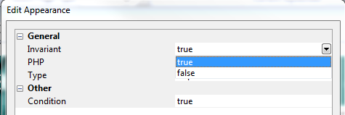

Section Pages

Taking People Straight to a Section
If you want to create a link to a section in a store, then use a link of the following form...
http://your.URL/cgi-bin/ss00000x.pl?SECTIONID=Section%5fPage%2ehtml&NOLOGIN=1
Where:
- http://your.URL/cgi-bin is the URL of your CGI-BIN
- ss00000x.pl is the name of your search script with the 'x' replaced with your CGI ID number
- Section%5fPage%2ehtml is the filename of your desired page. Note that you have to encode any non-alphanumeric characters so an underscore '_' becomes '%5f' and a full stop '.' becomes '%2e'.
- &NOLOGIN=1 is an essential thing to add to the end of the URL to order to bypass the login page

Linking from Other URLs
Note: If you are using this code from outside the 'acatalog' folder then you will need to include a hidden form field of 'ACTINIC_REFERRER=' where the value is your 'Catalog URL' from 'Web | Network Setup'. For example:
http://your.URL/cgi-bin/ss00000x.pl?PRODREF=12345&NOLOGIN=1&ACTINIC_REFERRER=http://your.URL/acatalog/
and also
<INPUT TYPE=HIDDEN NAME="ACTINIC_REFERRER" VALUE="http://your.URL/acatalog/">

Optimising Page Titles For Search Engines
By default, SellerDeck will automatically create a page titles for your pages. By default it uses the product name (the ‘short description’) for product pages; the section name for section pages; the brochure page name for brochure pages; and the company name and page type for other pages. You can override this by entering a value in the 'Page Title' field within the 'Page Settings' panel of a section. It is, however, possible to edit the automatically generated page titles for all your sections.
To do this, you need to locate the <title></title> field within the overall page layout of your pages. This will contain a variable called PageTitle.
Replace the PageTitle variable with the following code:
<actinic:block if="%3cactinic%3avariable%20name%3d%22PageType%22%20%2f%3e%20%3d%3d%20%22Product%20Page%22"><actinic:variable name="ProductName" /></actinic:block><actinic:block if="%3cactinic%3avariable%20name%3d%22PageType%22%20%2f%3e%20%3d%3d%20%27Section%27"><actinic:block if="%3cactinic%3avariable%20name%3d%22SectionLevel%22%20%2f%3e%20%3e%200"><actinic:variable name="SectionName" /></actinic:block><actinic:block if="%3cactinic%3avariable%20name%3d%22SectionLevel%22%20%2f%3e%20%3d%3d%200"><actinic:variable name="CompanyName" /></actinic:block></actinic:block><actinic:block if="%3cactinic%3avariable%20name%3d%22PageType%22%20%2f%3e%20%3d%3d%20%27Brochure%27"><actinic:variable name="BrochureName" /></actinic:block><actinic:block if="%28%3cactinic%3avariable%20name%3d%22PageType%22%20%2f%3e%20%21%3d%20%27Section%27%29%20AND%20%28%3cactinic%3avariable%20name%3d%22PageType%22%20%2f%3e%20%21%3d%20%27Brochure%27%29%20AND%20%28%3cactinic%3avariable%20name%3d%22PageType%22%20%2f%3e%20%21%3d%20%22Product%20Page%22%29" ><actinic:variable name="CompanyName" /> <actinic:variable name="PageType" /></actinic:block>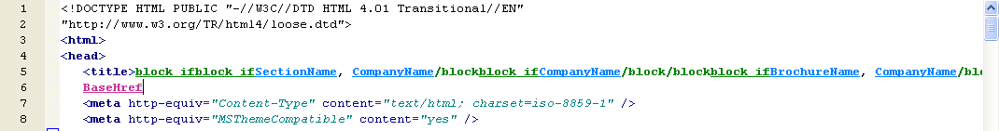
All the conditions (green 'block' tags) are there to show different titles on different types of pages.

Inserting Content to Only Appear on the Store Front Page
If you want a message or an image to appear on the front page of the store, but no other page, then do the following:
- Change the preview to show the front page of the store. This is the 'Online Catalogue' icon in the content tree.
- Select the 'Main Product Area Layout' in the 'Design' tab. This will be called something like 'Standard Section Page' or 'Section Page With Section Name At The Top'. The easiest way to do this is to click on anything in the main part of a section page and then keep pressing the 'Navigate to Parent Layout' button - - until the correct layout is selected.
- Insert your content that you only want to appear on the front page.
- Once you have got it looking correct, highlight all the content and press the 'Insert Block' button on the toolbar - .
- The condition to enter is:
<actinic:variable name="SectionLevel" /> == 0
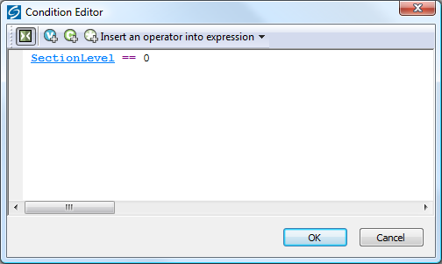
- Click 'OK' and then click 'Apply' to save the changes to your layout.
Your content will now only appear on the store front page.

Creating Links to 'Previous' and 'Next' Sections at the Same Level
SellerDeck allows you to include links to 'previous' and 'next' sections (i.e. sections at the same level in the store – sometimes known as 'sibling sections').
To include a link to the previous section, insert the layout selector called 'PrevNextSectionLink' and use a fixed layout of 'Link To Previous Section'. For the link to the next section, the fixed layout you want to use is 'Link To Next Section'.
The following screenshot shows some example code to do this:
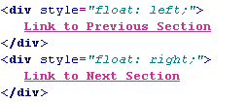
Here is the code to copy and paste:
<div style="float: left;">
<actinic:variable name="PrevNextSectionLink" value="Link to Previous Section" />
</div>
<div style="float: right;">
<actinic:variable name="PrevNextSectionLink" value="Link to Next Section" />
</div>

Only Using a Single Parent Section List in a Design
By default, SellerDeck has two 'parent section lists' (breadcrumb trails) in the design – a top one and a bottom one. If you want to simplify this, and just have one parent section list, use the following steps.
- Go to 'Design | Library | Layouts' and expand the 'Parent Section Lists' group.
- Double-click on the 'ParentSectionListBottom' layout selector and de-select 'Site' under 'Place of Setting'.
- Click 'OK' and close the library.
- Now click on the 'bottom' parent section link in the preview in the 'Design' tab.
- Click the 'Navigate To Parent Layout' button - - until you are in the 'Section Page' layout (called something like 'Standard Section Page' or 'Section Page With Section Name At The Top').
- You can now delete the 'ParentSectionListBottom' layout selector.

Having Different Background Colours on Different Pages
NB this method does not work well with the Angles, Art, Edged, Panache, Splash or Venture themes, or with other designs that use background images or hard-coded colours.
To have a different background colour on each page, you need to create a new user-definable variable called 'BackgroundColor' to replace the default 'BGColor' system variable.
- To do this, first of all go into 'Design | Themes' and click 'Advanced Themes Configuration', and change to the 'Colour Scheme' tab.
- Make a note of whatever you have set for the background colour at the moment
- Next, go to 'Design | Library | Variables', right-click on 'Appearance Settings' and select 'New Variable'.
- Give it a name of 'BackgroundColor' and use a prompt of 'Background Color'.
- Under 'Place of Setting', select 'Site', 'Section' and 'Brochure' and set the 'Panel Name' to 'General'.
- In 'Top Level Value', enter whatever you have got set as the background colour e.g. 'white' or '#ffffff'.
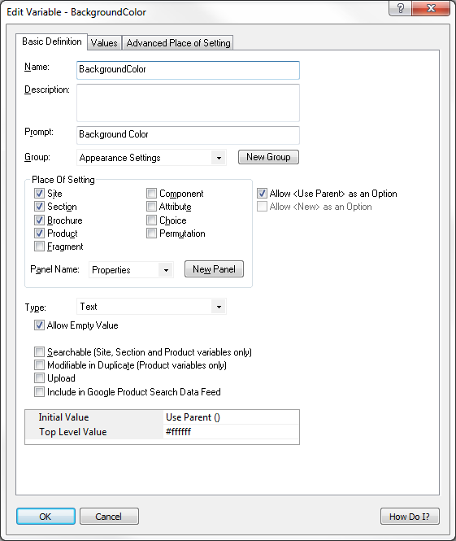
- Click 'OK' and close the library.
You now need to insert this variable into your overall page layouts for your sections and brochure pages.
- View a section in the 'Design' tab.
- Select the overall page layout for the page.
- Locate the <body... > tag.
- Add in the following line within the <body> tag:
style="background-color: <actinic:variable name="BackgroundColor" />;"
You should now be able to change the background colour for each section by changing the 'Background Color' value in the 'General' panel of each section.
To apply this to brochure pages, just edit the overall page layout of a brochure page.
Note: some themes use <div> tags to control the background colour of the main area of the page separately from the body background. For example, in the 'Executive' look out for this line:
<div class="page_body" align="center">
Add the style= command into this line to see the effect.

Preventing Search Engines from Indexing Certain Pages
As you may know, search engines will 'spider' through all your pages on your website and make a note of the content of each page. This is great for your store pages, as customers can search on words that are on your pages, but there may be certain pages in your store that you do not want search engines finding.
- Go into the 'Layout' panel that of the section that you want hide from search engines.
- Locate the 'Overall Page Layout' field and make a mental note of the name of the current overall page layout.
- Click in the 'Overall Page Layout' field and select '<New>' from the bottom of the list.
- In the 'Based On' field, select the overall page layout that is currently being used by the section.
- In the 'Name' field enter 'Hidden From Search Engines'.
- Click 'OK' and then click 'Apply' to make this section use the new layout.
- Now change to the 'Design' tab and select the overall page layout.
- Within the <head> section of the layout, enter the following line:
<META NAME="robots" CONTENT="none">
You can now specify this file as the overall page layout for any pages that you do not want indexed.

Section Navigation

Hiding Top Level Section Links from the Sitemap
This exercise will show you how to prevent any links to top level sections from appearing in the Site Map.
First of all you need to get into the layout called 'Site Map Section List'.
You can either do this by going into 'Design | Library' – you will find it in the group called 'Site Map Section Lists' - or change the 'Select Page Type' drop down list in the 'Design' tab to 'Site Map'. Then click on one of the links in the sitemap and click the 'Navigate to Parent Layout' button - - a couple of times.
Highlight the 'Site Map Section Link' layout selector and click the 'Insert Block' button - . The condition you want is:
<actinic:variable name="SectionLevel" /> > 2
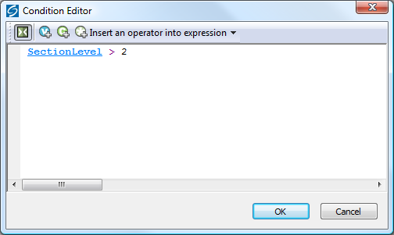
Click 'OK' to implement the rule.
The top level section links will now be hidden from the sitemap.

Using a different Section Name in the Breadcrumb Trail
Sometimes, you might want to have more specific control over what appears in your breadcrumb trail (parent section list) at the top and bottom of each page.
If you want to show something other than the section name in the breadcrumb trail, then you just need to create a new variable at the section level called 'BreadCrumbName'. To do this:
- Go to 'Design | Library | Variables' and expand the 'Section' group.
- Right-click on the 'Section' group name and select 'New Variable'.
- Give it a name of 'BreadCrumbName' and a prompt of 'Name for Breadcrumb Trail'
- Under 'Place of Setting' select 'Section'.
- De-select 'Allow <Use Parent> as an option'
- Leave 'Panel Name' as 'Properties'
- Leave both 'Initial Value' and 'Top Level Value' as empty
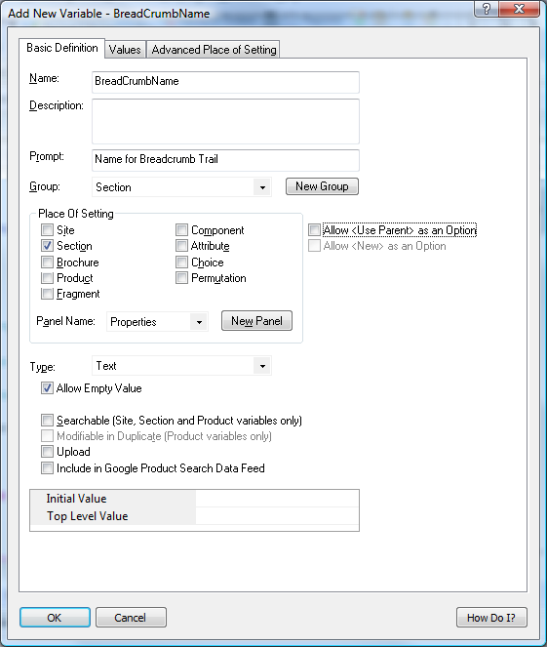
- Now go to the 'Layouts' tab of the library and expand the 'Parent Section List Entry' group.
- In all the layouts you see there, replace the 'SectionName' variable with the following code:
<actinic:variable encoding="actinic" name="SectionName" if="%3cactinic%3avariable%20name%3d%22BreadCrumbName%22%20%2f%3e%20%3d%3d%20%22%22" /><actinic:variable name="BreadCrumbName" />
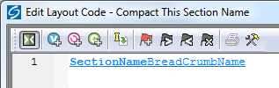
You can now enter a 'Name for Breadcrumb Trail' within the 'Properties' panel of your sections.

How to Only Show Certain Sections in the Top Level Section List
This will show you how to manually select which sections will appear in the 'top level section list' that is in the sidebar of most of the SellerDeck designs.
- Go to 'Design | Library' and go to the 'Variables' tab.
- Right click on the 'Section' group and select 'New Variable'
- Give the variable a name of 'ShowInSidebar'.
- Give it a prompt of 'Show Section in Sidebar'.
- Under 'Place of Setting' select 'Section'.
- Under 'Panel Name' select 'General'.
- De-select 'Allow <Use parent> as an Option'
- Change the 'Type' field to 'True/False'.
- Leave the 'Top Level Value' and 'Initial Value' to 'True' if you want all sections shown by default. Set them both to 'False' if you don't.
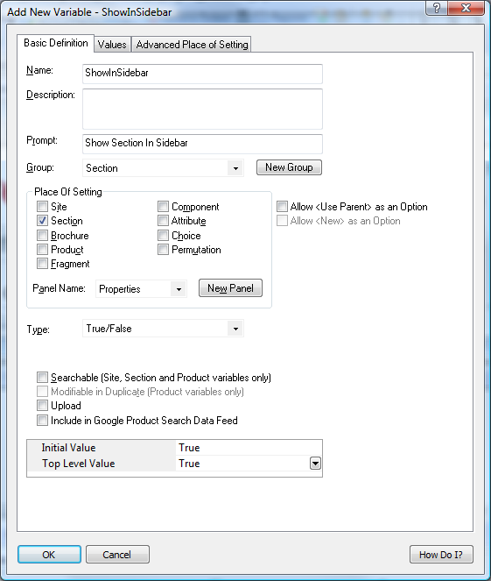
- Click 'OK' and close the library.
- Go to the 'Design' tab and in the preview pane click on one of the sections in your top level section list. You should now be looking at a layout called 'Section Name Only Section Link'.
- Double click on the block if at the top of the layout code.
- You should now be in the Condition Editor. Change the condition to:
<actinic:variable name="IsSectionIncludedInSiteMap" /> AND <actinic:variable name="ShowInSidebar" />
You can just copy and paste the code straight into the editor.
- Click 'OK' and then click 'Apply' to confirm your changes.
You can now go into the 'General' panel of any section that you don't want in the top level section list in the sidebar, and change 'Show Section In Sidebar' to 'False'.
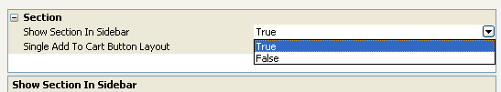

Highlighting the 'Current' Section in the Section List
This technique will show you how to include a section list in the store where the 'current' section (i.e. the one the customer is currently on) is highlighted. In this case it is made a different colour, but you can adapt this code as required. This technique uses the 'Advanced Lists' as described earlier in this guide.
Copy and paste the following code into your layouts where you want the section list to appear:
<actinic:block type="TopLevelSectionList" >
<a href="<actinic:block if="%3cactinic%3avariable%20name%3d%22IsLoginPageSuppressed%22%20%2f%3e%20AND%0d%3cactinic%3avariable%20name%3d%22UnregCustomersAreNotAllowed%22%20%2f%3e" ><actinic:variable name="SectionPageName" /></actinic:block><actinic:block if="%28%3cactinic%3avariable%20name%3d%22IsLoginPageSuppressed%22%20%2f%3e%20%3d%3d%20false%29%20OR%0d%28%3cactinic%3avariable%20name%3d%22UnregCustomersAreNotAllowed%22%20%2f%3e%20%3d%3d%20false%29" ><actinic:variable name="SectionURL" /></actinic:block>" target="_self">
<actinic:block if="%3cactinic%3avariable%20name%3d%22SectionID%22%20%2f%3e%20%3d%3d%20%3cactinic%3avariable%20name%3d%22MainSection%3a%3aSectionID%22%20%2f%3e"><span style="color: green;"><strong></actinic:block>
<actinic:variable name='SectionName'/>
<actinic:block if="%3cactinic%3avariable%20name%3d%22SectionID%22%20%2f%3e%20%3d%3d%20%3cactinic%3avariable%20name%3d%22MainSection%3a%3aSectionID%22%20%2f%3e">&lt;&lt;</strong></span></actinic:block>
</a>
<br />
</actinic:block>
It will look like this once you've copied and pasted it in:
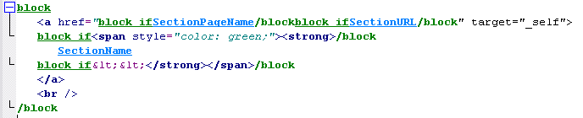
And the results will look something like:
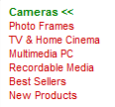
You'll need to adapt this code to get it looking as you need it – look at the two block if tags above and below the SectionName variable. They are what changes the formatting of the link in specific sections.
It is possible to adapt this trick to keep the section highlighted even if you go into a sub-section within the section.
To do this, you first need to create a new user definable variable called 'SectionNumber' as follows:
  - Go to 'Design | Library | Variables'.
  - Right-click on 'Section' and select 'New Variable'.
  - In the 'Name' field, enter 'SectionNumber'.
  - In the 'Prompt' field, enter 'Section Number'.
  - Under 'Place of Setting' select 'Section'.
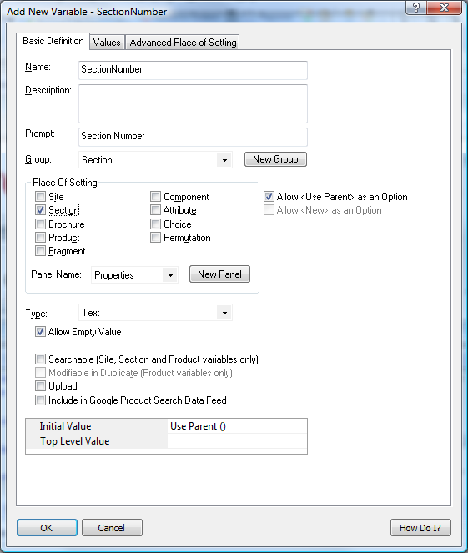
  - Now go to your first main top-level section in the content tree and change to the 'Properties' panel.
  - Set the value of 'Section Number' as '1'.
  - Repeat this for all your other main top-level sections, using a different number for each section.
  - Now use the following code for the section list:
<actinic:block type="TopLevelSectionList" >
<a href="<actinic:block if="%3cactinic%3avariable%20name%3d%22IsLoginPageSuppressed%22%20%2f%3e%20AND%0d%3cactinic%3avariable%20name%3d%22UnregCustomersAreNotAllowed%22%20%2f%3e" ><actinic:variable name="SectionPageName" /></actinic:block><actinic:block if="%28%3cactinic%3avariable%20name%3d%22IsLoginPageSuppressed%22%20%2f%3e%20%3d%3d%20false%29%20OR%0d%28%3cactinic%3avariable%20name%3d%22UnregCustomersAreNotAllowed%22%20%2f%3e%20%3d%3d%20false%29" ><actinic:variable name="SectionURL" /></actinic:block>" target="_self">
<actinic:block if="%3cactinic%3avariable%20name%3d%22SectionNumber%22%20%2f%3e%20%3d%3d%20%3cactinic%3avariable%20name%3d%22MainSection%3a%3aSectionNumber%22%20%2f%3e" ><span style="color: green;"><strong></actinic:block>
<actinic:variable name='SectionName'/>
<actinic:block if="%3cactinic%3avariable%20name%3d%22SectionNumber%22%20%2f%3e%20%3d%3d%20%3cactinic%3avariable%20name%3d%22MainSection%3a%3aSectionNumber%22%20%2f%3e" >&lt;&lt;</strong></span></actinic:block>
</a>
<br />
</actinic:block>

Section List With Sub Sections In Bullets
This code can be used on any page, and will give a list of the main sections, and any sub-sections will be listed in a bulleted list underneath the main section heading.
<actinic:block type="EntireSectionList">

<actinic:block if="%3cactinic%3avariable%20name%3d%22SectionLevel%22%20%2f%3e%20%3d%3d%201" >
<br /><strong><a href="<actinic:variable name="SectionPageName"/>" target="_self"><actinic:variable name='SectionName'/></a></strong>
</actinic:block>

<actinic:block if="%28%3cactinic%3avariable%20name%3d%22SectionLevel%22%20%2f%3e%20%3d%3d%202%29%20AND%20%28%3cactinic%3avariable%20name%3d%22ListIndex%22%20%2f%3e%20%3d%3d%201%29" >
<ul>
</actinic:block>
<actinic:block if="%3cactinic%3avariable%20name%3d%22SectionLevel%22%20%2f%3e%20%3d%3d%202">
<li><a href="<actinic:variable name="SectionPageName"/>" target="_self"><actinic:variable name='SectionName'/></a></li>
</actinic:block>
<actinic:block if="%28%3cactinic%3avariable%20name%3d%22SectionLevel%22%20%2f%3e%20%3d%3d%202%29%20AND%20%28%3cactinic%3avariable%20name%3d%22ListIndex%22%20%2f%3e%20%3d%3d%20%3cactinic%3avariable%20name%3d%22ListCount%22%20%2f%3e%29" >
</ul>
</actinic:block>

</actinic:block>

Jump List Containing Every Section
The following code will include a jump list into the site that contains every section in the store, with indents showing the depth of section.
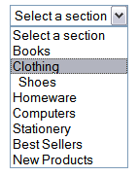
<select size="1" name="ACT_droplstbox" onClick="if(options[selectedIndex].value) window.location.href=(options[selectedIndex].value)">
<option value="" selected="selected">Select a section</option>
<actinic:block type="EntireSectionList" >
<option value="<actinic:block if="%3cactinic%3avariable%20name%3d%22IsLoginPageSuppressed%22%20%2f%3e%20AND%0d%3cactinic%3avariable%20name%3d%22UnregCustomersAreNotAllowed%22%20%2f%3e" ><actinic:variable name="SectionPageName" /></actinic:block><actinic:block if="%28%3cactinic%3avariable%20name%3d%22IsLoginPageSuppressed%22%20%2f%3e%20%3d%3d%20false%29%20OR%0d%28%3cactinic%3avariable%20name%3d%22UnregCustomersAreNotAllowed%22%20%2f%3e%20%3d%3d%20false%29" ><actinic:variable name="SectionURL" /></actinic:block>">
<actinic:block if="%3cactinic%3avariable%20name%3d%22SectionLevelIsGreaterThan1%22%20%2f%3e">&nbsp;</actinic:block>
<actinic:block if="%3cactinic%3avariable%20name%3d%22SectionLevelIsGreaterThan2%22%20%2f%3e">&nbsp;</actinic:block>
<actinic:block if="%3cactinic%3avariable%20name%3d%22SectionLevelIsGreaterThan3%22%20%2f%3e">&nbsp;</actinic:block>
<actinic:block if="%3cactinic%3avariable%20name%3d%22SectionLevelIsGreaterThan4%22%20%2f%3e">&nbsp;</actinic:block>
<actinic:block if="%3cactinic%3avariable%20name%3d%22SectionLevelIsGreaterThan5%22%20%2f%3e">&nbsp;</actinic:block>
<actinic:block if="%3cactinic%3avariable%20name%3d%22SectionLevelIsGreaterThan6%22%20%2f%3e">&nbsp;</actinic:block>
<actinic:block if="%3cactinic%3avariable%20name%3d%22SectionLevelIsGreaterThan7%22%20%2f%3e">&nbsp;</actinic:block>
<Actinic:Variable Name="SectionName">
</option>
</actinic:block>
</select>

Different Sections in Different Parts of the Page
This technique uses 'Advanced Lists' to include two different section lists into the page – with each one containing different section links.
Before you can insert the design code to support this, you need to create a new variable within SellerDeck called 'WhichSectionList'. To do this:
- Go to 'Design | Library | Variables'.
- Expand the 'Section' group and then right-click on any variable and select 'New Variable'
- Give it a name of 'WhichSectionList' and a prompt of 'Where do you want this section link to appear?'
- Set 'Place of Setting' to 'Section' and leave the 'Panel' as 'Properties'.
- Change the 'Type' to 'List of Choices'.
- Change to the 'Values' tab, and click the 'New' button to create two choices of 'List 1' and 'List 2'.
- Change back to the 'Basic Definition' tab.
- Check 'Initial Value' is set to 'Use Parent ()' and 'Top Level Value' is set to 'List 1'.
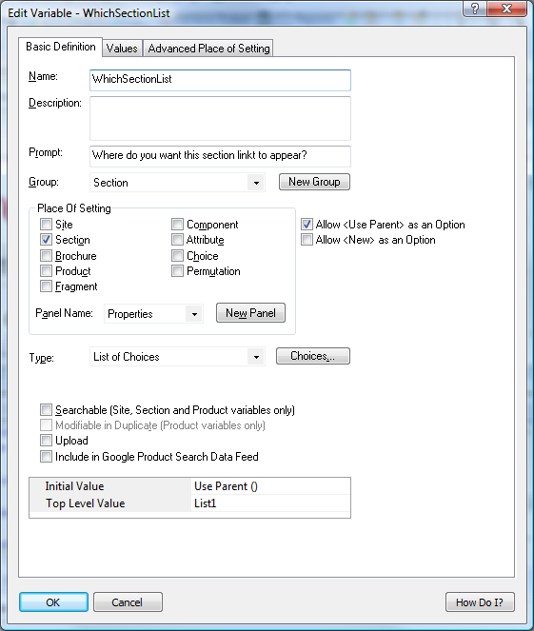
- Click 'OK' to save your changes.
You can then categorise your sections as appearing in either 'List 1' or 'List 2'. This is done in the 'Properties' panel of each section.
Then use the following code to insert your 'List 1' and 'List 2' code into the design.
List 1:
<actinic:block type="TopLevelSectionList" >
<actinic:block if="%3cactinic%3avariable%20name%3d%22WhichSectionList%22%20%2f%3e%20%3d%3d%20%22List%201%22" >
<a href="<actinic:block if="%3cactinic%3avariable%20name%3d%22IsLoginPageSuppressed%22%20%2f%3e%20AND%0d%3cactinic%3avariable%20name%3d%22UnregCustomersAreNotAllowed%22%20%2f%3e" ><actinic:variable name="SectionPageName" /></actinic:block><actinic:block if="%28%3cactinic%3avariable%20name%3d%22IsLoginPageSuppressed%22%20%2f%3e%20%3d%3d%20false%29%20OR%0d%28%3cactinic%3avariable%20name%3d%22UnregCustomersAreNotAllowed%22%20%2f%3e%20%3d%3d%20false%29" ><actinic:variable name="SectionURL" /></actinic:block>" class="product_section">
<Actinic:Variable Name="SectionName"/>
</a>
<br />
</actinic:block>
</actinic:block>

List 2:
<actinic:block type="TopLevelSectionList" >
<actinic:block if="%3cactinic%3avariable%20name%3d%22WhichSectionList%22%20%2f%3e%20%3d%3d%20%22List%202%22" >
<a href="<actinic:block if="%3cactinic%3avariable%20name%3d%22IsLoginPageSuppressed%22%20%2f%3e%20AND%0d%3cactinic%3avariable%20name%3d%22UnregCustomersAreNotAllowed%22%20%2f%3e" ><actinic:variable name="SectionPageName" /></actinic:block><actinic:block if="%28%3cactinic%3avariable%20name%3d%22IsLoginPageSuppressed%22%20%2f%3e%20%3d%3d%20false%29%20OR%0d%28%3cactinic%3avariable%20name%3d%22UnregCustomersAreNotAllowed%22%20%2f%3e%20%3d%3d%20false%29" ><actinic:variable name="SectionURL" /></actinic:block>" class="product_section">
<Actinic:Variable Name="SectionName"/>
</a>
<br />
</actinic:block>
</actinic:block>
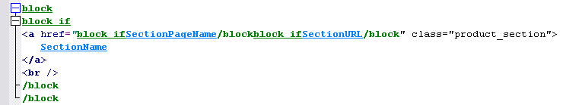

Including Section Lists with Javascript
SellerDeck has the ability to generate a JavaScript array file (with an extension of *.js) that contains information about all the top-level sections, or the entire section tree complete with sub-sections. This section information is in the form of 'array' data. This file is uploaded with the store pages, and can be used to generate drop-down lists, list boxes and other more advanced navigation tools to help your customers to jump to their desired sections of the store. The advantage of using this external file is that it can be used by web pages that are located outside the store, so that a list of all the store sections can be incorporated into any web page. This list will be automatically updated by SellerDeck as you make changes to the structure of the online store.
The list of all the layouts available to perform this function, with a description of what they do, the JavaScript file they cause to generate and the HTML they include in the page, is below. You will find all the layouts within the 'JavaScript Section List' group in the library, and they are all inserted into the design via the 'JavaScriptArray' layout selector.
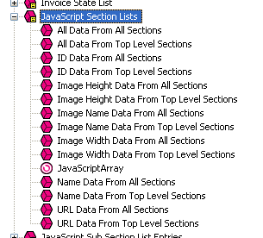
There are some examples of how to incorporate this code at the bottom of this section.

Layout: | All Data From Top Level Sections
Description: | Will cause the generation of a JavaScript file called Act_sections.js that contains all the names, URLs, image filenames, image heights and widths and section IDs* of the top-level sections of the online store. Also creates the HTML in the store to incorporate that file.
Code inserted into design: | <script type="text/javascript" src="Act_sections.js"></script>

Layout: | All Data From All Sections
Description: | Will cause the generation of a JavaScript file called Act_section_tree.js that contains all the names, URLs, image filenames, image heights and widths and section IDs* for every section of the online store. Also creates the HTML in the store to incorporate that file.
Code inserted into design: | <script type="text/javascript" src="Act_section_tree.js"></script>

Layout: | Name Data From All Sections
Description: | Will cause the generation of a JavaScript file called Act_section_tree_names.js that contains all the names for every section of the online store. Also creates the HTML in the store to incorporate that file.
Code inserted into design: | <script type="text/javascript" src="Act_section_tree_names.js"></script>

Layout: | URL Data From All Sections
Description: | Will cause the generation of a JavaScript file called Act_section_tree_URLs.js that contains all the URLs for every section of the online store. Also creates the HTML in the store to incorporate that file.
Code inserted into design: | <script type="text/javascript" src="Act_section_tree_URLs.js"></script>

Layout: | Image Name Data From All Sections
Description: | Will cause the generation of a JavaScript file called Act_section_tree_images.js that contains all the image filenames for every section of the online store. Also creates the HTML in the store to incorporate that file.
Code inserted into design: | <script type="text/javascript" src="Act_section_tree_images.js"></script>

Layout: | Image Width Data From All Sections
Description: | Will cause the generation of a JavaScript file called Act_section_tree_imagewidths.js that contains all the image widths for every section image in the online store. Also creates the HTML in the store to incorporate that file.
Code inserted into design: | <script type="text/javascript" src="Act_section_tree_imagewidths.js"></script>

Layout: | Image Height Data From All Sections
Description: | Will cause the generation of a JavaScript file called Act_section_tree_imageheights.js that contains all the image heights for every section image in the online store. Also creates the HTML in the store to incorporate that file.
Code inserted into design: | <script type="text/javascript" src="Act_section_tree_imageheights.js"></script>

Layout: | ID Data From All Sections
Description: | Will cause the generation of a JavaScript file called Act_section_tree_ids.js that contains all the section IDs* for every top-level section in the online store. Also creates the HTML in the store to incorporate that file.
Code inserted into design: | <script type="text/javascript" src="Act_section_tree_ids.js"></script>

Layout: | Name Data From Top Level Sections
Description: | Will cause the generation of a JavaScript file called Act_sections_names.js that contains all the names for every top-level section of the online store. Also creates the HTML in the store to incorporate that file.
Code inserted into design: | <script type="text/javascript" src="Act_sections_names.js"></script>

Layout: | URL Data From Top Level Sections
Description: | Will cause the generation of a JavaScript file called Act_sections_URLs.js that contains all the URLs for every top-level section of the online store. Also creates the HTML in the store to incorporate that file.
Code inserted into design: | <script type="text/javascript" src="Act_sections_URLs.js"></script>

Layout: | Image Name Data From Top Level Sections
Description: | Will cause the generation of a JavaScript file called Act_sections_images.js that contains all the image filenames for every top-level section of the online store. Also creates the HTML in the store to incorporate that file.
Code inserted into design: | <script type="text/javascript" src="Act_sections_images.js"></script>

Layout: | Image Width Data From Top Level Sections
Description: | Will cause the generation of a JavaScript file called Act_sections_imagewidths.js that contains all the image widths for every top-level section image in the online store. Also creates the HTML in the store to incorporate that file.
Code inserted into design: | <script type="text/javascript" src="Act_sections_imagewidths.js"></script>

Layout: | Image Height Data From Top Level Sections
Description: | Will cause the generation of a JavaScript file called Act_sections_imageheights.js that contains all the image heights for every top-level section image in the online store. Also creates the HTML in the store to incorporate that file.
Code inserted into design: | <script type="text/javascript" src="Act_sections_imageheights.js"></script>

Layout: | ID Data From Top Level Sections
Description: | Will cause the generation of a JavaScript file called Act_sections_ids.js that contains all the section IDs* for every top-level section in the online store. Also creates the HTML in the store to incorporate that file.
Code inserted into design: | <script type="text/javascript" src="Act_sections_ids.js"></script>
There is also a layout type group called 'JavaScript Sub Section Lists' which contains the following layouts:
- List Of All Data From Sub Sections
- List Of Name Data From Sub Sections
- List Of URL Data From Sub Sections
- List Of Image Name Data From Sub Sections
- List Of Image Width Data From Sub Sections
- List Of Image Height Data From Sub Sections
- List Of ID Data From Sub Sections
They are all inserted into the design via the 'JavaScriptSubSectionArray' layout selector.
These perform the same function as the layouts already described (creating a JavaScript array containing the section details) but these insert the information about the sub-sections within the current section. In other words, the section information they contain will depend on what section page they are being used within. These placeholders work differently as they will actually embed the JavaScript array into the page when the pages are generated. They do not cause the creation of an external JavaScript file.
* A section ID is a unique number associated with every section in the online store. They are used by forms to allow customers to jump to particular sections in the online store.

Note About Inserting Jump Lists In The Main Product Area
If you are including any of the 'jump lists' below within the main product area of a page, you will need to precede the code with the following line:
</form>
and then copy and paste the following lines after the form code:

<actinic:block if="%3cactinic%3avariable%20name%3d%22IsMainFormUsed%22%20%2f%3e">
<form method="post" action="<actinic:variable name="OnlineScriptURL" value="Shopping Cart Script URL" />">
<input type="hidden" name="SID" value="<Actinic:Variable Name="SectionID"/>" />
<input type="hidden" name="PAGE" value="PRODUCT" />
<input type="hidden" name="PAGEFILENAME" value="<actinic:variable name="SectionPageName" />" />
<Actinic:SECTION blob='<Actinic:Variable Name="SectionCatFile"/>'/>
<input type="hidden" name="RANDOM" value="<actinic:variable name="Random" />" />
<actinic:block if="%3cactinic%3avariable%20name%3d%22IsHostMode%22%20%2f%3e">
<!-- Hidden field when in trial mode -->
<input type="hidden" name="SHOP" value="<Actinic:Variable Name="HiddenFields"/>" />
</actinic:block>
</actinic:block>
This is to ensure the continuation of the main store page form either side of the jump list.

Creating a Jump List Containing the Top-Level Sections
This exercise will insert a drop-down list containing a list of top-level sections into the HTML of your store. As soon as a customer selects a section, they will jump to it.
When presented to customers in the browser, the code becomes a drop-down list containing a list of the top-level sections.
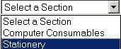
To include this, paste the following just above the </head> tag of your overall page layout:

<actinic:variable name="JavaScriptArray" value="All Data From Top Level Sections" />
<SCRIPT LANGUAGE="JavaScript" TYPE="text/javascript">
<!--
/***********************************************************************
*
* ACT_DropListBox - returns a string containing the HTML for the SELECT listbox
*
************************************************************************/

function ACT_DropListBox(ar)
{
var strIDs = '<SELECT SIZE="1" NAME="ACT_droplstbox" onClick="if(options[selectedIndex].value) window.location.href=(options[selectedIndex].value)">'
var sel = " SELECTED"
strIDs += '<OPTION ' + sel + ' VALUE="">Select a Section</OPTION>'
for (var i=1;i<=ar.length;i++)
{
if (ar[i].sURL !=null)
{
strIDs += '<OPTION VALUE="' + ar[i].sURL + '">' + ar[i].sName + '</OPTION>'
}
}
strIDs+='</SELECT>'
return strIDs
}
//-->
</SCRIPT>

Paste the following code within your store design where you want the drop-down list to appear.

<form name="Act_SectionDroplist">
<script language=Javascript1.1>document.write(ACT_DropListBox(sections))</script>
</form>

Creating a Drop-Down List Containing the Top-Level Sections and Sub Sections
This exercise will insert a drop-down list containing a list of sections and subsections (to three levels of depth) into the HTML of your store. As soon as a customer selects a section, they will jump to it.
Paste the following code just above the </head> tag in your overall page layout:

<actinic:variable value="All Data From All Sections" name="JavaScriptArray" />

<SCRIPT LANGUAGE="JavaScript" TYPE="text/javascript">
<!--
/***********************************************************************
*
* ACT_DropListBox - returns a string containing the HTML for the SELECT listbox
*
************************************************************************/

function ACT_DropListBox(ar)
{
var strIDs = '<SELECT SIZE="1" NAME="ACT_droplstbox" onClick="if(options[selectedIndex].value) window.location.href=(options[selectedIndex].value)">';
var sel = " SELECTED"
strIDs += '<OPTION ' + sel + ' VALUE="">Select a Section</OPTION>';
for (var i=1;i<=ar.length;i++)
{
if (ar[i].sURL !=null)
{
strIDs += '<OPTION VALUE="' + ar[i].sURL + '">' + ar[i].sName + '</OPTION>';
{
if (ar[i].pChild)
{
for (var j=1;j<=ar[i].pChild.length;j++)
{
strIDs += '<OPTION VALUE="' + ar[i].pChild[j].sURL + '">' + '- ' + ar[i].pChild[j].sName + '</OPTION>';
{
if (ar[i].pChild[j].pChild)
{
for (var k=1;k<=ar[i].pChild[j].pChild.length;k++)
{
strIDs += '<OPTION VALUE="' + ar[i].pChild[j].pChild[k].sURL + '">' + '- - ' + ar[i].pChild[j].pChild[k].sName + '</OPTION>';
}
}
}
}
}
}
}
}
strIDs+='</SELECT>'
return strIDs
}
//-->
</SCRIPT>

Then paste the following code where you want the drop-down list to appear.

<form name="Act_SectionDroplist">
<script language=Javascript1.1>document.write(ACT_DropListBox(section_tree))</script>
</form>

Creating a List Box Containing the Top-Level Sections
This exercise will insert a list box containing a list of top-level sections into the HTML of your store. As soon as a customer selects a section, they will jump to it.
It will look like the following:
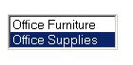
Place the following function just above the </head> tag in your overall page layout..

<actinic:variable name="JavaScriptArray" value="All Data From Top Level Sections" />

<SCRIPT LANGUAGE="JavaScript" TYPE="text/javascript">
<!--
//ACT_ListBox(ar)
//ar= Section array name, returns a string containing the HTML for the SELECT listbox.

function ACT_ListBox(ar)
{
var strIDs = '<SELECT SIZE="' + ar.length + '" NAME="ACT_lstbox" onClick="if(options[selectedIndex].value) window.location.href=(options[selectedIndex].value)">'
var sel = ' SELECTED'
for (var i=1;i<=ar.length;i++)
{
strIDs += '<OPTION ' + sel + ' VALUE="' + ar[i].sURL + '">' + ar[i].sName + '</OPTION>'
sel = ''
}
strIDs+='</SELECT>'
return strIDs
}
//-->
</script>

And then the following code where you want the list box to appear:

<FORM>
<script language=Javascript1.2>
document.write(ACT_ListBox(sections) + "<BR>")
</script>
</FORM>

Creating a List of Hyperlinks with Sections and Sub-sections
This code will lay out your sections and sub-sections within a list of hyperlinks (first depth of sub-sections only). The sub-sections will appear indented.
Paste the following code just above the </head> tag in your overall page layout:

<actinic:variable value="All Data From All Sections" name="JavaScriptArray" />

<SCRIPT LANGUAGE="JavaScript" TYPE="text/javascript">
<!--
function SectionList(ar)
{
var strIDs = '<table border=0 width=95% cols=2>';
for (var i=1;i<=ar.length;i++)
{
if (ar[i].sURL !=null)
{
strIDs += '<tr><td colspan=2><a href="' + ar[i].sURL + '"><span class="actxxsmall">' + ar[i].sName + '</span></a></td></tr>';
{
if (ar[i].pChild)
{
for (var j=1;j<=ar[i].pChild.length;j++)
{
if (j <= ar[i].pChild.length)
{
strIDs += '<tr><td><img src=shim.gif width=5></td><td><a href="' + ar[i].pChild[j].sURL + '"><span class="actxxsmall">' + ar[i].pChild[j].sName + '</span></a></td></tr>';
}
}
}
}
}
}
strIDs += '</table>'
return strIDs
}
//-->
</SCRIPT>

And then insert the following code in the main body of the page where you want the list to appear.

<script language=Javascript1.1>document.write(SectionList(section_tree))
</script>

Creating a List of Hyperlinks with Sections and Two Levels of Sub-sections
This code will lay out your sections and two levels of sub-sections within a list of hyperlinks. The sub-sections will appear indented.
Paste the following code just above the </head> tag in your overall page layout:

<actinic:variable value="All Data From All Sections" name="JavaScriptArray" />

<SCRIPT LANGUAGE="JavaScript" TYPE="text/javascript">
<!--
function SectionList(ar)
{
var strIDs = '<table border=0 width=95% cols=2>';
for (var i=1;i<=ar.length;i++)
{
if (ar[i].sURL !=null)
{
strIDs += '<table><tr><td colspan=2><a href="' + ar[i].sURL + '"><span class="actxxsmall">' + ar[i].sName + '</span></a></td></tr></table>';
{
if (ar[i].pChild)
{
for (var j=1;j<=ar[i].pChild.length;j++)
{
strIDs += '<table><tr><td><img src=shim.gif width=5></td><td><a href="' + ar[i].pChild[j].sURL + '"><span class="actxxsmall">' + ar[i].pChild[j].sName + '</span></a></td></tr></table>';

{
if (ar[i].pChild[j].pChild)
{
for (var k=1;k<=ar[i].pChild[j].pChild.length;k++)
{

strIDs += '<table><tr><td width="20"></td><td><a href="' + ar[i].pChild[j].pChild[k].sURL + '"><span class="actxxsmall">' + ar[i].pChild[j].pChild[k].sName + '</span></a></td></tr></table>';

}
}
}
}
}
}
}
}
strIDs += '</table>'
return strIDs
}
//-->
</SCRIPT>

and this bit to go into the main body:

<script language=Javascript1.1>document.write(SectionList(section_tree))
</script>

Creating a Section List (With Sub-Sections) in 2 Columns
This code will lay out your sections and two levels of sub-sections within a list of hyperlinks. The sub-sections will appear indented.
Paste the following code just above the </head> tag in your overall page layout:

<actinic:variable value="All Data From All Sections" name="JavaScriptArray" />
<SCRIPT LANGUAGE="JavaScript" TYPE="text/javascript">
<!--
function SectionList(ar)
{
var col = 1;
var strIDs = '<table width="100%"><tr><td valign=top width="50%">';
for (var i=1;i<=ar.length;i++)
{
if (ar[i].sURL !=null)
{
strIDs += '<a href="' + ar[i].sURL + '"><span class="actxsmall">' + ar[i].sName + '</span></a><br>';
{
if (ar[i].pChild)
{
for (var j=1;j<=ar[i].pChild.length;j++)
{
if (j <= ar[i].pChild.length)
{
strIDs += '<a href="' + ar[i].pChild[j].sURL + '"><span class="actxxsmall">' + ar[i].pChild[j].sName + '</span></a><br>';
}
}
}
}
if ( col == 1 )
{
strIDs += '</td><td valign=top width="50%">';
col++;
}
else
{
strIDs += '</td></tr><tr><td valign=top width="50%">';
col = 1;
}
}
}
if ( col == 1 ) strIDs += '</td><td>';
return strIDs + '</td></tr></table>';
}
//-->
</SCRIPT>
and this bit to go into the main body:

<script language=Javascript1.1>document.write(SectionList(section_tree))
</script>

Listing Sub-Sections Within Each Main Section
This code will create a list of sections and sub-sections (first depth of sub-sections only) into your store in the following style:
First Section
Subsection 1, Subsection 2
Second Section
Sub section 1, Subsection 2, Subsection 3
Paste the following code just above the </head> tag in your overall page layout:

<actinic:variable value="All Data From All Sections" name="JavaScriptArray" />

<SCRIPT LANGUAGE="JavaScript" TYPE="text/javascript">
<!--
function YahooSections(ar)
{
var strIDs = '';
for (var i=1;i<=ar.length;i++)
{
if (ar[i].sURL !=null)
{
strIDs += '<a href="' + ar[i].sURL + '"><span class="actregular">' + ar[i].sName + '</span></a><br>';
{
if (ar[i].pChild)
{
for (var j=1;j<=ar[i].pChild.length;j++)
{
if (j < ar[i].pChild.length)
{
strIDs += '<a href="' + ar[i].pChild[j].sURL + '"><span class="actxsmall">' + ar[i].pChild[j].sName + '</span></a>, ';
}
else
{
strIDs += '<a href="' + ar[i].pChild[j].sURL + '"><span class="actxsmall">' + ar[i].pChild[j].sName + '</span></a>, ...';
}
}
}
}
strIDs += '<br><br>'
}
}
return strIDs
}
//-->
</SCRIPT>

And then insert the following code in the main body of the page where you want the list to appear.

<script language=Javascript1.2>
document.write(YahooSections(section_tree))
</script>

Inserting a List of Section Images With JavaScript
This section will insert your top-level section images in a list, one underneath the other. When a customer clicks on a section image they will be taken into that section.
Paste the following code just above the </head> tag in your overall page layout:

<actinic:variable value="All Data From Top Level Sections" name="JavaScriptArray" />

<SCRIPT LANGUAGE = JavaScript>
<!--
function ImageList(pItem)
{
var strIDs = '';
{
for (var i = 1; i <= pItem.length; i++)
{
strIDs += '<a href=' + pItem[i].sURL + '><img src="' + pItem[i].sImage + '" alt="'+ pItem[i].sName + '" width=' + pItem[i].nImageWidth + ' height=' + pItem[i].nImageHeight + ' border=0></a><br>';
}
}
return strIDs
}
-->
</SCRIPT>

And then insert the following code in the main body of the page where you want the image list to appear.

<script language=Javascript1.2>
document.write(ImageList(sections))
</script>

NB this method does not work on the site home page.

Including a SellerDeck-Generated Jump List Anywhere on the Internet
Any of the preceding examples should work anywhere on the Internet, with the following conditions.
Obviously the SellerDeck variables layouts will not be substituted on other pages, so you will need to include the fully generated call to the *.js file – including full path information. For example:
<script language="JavaScript" src="Act_section_tree.js"></script>
…will not work as it refers to a local file called 'Act_section_tree.js'. What will work are the following examples:
<script language="JavaScript src="../acatalog/Act_section_tree.js"></script>
or
<script language="JavaScript src="http://your.URL/acatalog/Act_section_tree.js"></script>
You also need to include the code contained within actiniccore.js and actinicextras.js. In other words, also include lines of the following form:
<script language="JavaScript" src="../acatalog/actiniccore.js"></script>
or
<script language="JavaScript" src="http://your.URL/acatalog/actiniccore.js"></script>
and
<script language="JavaScript" src="../acatalog/actinicextras.js"></script>
or
<script language="JavaScript" src="http://your.URL/acatalog/actinicextras.js"></script>
These lines must be ABOVE any other script functions in the headers of your web site pages.

Marketing

Only Displaying Certain Products in the Marketing Lists
This tip allows you to generate a long best sellers or new products list (e.g. with 20 products) but then only show a few of them within the store pages (e.g. the top 6).
To do this:
Within SellerDeck, select the list you want to edit. This might be called something like 'New Products List With Horizontal Dividers' or 'Sidebar Best Sellers List'. You can find these in the library within either the 'Best Sellers List' group or the 'New Products List' group.
Highlight all the code within this list and click the 'Insert Block' button -
Enter the following expression:
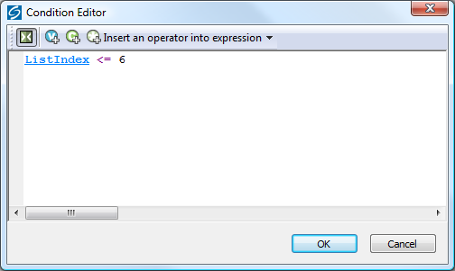
This will mean only the first 6 products are shown.
Click 'OK' when done.
You can vary the expression as required. For example, the following code will show products 7-15:
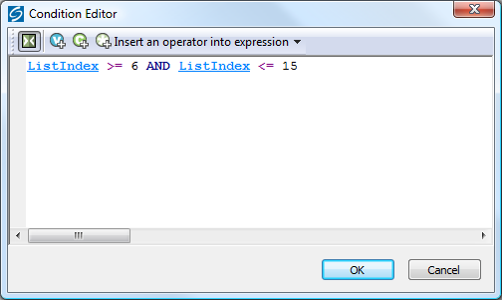
Thanks to John at www.bikster.co.uk for this solution.

Using the 'Thumbnail' Image in Marketing Lists
The items in the best sellers list, new products list, also bought list and related items list all use the main product image, reduced in size. This article offers a method for substituting the ‘Thumbnail’ images, if present. These will normally be smaller files, and using them may reduce page load times.
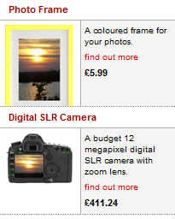
- To modify ‘Best Sellers List Without Descriptions’ and ‘New Products List Without Descriptions’, find the following code:
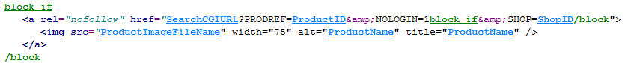
And replace it with:
<actinic:block if="%28%3cactinic%3avariable%20name%3d%22ProductImageFileName%22%20%2f%3e%20%21%3d%20%22%22%29%20AND%20%28%3cactinic%3avariable%20name%3d%22ProductThumbnailImageFileName%22%20%2f%3e%20%3d%3d%20%22%22%29" >
<a rel="nofollow" href="<actinic:variable name="SearchCGIURL" />?PRODREF=<actinic:variable name="ProductID" />&amp;NOLOGIN=1<actinic:block if="%3cactinic%3avariable%20name%3d%22IsHostMode%22%20%2f%3e" >&amp;SHOP=<actinic:variable name="ShopID" /></actinic:block>">
<img src="<actinic:variable name="ProductImageFileName" />" width="75" alt="<actinic:variable name="ProductName" encoding="strip"/>" title="<actinic:variable name="ProductName" encoding="strip"/>" />
</a>
</actinic:block>
<actinic:block if="%3cactinic%3avariable%20name%3d%22ProductThumbnailImageFileName%22%20%2f%3e%20%21%3d%20%22%22" >
<a rel="nofollow" href="<actinic:variable name="SearchCGIURL" />?PRODREF=<actinic:variable name="ProductID" />&amp;NOLOGIN=1<actinic:block if="%3cactinic%3avariable%20name%3d%22IsHostMode%22%20%2f%3e" >&amp;SHOP=<actinic:variable name="ShopID" /></actinic:block>">
<img src="<actinic:variable name="ProductThumbnailImageFileName" />" alt="<actinic:variable name="ProductName" encoding="strip"/>" title="<actinic:variable name="ProductName" encoding="strip"/>" />
</a>
</actinic:block>
- To modify ‘Regular Also Bought Item’ and ‘Regular Related Products Item’, delete all the code in each layout and replace it with the following:
<actinic:block if="%28%3cactinic%3avariable%20name%3d%22ProductImageFileName%22%20%2f%3e%20%21%3d%20%22%22%29%20AND%20%28%3cactinic%3avariable%20name%3d%22ProductThumbnailImageFileName%22%20%2f%3e%20%3d%3d%20%22%22%29" >
<div class="product-image"><a href="<actinic:variable name="SearchCGIURL" />?PRODREF=<actinic:variable Name="ProductID" />&amp;NOLOGIN=1<actinic:block if="%3cactinic%3avariable%20name%3d%22IsHostMode%22%20%2f%3e">&amp;SHOP=<actinic:variable name="ShopID" /></actinic:block>"><img style="border: 0;" src="<actinic:variable name="ProductImageFileName" />" alt="<actinic:variable name="ProductName" encoding="strip"/>" /></a></div>
</actinic:block>
<actinic:block if="%3cactinic%3avariable%20name%3d%22ProductThumbnailImageFileName%22%20%2f%3e%20%21%3d%20%22%22" >
<div class="product-image"><a href="<actinic:variable name="SearchCGIURL" />?PRODREF=<actinic:variable Name="ProductID" />&amp;NOLOGIN=1<actinic:block if="%3cactinic%3avariable%20name%3d%22IsHostMode%22%20%2f%3e">&amp;SHOP=<actinic:variable name="ShopID" /></actinic:block>"><img style="border: 0;" src="<actinic:variable name="ProductThumbnailImageFileName" />" alt="<actinic:variable name="ProductName" encoding="strip"/>" title="<actinic:variable name="ProductName" encoding="strip"/>" /></a></div>
</actinic:block>
<div class="product-text"><a href="<actinic:variable name="SearchCGIURL" />?PRODREF=<actinic:variable Name="ProductID" />&amp;NOLOGIN=1<actinic:block if="%3cactinic%3avariable%20name%3d%22IsHostMode%22%20%2f%3e">&amp;SHOP=<actinic:variable name="ShopID" /></actinic:block>"><actinic:variable name="ProductName" /></a><div class="product-list-price"><Actinic:PRICES PROD_REF="<actinic:variable Name="ProductID" />" RETAIL_PRICE_PROMPT="<Actinic:Variable Name="ProductPriceDescription"/>"><actinic:variable value="Marketing Price List" name="PriceListRetail" /></Actinic:PRICES></div></div>
- To modify ‘Compact Best Seller Layout’ and ‘Compact New Products Item’, find the following code:
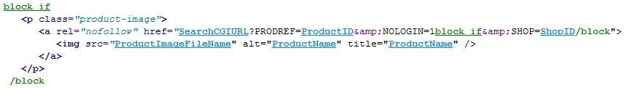 And replace it with:
<actinic:block if="%28%3cactinic%3avariable%20name%3d%22ProductImageFileName%22%20%2f%3e%20%21%3d%20%22%22%29%20AND%20%28%3cactinic%3avariable%20name%3d%22ProductThumbnailImageFileName%22%20%2f%3e%20%3d%3d%20%22%22%29" >
<p class="product-image">
<a rel="nofollow" href="<actinic:variable name="SearchCGIURL" />?PRODREF=<actinic:variable name="ProductID" />&amp;NOLOGIN=1<actinic:block if="%3cactinic%3avariable%20name%3d%22IsHostMode%22%20%2f%3e" >&amp;SHOP=<actinic:variable name="ShopID" /></actinic:block>">
<img src="<actinic:variable name="ProductImageFileName" />" alt="<actinic:variable encoding="strip" name="ProductName" />" title="<actinic:variable encoding="strip" name="ProductName" />" />
</a>
</p>
</actinic:block>
<actinic:block if="%3cactinic%3avariable%20name%3d%22ProductThumbnailImageFileName%22%20%2f%3e%20%21%3d%20%22%22" >
<p class="product-image">
<a rel="nofollow" href="<actinic:variable name="SearchCGIURL" />?PRODREF=<actinic:variable name="ProductID" />&amp;NOLOGIN=1<actinic:block if="%3cactinic%3avariable%20name%3d%22IsHostMode%22%20%2f%3e" >&amp;SHOP=<actinic:variable name="ShopID" /></actinic:block>">
<img src="<actinic:variable name="ProductThumbnailImageFileName" />" alt="<actinic:variable name="ProductName" encoding="strip"/>" title="<actinic:variable name="ProductName" encoding="strip"/>" />
</a>
</p>
</actinic:block>
Apply the changes and upload; the modified layout(s) will use 'Thumbnail' images if available.

Changing the Configuration of the ‘Recently Viewed Products’ List
Through the user interface you can change the layout of the ‘Recently Viewed Products’ list, and a few other settings. But there are a few other things you can adjust by changing settings in the Javascript configuration.
Firstly, go to 'Design | Library | Layouts' and scroll down to the 'Recent Products' group.
Click on the '+' icon next to 'Recent Products' and double-click on 'Recent Products List – Configuration Details' to open the Javascript configuration file.
Now you can make a few changes.
- To reduce the number of items stored in the list, find this statement:
var nMaxRecent = 12;
and change '12' to a lower number. We do not recommend storing more than 12, because of limitations on cookie size.
- To create overlap when scrolling through the list, so that the last product in the first list page appears as the first product in the next, find this statement:
var nScrollBy = RecentProductsShowCount;
and change it to:
var nScrollBy = RecentProductsShowCount-1;
- To reverse the order of filling the list, so that the most recent product is added to the right instead of to the left, find the following statement:
var bDisplayReversed = true;
and change it to:
var bDisplayReversed = false;
- To change the length of time for which the list is remembered, find the following statement:
var nKeepRecentHours = 12;
and change '12' to the length of time you want, in hours.
Click 'OK' and then 'Close' to save your changes.

Enable Automatic Resubmission of the Google Product Feed
The SellerDeck Google Product Feed enables you to submit your products to Google Product Search. Normally, your feed needs to be re-uploaded to Google each time you change the contents of your online catalogue. However, the need for this can be removed by using Google’s Merchant Center tools and making a few small changes in SellerDeck.
Firstly, you need to generate your Google Product Feed and have it uploaded to your web site. To do this, follow these steps.
- Select 'Export Google Product Search Data Feed' from the 'Marketing' menu.
- Click 'Browse', make sure your Site folder is selected, and enter a File name such as 'GoogleProducts.txt'.
- Click 'Save' and then 'OK'. This generates the feed.
- Now select 'Additional Files' from the 'Design' menu.
- Click 'Add', click on the file you just saved, and click 'Open'.
- Click 'OK'.
This will make SellerDeck upload the file automatically to your 'acatalog' folder or equivalent.
Next, you will need to set up a Google Account if you do not already have one. This is free to do, and you can find the registration page by searching on Google for 'Google Account'. If you are using Google Adwords or Google Mail then you have a Google Account already, and you can log into it using the same username and password.
To register your feed, do the following. The exact steps are subject to change by Google, but are correct at the time of writing. You will still need to export your feed manually when you make changes, but SellerDeck will then upload it and Google will regularly spider it automatically.
- Log in to your Google Account and click on 'Merchant Center' in the 'My products' list.
- Click on 'Data feeds' in the left-hand sidebar, the click the 'New Data Feed' button.
- Enter the Date feed file name, eg 'GoogleProducts.txt' if you followed the example above.
- On the page you are then taken to, click the 'Create' button.
- Enter the location of the file in the format 'http://yoururl.com/acatalog/'.
- Click 'Save Changes'.

Creating a Customer Reviews Page
SellerDeck enables you to display Feefo customer reviews of your site and your products. Product feedback is displayed on product pages. By default, site feedback is displayed at the foot of every page, but you may prefer to create a separate page specifically for it. This article explains how to do so.
NB it does not require Feefo Content to be enabled in Site Options | PageSettings.
- Select Library from the ‘Design’ menu and select the ‘Layout’ tab
- Scroll down to the ‘Web Page Inner Layout’ group. Click the [+] icon to its left to expand the group
- Right-click on ‘Brochure Page Body’ and select ‘Copy’
- 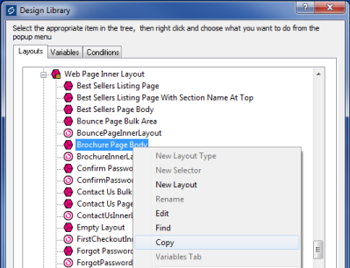
- Rename the new layout ‘Reviews Page Body’, and double-click to open it
- Delete all the code in the layout, and paste in the following instead:
<actinic:variable name="FeefoSiteFeedback" />
Unless you have switched the Layout Code window from Basic to Advanced View, the layout should now look like this:
- 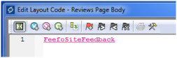
- Click ‘OK’ and ‘Close’
- Right-click on ‘Home’ in the Content Tree and select ‘New Brochure Page’.
- 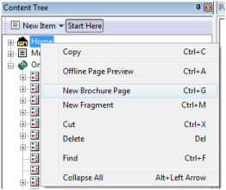
- Give it new page the name ‘Customer Reviews’.
- Select the ‘Page Settings’ tab and change the Brochure Inner Layout to ‘Reviews Page Body’
- 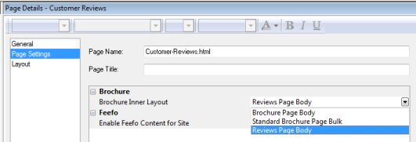
- Click ‘Apply Changes’ and ‘Publish to Web’
- Now go to your site and click the link to your ‘Customer Reviews’ page. Your Feefo site reviews should appear in the body of the page.
- To change the number of reviews that are listed, change the value of ‘Maximum number of site feedback’ in Site Options | Layout | Feefo.

Products

Taking People Straight to a Product
It is possible to take people straight to a specific product with a hyperlink of the following form:
http://your.URL/cgi-bin/ss00000x.pl?PRODREF=12345&NOLOGIN=1
Where:
- http://your.URL/cgi-bin is the URL of your CGI-BIN
- ss00000x.pl is the name of your search script with the 'x' replaced with your CGI ID number
- 12345 is the product reference of your desired product.
- &NOLOGIN=1 is an essential thing to add to the end of the URL to order to bypass the login page

Linking from Other URLs
Note: If you are using this code from outside the 'acatalog' folder then you will need to include a hidden form field of 'ACTINIC_REFERRER=' where the value is your 'Catalog URL' from 'Web | Network Setup'. For example:
http://your.URL/cgi-bin/ss00000x.pl?PRODREF=12345&NOLOGIN=1&ACTINIC_REFERRER=http://your.URL/acatalog/

Only Displaying the First Ten Words of the Full Description
It is possible to include a PHP statement which only displays the first 10 words of the full description in the store pages. This is useful if you are displaying a compact version of the product, and don't want the full description to appear.
Simply click on the product description (in the 'Design' tab) that you want to shorten.
Then locate the 'ProductDescription' variable in the layout code.
Highlight that variable and replace it with the following code:
<actinic:block php="true" >
$sShort = "";
$nCount = 0;
$sOriginal = '<actinic:variable encoding="perl" name="ProductDescription" selectable="false" />';
foreach(explode(" ", $sOriginal) as $sWord)
{
if ($nCount > 10)
{
$sShort .= "...";
break;
}
$sShort .= $sWord . " ";
$nCount++;
}
echo $sShort;
</actinic:block>

Different Cart Button Text for Each Product
This technique will allow you to enter different text for the cart button for each product in your store.
- Go to 'Design | Library | Variables' and expand the 'Product' group.
- Double-click on the 'CartButtonText' variable.
- Under 'Place of Setting' select 'Section' and 'Product'.
- Change 'Panel Name' to 'Properties'.
- Select 'Allow <Use Parent> as an Option'.
- Set 'Initial Value' to 'Use Parent()'.
- Click 'OK'.
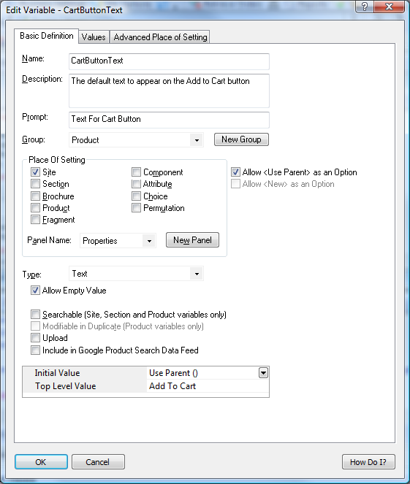
You will now be able to edit the text on the cart buttons in the 'Properties' panel of each product, or set the defaults for an entire section within the 'Properties' panel of a section.

Selecting Quantity From A Drop-Down
This technique will replace the usual text field for entering a product quantity on the product page, with a drop-down list for customers to select how many they want.
Go to a store page where you can see a 'Quantity' field. Click on the 'Quantity' text – and just after it, you should see this line:
Replace HTML tag with the following:
<select name="Q_<Actinic:Variable Name="ProductID"/>"><option selected value="<Actinic:Variable Name="DefaultQuantity"/>">1</option><option value="2">2</option><option value="3">3</option><option value="4">4</option><option value="5">5</option><option value="6">6</option><option value="7">7</option><option value="8">8</option><option value="9">9</option></select>
This code contains options up to '9' – but you can easily adapt it for more or fewer items.

Including an 'Email A Friend' Link into SellerDeck
Enter the following code into your product layout:
Enter e-mail address to tell a friend
<input type=text value="" size=40 onchange="
var thisloc=location.href + '%23<Actinic:Variable Name="EncodedProductAnchor"/>';
if (this.value != '') {
location.href='mailto:' + this.value +'?subject=Take%20a%20look%20at%20<Actinic:Variable Name="ProductName"/>&body=I%20saw%20' + thisloc + '%20and%20thought%20you%20would%20be%20interested.'
}
">
<input type=button value="OK">
NB If any of your product names contains an apostraphe, this will cause a Javascript error with the above script. In this case you will need to delete the ProductName variable <Actinic:Variable Name="ProductName"/> from the code before using it.

Displaying Store Prices In Three Currencies
This solution will display a third currency alongside the two currencies you are already displaying (this is enabled in 'Settings | Business Settings | Options').
To insert the third currency, simply click on a price in the 'Design' tab. You should highlight a layout called something like 'Product Price Including Tax' or 'Product Price Excluding Tax'.
Replace the code in the layout with the following:

<actinic:block PHP='true' SELECTABLE='false'>
priceformat('<actinic:variable name="SecondCurrencyFormat"/>','<Actinic:Variable Name="TaxExclusivePrice"/>', '<actinic:variable name="TaxExclusivePriceAlt" />');

$nExchangeRate = 2.5;
$sCurrencySymbol = "$";
$nDecimals = 2;
$sDecimalSep = ".";
$sThousandsSep = ",";
echo "/ ";
formattedcurrency($nExchangeRate * <actinic:variable encoding="perl" name="ProductPriceRaw" selectable="false" />, $nDecimals, $sDecimalSep, $sThousandsSep, $sCurrencySymbol);
</actinic:block>

Please note that this technique doesn't work with quantity-dependent prices.

Automatically Calculate Savings based on an RRP
This technique will calculate a saving on prices based on the value of 'RRP' – a custom variable that you will need to create.
It will display as follows within your product layouts.
RRP: £10.00 – you save 8%
To do this:
- Create a new variable called 'RRP' based on the instructions in the main help: 'Understanding Variables > Adding a New Variable'. It needs to have a type of 'Number' rather than 'Text'.
- Enter some RRP values for your products. Remember to NOT include a currency symbol.
- Copy and paste the following code into your product layout(s) wherever you want the price saving message to appear.

<actinic:block php="true">
$rrp = <actinic:variable name="RRP" selectable="false" />;
$rawprice = <actinic:variable name="ProductPriceRaw" selectable="false" />;
$rawprice = $rawprice * 1.2; // add in vat if showing VAT inc prices
// only display is we have an RRP and there's a saving to show
if ( ($rrp != 0) && ($rrp > $rawprice) )
{
$savepercent = round((($rrp - $rawprice) / $rrp) * 100);
echo "RRP £$rrp - you save $savepercent%";
}
</actinic:block>

- Apply changes and check the results in the preview.

There are several areas where you can tweak this code.
- Use a currency other than pounds by amending the '£' just before where it says '£$rrp'
- If you use a tax rate other than VAT at 20% then you can amend the line that talks about 'add in vat if showing VAT inc. prices'. If you don't charge tax at all you can safely delete this line.

With thanks to Norman Rouxel (http://www.drillpine.biz/) for this solution.

Creating a Rollover for your Add to Cart Button
This exercise will create a new user-definable variable called 'AltCartButtonImage' and a new layout for the 'add to cart button', which includes rollover code.
- Go to 'Design | Library | Variables' and right-click on the 'Product' group. Select 'New Variable'.
- Give the variable a name of 'AltCartButtonImage' and enter a prompt of 'Alternative Cart Button Image'.
- Set 'Place of Setting' as 'Site' and set the 'Panel Name' as 'General'.
- De-select the 'Allow <Use Parent> as an Option' checkbox and under 'Type' select 'Filename'. Select the 'Allow Empty Values' checkbox.
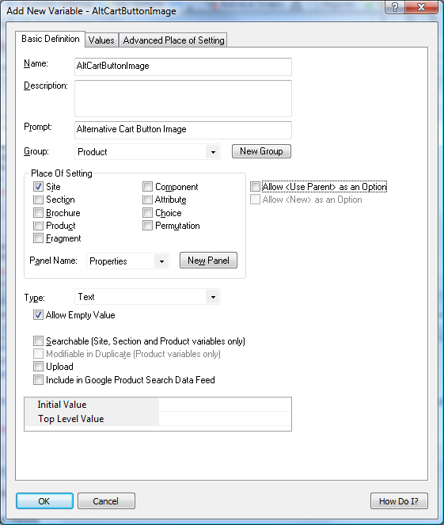
- Click 'OK' and switch to the 'Layouts' tab of the library.
- Locate the 'Add to Cart Button' group at the top of the library.
- Right-click on 'Add To Cart Button Image' layout and select 'New Layout'.
- Call it 'Rollover Add To Cart Button' and click 'OK'.
- Now edit the code of the layout, and change it to look like the following:
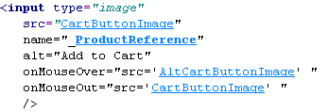
Here's some code to copy and paste:
<input type="image"
src="<actinic:variable name="CartButtonImage" />"
name="_<actinic:variable name="ProductID" />"
alt="Add to Cart"
onMouseOver="src='<actinic:variable name="AltCartButtonImage" />' "
onMouseOut="src='<actinic:variable name="CartButtonImage" />' "
/>
- Click 'OK' and then close the library.
You can now go to 'Settings | Site Options | General' and enter a filename for 'Alternative Cart Button Image'. Then all you need to do is change the 'Add To Cart Button Layout' to 'Rollover Add To Cart Button' and you will have a working cart button with rollovers.

Reversing the Order of Years in the Date Prompt
This fix will change the order of the years that are listed within the 'Date Prompt' drop down list – and show the current year first (rather than showing the last year first).
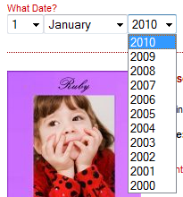
- Go to 'Design | Library | Layouts' and open the 'Year List' group.
- Edit the 'Standard Year List' layout.
- Replace the line:
- with the following code
<actinic:block php="true">
echo " ";
$dates[] = '<Actinic:Variable Name="YearLayout" encoding="perl" selectable="false" />';
</actinic:block>
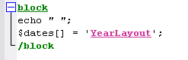
- Next, click the orange "Click here to edit list layout settings" text and select the 'Edit Rows and Columns' tab.
- Delete the text in Middle Rows > First Item > Before
- Delete the text in Middle Rows > First Item > After
- Set No of Items > Last Row to be '1'
- In Last Row > Before Row add the code
<actinic:block php="true"> $dates = array_reverse($dates); foreach($dates as $thisdate) { echo "<option>$thisdate</option>"; } $dates = array(); </actinic:block>
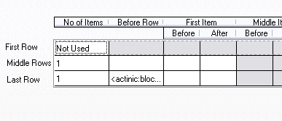
- Click 'OK' and close and save the layout.
Now the years appear reversed.

Allowing Ordering of Out of Stock Products
By default, SellerDeck suspends ordering for items that are out of stock. To prevent this you can set the ‘Default “Suspend if Below”’ value in Business Settings | Options | Stock Control / Monitoring to a large negative number, eg -999. However in this case SellerDeck will add this to the stock level that it displays on the site – the stock level displayed will be the number for which orders will be accepted, not the number actually held in stock.
To prevent this you need to change some of the Layouts in Design | Library.
- In the ‘Javascript Header Functions’ section, open the ‘Standard Javascript Header Functions’ layout and paste the following code at the very end, after the link to the Google Analytics Tracking Code:
<script language="javascript" type="text/javascript">
/***********************************************************************
*
* getSectionStockSuspend - Call our server script to determine the real time stock
* levels of the products in the given section
* When the page is previewed from the desktop (within EC) we do not want to make
* server calls for RTS levels. Therefore in this case we are passing in the
* list of stock monitored products and their offline stock level in sProdRefs and
* sStockList parameters.
*
* Input: sURL - the ajax script URL to call
* sSID - the section ID list to be passed in to the ajax script
* sProdRefs - list of the products with stock monitoring on in this section
* sStockList - the stock level of the products in the list above
* sSuspendLevel - current suspend offset of the products in the list
*
* SellerDeck handle negative suspend levels by adding them to the stock level
* this code removes the compensation from the displayed value. In order to handle
* multiple negative suspend values, this code accepts an array of suspend levels.
*
* The suspend levels always come from the page not from the server.
*
************************************************************************/

function getSectionStockSuspend(sURL, sSID, sProdRefs, sStockList, sSuspendLevel)
{
var mapStockByRef = {};
var mapStockByLevel = sSuspendLevel;
//
// In case of preview use passed in data
//
if (sURL.indexOf("file://") == 0)
{
var arrProds = sProdRefs.split("|");
var arrStock = sStockList.split("|");
for (var i = 0; i < arrProds.length; i++)
{
var aRef = arrProds[i].split("!");
var sKey = aRef[aRef.length - 1];
mapStockByRef[sKey] = arrStock[i];
}
updateStockDisplayLevel(mapStockByRef,mapStockByLevel);
}
else
{
var ajaxRequest = new ajaxObject(sURL);
ajaxRequest.callback = function (responseText)
{
mapStockByRef = responseText.parseJSON();
updateStockDisplayLevel(mapStockByRef,mapStockByLevel);
}
ajaxRequest.update("ACTION=GETSECTIONSTOCK&SID="+sSID, "GET");
}
}

/***********************************************************************
*
* updateStockDisplayLevel - dynamically update the DOM tree depending on stock levels
*
* Input: mapStockByRef - product ref to stock level map
* mapStockByLevel - offeset to compensate for suspend setting
*
************************************************************************/

function updateStockDisplayLevel(mapStockByRef,mapStockByLevel)
{
//
// For each product reference set the stock level and enable/disable
// the controlling DIV tags in the page source
//
var arrStockElems= getStockNodes();

for (var nIndex = 0; nIndex < arrStockElems.length; nIndex++)
{
var aRef = arrStockElems[nIndex].id.split("_");
var sProdRef = aRef[aRef.length - 1];
var sIDStart = arrStockElems[nIndex].id.substring(0, arrStockElems[nIndex].id.length - sProdRef.length - 1);
if (mapStockByRef[sProdRef] != null)
{
// single value passed from web page.
var iStockLevel = mapStockByRef[sProdRef] - mapStockByLevel;
//
// The stock level
//
if (sIDStart == 'StockLevel')
{
if ( iStockLevel <= 0)
{
iStockLevel = 0;
}
arrStockElems[nIndex].innerHTML = iStockLevel;
}
//
// Out of stock
//
if (sIDStart == 'EnableIfOutOfStock')
{
if (iStockLevel <= 0)
{
arrStockElems[nIndex].style.visibility = "visible";
arrStockElems[nIndex].style.display = "inline";
}
else
{
arrStockElems[nIndex].style.visibility = "hidden";
arrStockElems[nIndex].style.display = "none";
}
}

if (sIDStart == 'RemoveIfOutOfStock')
{
if (iStockLevel <= 0)
{
arrStockElems[nIndex].innerHTML = "";
}
}
//
// In stock
//
if (sIDStart == 'EnableIfInStock')
{
if (iStockLevel > 0)
{
arrStockElems[nIndex].style.visibility = "visible";
arrStockElems[nIndex].style.display = "inline";
}
else
{
arrStockElems[nIndex].style.visibility = "hidden";
arrStockElems[nIndex].style.display = "none";
}
}
if (sIDStart == 'RemoveIfInStock')
{
if (iStockLevel > 0)
{
arrStockElems[nIndex].innerHTML = "";
}
}
//
// Generic flag to indicate ajax call went fine
//
if (sIDStart == 'EnableIfStockOk')
{
arrStockElems[nIndex].style.visibility = "visible";
arrStockElems[nIndex].style.display = "inline";
}
}
}
}
</script>
- Next open the ‘Display Stock Quantities’ layout in the ‘Real Time Stock Display’ section and replace the existing code with the following:
<!-- The code below is automatically enabled/disabled by js depending on RTS -->
<actinic:block if="%3cactinic%3avariable%20name%3d%22RealTimeStockEnabled%22%20%2f%3e%20%26%26%20%3cactinic%3avariable%20name%3d%22DisplayRealStockLevel%22%20%2f%3e" >
<span id="RemoveIfOutOfStock_<actinic:variable name="ProductReference" selectable="false" />" class="ActinicRTS" >
<span id="EnableIfStockOk_<actinic:variable name="ProductReference" selectable="false" />" class="ActinicRTS" style="visibility: hidden; display: none;">
<span id="StockLevel_<actinic:variable name="ProductReference" selectable="false" />" class="ActinicRTS" style="display: inline;"></span>&nbsp;in stock.
</span>
</span>
<span id="EnableIfOutOfStock_<actinic:variable name="ProductReference" selectable="false" />" class="ActinicRTS" style="visibility: hidden; display: none;">
<strong><span class="actrequired"><br /><Actinic:Variable Name="OutOfStock"/></span></strong>
</span>
</actinic:block>
- Thirdly, open the ‘Javascript Section Stock Query’ layout in the 'Javascript Section Stock Query' section, and replace the existing code with the following:
<actinic:block if="%3cactinic%3avariable%20name%3d%22PageType%22%20%2f%3e%20%3d%3d%20%22Section%22" >
<actinic:block if="%3cactinic%3avariable%20name%3d%22RealTimeStockEnabled%22%20%2f%3e%20%26%26%20%3cactinic%3avariable%20name%3d%22DisplayRealStockLevel%22%20%2f%3e" >
<script language="javascript" type="text/javascript">
function displayStock()
{
var sProdRefs = "";
var sStockList = "";
var sSuspendLevel = "1000";
<actinic:block if="%3cactinic%3avariable%20name%3d%22IsPreviewMode%22%20%2f%3e" >
sProdRefs = "<actinic:variable name="RTSProductsInThisSection" selectable="false" />";
sStockList = "<actinic:variable name="RTSStocksInThisSection" selectable="false" />";
</actinic:block>
getSectionStockSuspend('<actinic:variable name="StockScriptCGIURL" selectable="false" />', '<actinic:variable name="SectionID" selectable="false" />', sProdRefs, sStockList,sSuspendLevel);
}

AttachEvent(window, "load", displayStock);
</script>
</actinic:block>
</actinic:block>
NB if you use a figure other than -999 for the Default “Suspend if Below”’ value, you will need to change the figure of 1000 in the above code accordingly.
- Finally, you need to allow the ‘Add to Cart’ button for out of stock products. To do this, go to the Design tab and click the ‘Split View’ toolbar button. Click on a Section page in the Design or Content Tree, then click on the ‘Add to Cart’ button in the preview. In the Layout Code window, find the following lines in the ‘Add to Cart’ button layout (normally the first and the last), and delete them:
<span id="RemoveIfOutOfStock_<actinic:variable name="ProductReference" selectable="false" />" class="ActinicRTS" >
and
</span>
If you make these changes we recommend also changing the ‘Out of Stock’ message in Design Text to something more friendly, such as ‘Available Soon’.
Disclaimer: This code was provided by a SellerDeck user via the SellerDeck Community (http://community.sellerdeck.com/) and so can't be supported by the SellerDeck Technical Support team.

Show Added Prices Against Product Choices
SellerDeck 2013 added the ability to define prices for component choices, and use these to calculate automatically the cost of all the resulting permutations.
With a small layout modification you can also show the additional price against each choice. By default the price is only be shown for components with only one attribute, because this was all that was possible in earlier versions. To implement this for all components, regardless of the number of attributes, you need to make a small layout change. This workaround shows how to make this change for drop-down choice selection.
- Select ‘Library’ from the ‘Design’ menu and click the ‘Layout’ tab
- Scroll down to the ‘Choices’ group and click the [+] icon to expand it
- Double-click the ‘Drop Down Choice’ layout to open it
- Delete all the existing code and replace it with the following:
<option value="<Actinic:Variable Name="ChoiceSelectedValue"/>"><Actinic:Variable Name="ChoiceDisplayLabel"/>
<actinic:block if="%3cactinic%3avariable%20name%3d%22ChoicePriceRaw%22%20%2f%3e%20%3e%200">
(+<actinic:block PHP='true' SELECTABLE='false'>formattedcurrency(<actinic:variable name="ChoicePriceRaw" /> * <actinic:variable name="ComponentQuantity" />, <actinic:variable name="CurrencyDigits" />, '<actinic:variable name="MoneyDecimalSeparator" />', '<actinic:variable name="MoneyThousandSeparator" />', '<actinic:variable name="DefaultCurrency" />');</actinic:block>)
</actinic:block>
</option>
- Click ‘OK’ and then ‘Close
Now any choices that have a price greater than £0.00 will have the added price shown against the drop-down selection.
If you want to show choice prices with tax added (if you are using the Permutation Prices layout ‘Permutation Tax Inclusive Price), then use the following code instead of that supplied in item 4. above:
<option value="<Actinic:Variable Name="ChoiceSelectedValue"/>"><Actinic:Variable Name="ChoiceDisplayLabel"/>
<actinic:block if="%3cactinic%3avariable%20name%3d%22ChoicePriceRaw%22%20%2f%3e%20%3e%200">
<actinic:block PHP='true' SELECTABLE='false'>
$nPrice = <actinic:variable name="ChoicePriceRaw" /> * <actinic:variable name="ComponentQuantity" />;
$dTaxRate1 = <actinic:variable name="TaxRate1" />;
$dTaxRate2 = (int)"<actinic:variable name="TaxRate2" />";
if (!<actinic:variable name="IsTaxInclusiveMode" />)
{
$nTax1 = ActRound($nPrice * (($dTaxRate1 / 100)), <actinic:variable name="CurrencyDigits" />, (int)"<actinic:variable name="Tax1RoundRule" />");
$nTax2 = ActRound($nPrice * (($dTaxRate2 / 100)), <actinic:variable name="CurrencyDigits" />, (int)"<actinic:variable name="Tax2RoundRule" />");
$nPrice += $nTax1 + $nTax2;
}
$sDescription = "";
if (($dTaxRate1 != 0) and ($dTaxRate2 != 0))
{
$sDescription = "<actinic:variable name="TaxName1" />" . " &amp; " . "<actinic:variable name="TaxName2" />";
}
elseif ($dTaxRate1 != 0)
{
$sDescription = "<actinic:variable name="TaxName1" />";
}
elseif ($dTaxRate2 != 0)
{
$sDescription = "<actinic:variable name="TaxName2" />";
}
if ($sDescription != "")
{
$sDescription = " Inc. " . $sDescription;
}
formattedcurrency($nPrice, <actinic:variable name="CurrencyDigits" />, '<actinic:variable name="MoneyDecimalSeparator" />', '<actinic:variable name="MoneyThousandSeparator" />', '<actinic:variable name="DefaultCurrency" />');
echo $sDescription;
</actinic:block>
</actinic:block>
</option>

Product Images

Automatically Rescale Your Product Images to a Certain Size
This is a handy PHP expression that will dynamically rescale your product images and display them in their new size. This resizing happens on the desktop PC, and the new files will be uploaded to the store with the other image files. The names of the new image files will all start with 't_'.
In order for it to work, your current images must be in *.jpg format.
INSTALLATION
- In your site folder (usually called 'Site1') create a sub-folder called "Thumbnails".
- Go to 'Design | Library | Variables' and expand the 'Product' group.
- Right-click on 'Product' and choose 'New Variable'.
- Set the new variable as follows:
Setting | Value
Name | ProductImageScaledWidth
Description | Automatically resized product image
Prompt | Product Image Scaled Width
Group | Product
Place Of Setting | Site, Section, Product
Allow <Use Parent>... | Checked
Panel Name | Layout
Type | Number
Allow Empty Value... | Unchecked
Whole Numbers Only | Checked
Searchable | Unchecked
Modifiable In Duplicate | Unchecked
Upload | Unchecked
Initial Value | Use Parent
Top Level Value | 100
- Go to 'Design | Library | Layouts' and expand the 'Product Image' group.
- Right-click "Standard Product Image" and select Copy.
- Rename that copy variable to be "Thumbnail Product Image".
- Open layout "Thumbnail Product Image".
- Replace the entire contents of that layout with the following:
<actinic:block if="%3cactinic%3avariable%20name%3d%22IsPopUpDisplayedByImage%22%20%2f%3e">
<actinic:block if="%3cactinic%3avariable%20name%3d%22ExtendedInformationType%22%20%2f%3e%20%3d%3d%20%22Opens%20in%20a%20Pop%2dUp%20Window%22">
<a href="<actinic:variable name=ExtendedInfoPageEncoded />" target="ActPopup" onclick="return ShowPopUp('<actinic:variable name=ExtendedInfoPageEncoded />',<actinic:variable name="ExtInfoWindowWidth" />,<actinic:variable name="ExtInfoWindowHeight" />);">
</actinic:block>
<actinic:block if="%3cactinic%3avariable%20name%3d%22ExtendedInformationType%22%20%2f%3e%20%3d%3d%20%22Opens%20in%20the%20Same%20Window%22" >
<a href="<actinic:variable name="ExtendedInfoPageName" />">
</actinic:block>
</actinic:block>

<actinic:block if="%3cactinic%3avariable%20name%3d%22IsProductImageDisplayed%22%20%2f%3e">
<actinic:block php="true" >
// START Create a thumbnail image t_ProductImageFileName
$sOriginalImageName = str_replace('\\','/', '<actinic:variable name="ProductImageFileName" encoding="perl" selectable="false" />');
$nScaledWidth = <actinic:variable name="ProductImageScaledWidth" encoding="perl" selectable="false" />;
$sThumbImageName = 'Thumbnails/t_' . basename($sOriginalImageName);
$image = @imagecreatefromjpeg($sOriginalImageName); /* Attempt to open */
if (!$image)
{ /* See if it failed */
echo "<br><font color=red>Thumbnail creation error opening: $sOriginalImageName </font>";
}
else
{
// Get new dimensions
$width = imagesx($image);
$height = imagesy($image);
$t_width = $nScaledWidth;
$t_height = round($height * ($t_width / $width));
// Resample
$thumbimage = imagecreatetruecolor($t_width, $t_height);
imagecopyresampled($thumbimage, $image, 0, 0, 0, 0, $t_width, $t_height, $width, $height);
if ( ! imagejpeg($thumbimage, $sThumbImageName) )
{
echo "<font color=red>Thumbnail image creation failed: $sThumbImageName </font><br>";
}
else
{
echo "<img src=\"$sThumbImageName\" width=\"$t_width\" height=\"$t_height\" border=\"0\"";
echo " alt=\"<actinic:variable name="ProductName" encoding="strip"/>\" />";
}
}
// END Create a thumbnail image t_ProductImageFileName
</actinic:block>

</actinic:block>

<actinic:block if="%3cactinic%3avariable%20name%3d%22IsProductImageDisplayed%22%20%2f%3e%20%3d%3d%20False">
<img src="<actinic:variable name="DefaultProductImage" />"
border="0"
alt="<actinic:variable name="ProductName" />" />
</actinic:block>

<actinic:block if="%3cactinic%3avariable%20name%3d%22IsPopUpDisplayedByImage%22%20%2f%3e">
</a>
</actinic:block>

OPERATION
To select this layout, go to 'Settings | Site Options | Layout' and set Product Image Layout to "Thumbnail Product Image".
To alter the image width, go to 'Settings | Site Options | Layout' and set 'Product Image Scaled Width' as required.
NOTES
You can now use the following line to include the rescaled product images in the best seller / new products / related items / also bought lists:
<img src="Thumbnails/t_<actinic:variable name="ProductImageFileName" />" />
With grateful thanks to Norman Rouxel (http://www.drillpine.biz/) for this solution.
Disclaimer: This code was provided by a SellerDeck user via the SellerDeck Community (http://community.sellerdeck.com/) and so can't be supported by the SellerDeck Technical Support team.

Clickable Expanding Product Image Thumbnails
Here's a very simple way of replacing the Product Image with a small icon that expands / contracts when clicked.
Go to 'Design | Library | Layouts' and expand the 'Product Image' group.
Right-click on 'Standard Product Image' and choose 'Copy'.
Rename that copy to be 'Expanding Product Image'. Open 'Expanding Product Image' and replace all code there with the following:

<actinic:block if="%3cactinic%3avariable%20name%3d%22IsPopUpDisplayedByImage%22%20%2f%3e">
<actinic:block if="%3cactinic%3avariable%20name%3d%22ExtendedInformationType%22%20%2f%3e%20%3d%3d%20%22Opens%20in%20a%20Pop%2dUp%20Window%22">
<a href="javascript:ShowPopUp('<actinic:variable name=ExtendedInfoPageEncoded />',<actinic:variable name="ExtInfoWindowWidth" />,<actinic:variable name="ExtInfoWindowHeight" />);">
</actinic:block>
<actinic:block if="%3cactinic%3avariable%20name%3d%22ExtendedInformationType%22%20%2f%3e%20%3d%3d%20%22Opens%20in%20the%20Same%20Window%22" >
<a href="<actinic:variable name="ExtendedInfoPageName" />">
</actinic:block>
</actinic:block>

<actinic:block if="%3cactinic%3avariable%20name%3d%22IsProductImageDisplayed%22%20%2f%3e">
<img src="<actinic:variable name="ProductImageFileName" />"
border="0"
width="50"
style="cursor:pointer"
onclick="if(this.width == 50){this.width=<actinic:variable name="ProductImageWidth" />;}else{this.width=50;}"
alt="<actinic:variable name="ProductName" encoding="strip"/> - Click to change size" />
</actinic:block>

<actinic:block if="%3cactinic%3avariable%20name%3d%22IsProductImageDisplayed%22%20%2f%3e%20%3d%3d%20False">
<img src="<actinic:variable name="DefaultProductImage" />"
border="0"
alt="<actinic:variable name="ProductName" encoding="strip"/>" />
</actinic:block>

<actinic:block if="%3cactinic%3avariable%20name%3d%22IsPopUpDisplayedByImage%22%20%2f%3e">
</a>
</actinic:block>
Click 'OK'
Now, in your 'Product Image Layout' field (in the 'Layout' panel of your products' select 'Expanding Product Image' and the new layout will be used.
You can set your entire site to use this by going to 'Settings | Site Options | Layout' and change the 'Product Image Layout' setting there.
The browser will resize the product image down so the icon will be somewhat rough. As the icons are really the main image (scaled in the browser) they'll still add to the page load time.

You can change the icon width by altering the 3 occurrences of '50' in the code above.
Many thanks to Norman Rouxel (http://www.drillpine.biz/) for providing this neat trick.
Disclaimer: This code was provided by a SellerDeck user via the SellerDeck Community (http://community.sellerdeck.com/) and so can't be supported by the SellerDeck Technical Support team.

Product Options

Changing the Way Attributes are Laid Out
To lay out attributes side by side, rather than one underneath the other, go to the 'Layout' panel of the product that the attributes are within, and set the 'Column Count For Attributes' to something other than 'Use Parent'.
If you want to display different attributes in different parts of your product layout, rather than all in the same place, then do the following:
- Go to 'Design | Library | Layouts' and locate the 'Attribute Lists' Group.
- Right-click on 'Standard Attribute List' and select 'New Layout'.
- Call this new layout 'First Attribute'.
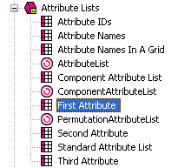
What you are going to do now is set a condition in the new list layout so that 'First Attribute' only displays the first attribute in the list.
- Double-click on the 'First Attribute' layout.
- Right-click on the 'AttributeLayout' layout selector and select 'Edit Appearance'.
- Under 'Condition', select '<Edit Expression>'.
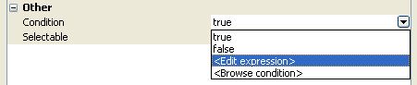
- The expression you need to enter is: ListIndex == 1
Feel free to copy and paste the following code to create the expression:
<actinic:variable name="ListIndex" /> == 1
- Now right-click on 'First Attribute' and select 'New Layout'. Call this new layout 'Second Attribute'.
- Now edit the code of the 'Second Attribute' list layout and edit the condition on 'AttributeLayout' so it reads 'ListIndex == 2'.
- Finally, create a 'Third Attribute' list layout and put a condition on 'AttributeLayout' of 'ListIndex == 3'.
You are now ready to use these new list layouts.
- Exit the library and go into the 'Design' tab.
- Locate 'AttributeList' within the layout code of a product.
- Delete this.
- In its place, click the 'Insert Layout' button.
- Select 'AttributeList' in the top list and select 'Use Fixed Layout'. Select 'First Attribute' in the bottom list.
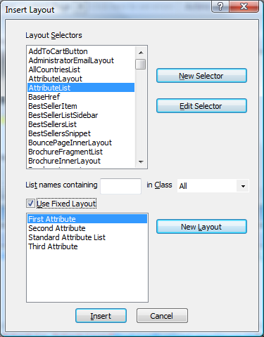
- You can now insert 'Second Attribute' and 'Third Attribute' in the same way.
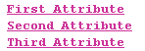
- Now put the different layout selectors in different parts of your design, depending on where you want the attributes to appear.

Displaying Images Against Radio Button Choices
It is possible to display an image against each radio button choice.
This change will include a new field for your choices called 'Image', and whatever image you specify there will be displayed next to the radio button for that choice in the web page.
To begin, go to 'Design | Library | Variables'. Then right click on the 'Choices' group and select 'New Variable'.
Use the following settings for the new variable:
Name | ChoiceImage
Description | An image to use with this choice.
Prompt | Image
Group | <leave as 'Choice'>
Place of Setting | Choice
Allow <Use Parent>... | <unchecked>
Panel Name | General
Type | Filename
Allow Empty Value | Checked
Initial Value | <blank>
Top Level Value | <blank>
Then click 'OK' and change to the 'Layouts' tab of the library.
Open the 'Choices' layout group and and double-click on the layout called 'Radio Button Choice'. Replace all the code with the following:
<input type="radio" name="<Actinic:Variable Name="UIWidgetName"/>" value="<Actinic:Variable Name="ChoiceSelectedValue"/>"<actinic:block if="%3cactinic%3avariable%20name%3d%22ListIndex%22%20%2f%3e%20%3d%3d%201">checked="checked"</actinic:block> />
<Actinic:Variable Name="ChoiceDisplayLabel"/><actinic:block php="true">
$choiceimage = '<Actinic:Variable Name="ChoiceImage" encoding="perl" selectable="false" />';
if ( $choiceimage )
{
list($width, $height, $type, $attr) = getimagesize($choiceimage);
if ( $width )
{
echo " <img src=\"$choiceimage\" width=\"$width\" height=\"$height\" />";
}
else
{
echo "<font color=\"red\"><b> BAD IMAGE</b></font>";
}
}
</actinic:block>&nbsp;&nbsp;

Click 'OK' and close the Library, and that's it.
Your 'Choice Details' dialogue should now have a new entry ' Image', where you can browse for an image to add to this choice.
Disclaimer: This code was provided by a SellerDeck user via the SellerDeck Community (http://community.sellerdeck.com/) and so can't be supported by the SellerDeck Technical Support team.

Extended Information Windows

Pop-Up Windows That Automatically Resize to Fit the Images Within Them
The code below can be used for an 'extended information' page layout. It works by creating a pop-up window that will automatically resize to the dimensions of the image that is within the pop-up window.
To use this code, go to 'Design | Library | Layouts' and expand the 'Extended Info Layout' group. Right-click on any existing layout in that group and select 'New Layout'. Give your new layout a name of 'Auto-Resizing Layout' and click 'OK'.
Once your new layout is created in the library, double-click on it to open it and replace all the code within it with the HTML below...

<html>
<head>
<Actinic:WINDOW width="<Actinic:Variable Name="ExtendedInfoImageWidth"/>" height="<Actinic:Variable Name="ExtendedInfoImageHeight"/>"/>
<title><actinic:variable name="PageTitle" /></title>
<actinic:variable name="BaseHref" />
<script language='javascript'>
var arrTemp=self.location.href.split("?");
var picUrl = (arrTemp.length>0)?arrTemp[1]:"";
var NS = (navigator.appName=="Netscape")?true:false;

function FitPic() {
iWidth = (NS)?window.innerWidth:document.body.clientWidth;
iHeight = (NS)?window.innerHeight:document.body.clientHeight;
iWidth = document.images[0].width - iWidth;
iHeight = document.images[0].height - iHeight;
window.resizeBy(iWidth, iHeight); self.focus(); };
</script>
</head>
<body bgcolor="<actinic:variable name="BGColor" />" onload='FitPic();' topmargin="0" marginheight="0" leftmargin="0" marginwidth="0">
<script language='javascript'>
document.write( '<a href="javascript:window.close();">' +
'<img src="<Actinic:Variable Name="ExtendedInfoImage"/>" ' +
'width="<Actinic:Variable Name="ExtendedInfoImageWidth"/>" ' +
'height="<Actinic:Variable Name="ExtendedInfoImageHeight"/>" border="0"></a>' );
</script>
</body>
</html>
Click 'OK' to save your changes when done.
Your new layout will be available to select within the 'Extended Information' panel of 'Site Options' or within your products/sections.
Disclaimer: This code was provided by a SellerDeck user via the SellerDeck Community (http://community.sellerdeck.com/) and so can't be supported by the SellerDeck Technical Support team.

Fragments and Brochure Pages

Displaying Fragments Separately From Products
By default, fragments within a section are laid out by the 'Standard Product List' layout (or the 'Product List With Horizontal Dividers' layout if you are using that one). So therefore all fragments and products are laid out as a single list.
It is possible though to create a list that just does products, and a list that just does fragments, and then include them in different parts of your design.
To begin, you need to find out what kind of product list layout you are using. To do this:
- Go to 'Settings | Site Options | Layout'
- Under the 'Product' sub-heading, locate the 'Product List Layout' field.
- Make a note of the layout that is selected in the field.
You can now edit this layout.
- Now go to 'Design | Library | Layouts' and expand the 'Product Lists' group.
- Right-click on the list layout you are using in your store and select 'New Layout'.
- Give the new layout a name of 'Section Fragment List' and click 'OK'.
- Double-click on this layout to edit it.
- Delete everything in this layout down to line '15' (i.e. remove the references to 'ProductLayout' but leave the references to 'FragmentLayout').
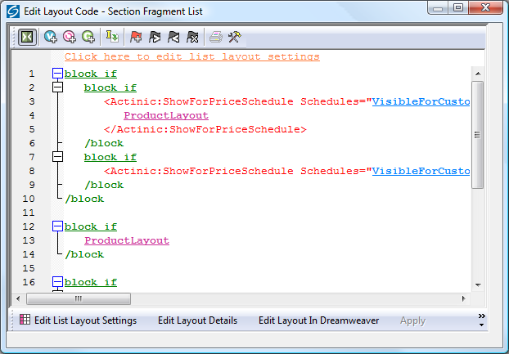
- You now need to highlight all the code in this layout and then click the 'Insert Block' button:
- Enter the following condition:
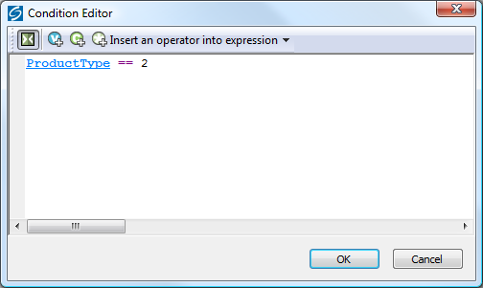
You can copy and paste the following code to create the condition:
<actinic:variable name="ProductType" /> == 2
- Click 'OK' to save the condition, and then click 'Apply' and then 'OK' to save the changes to the list layout.
- Now double-click on the product list layout that your store is using.
- Delete everything AFTER line 15 (i.e. remove the references to 'FragmentLayout' but leave the references to 'ProductLayout')
- Now highlight all this code and again click the 'Insert Block' button:
- This time, use the following condition:
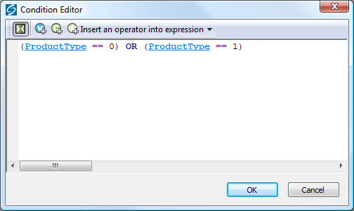
If you prefer, you can copy and paste the following code:
(<actinic:variable name="ProductType" /> == 0) OR (<actinic:variable name="ProductType" /> == 1)
- Click 'OK' to save the condition, and then click 'Apply' and then 'OK' to close the layout.
You have now created two different layouts. Your next job is to include those layouts into the design of your section pages.
- Close the library and switch to the 'Design' tab.
- Make sure you are looking at a section that contains both fragments and products. You should find that the fragments within the section are not appearing.
- Click anywhere within the main part of the section page (e.g. on a product).
- Press the 'Navigate to parent layout' button (yellow spiral with up arrow) until you are in a layout called something like 'Standard Section Page' or 'Section Page With Section Name At The Top'.
- Within this layout, locate the pink 'ProductList' selector:
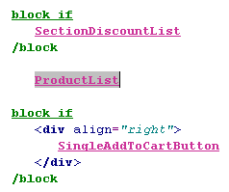
This shows you where your products are being inserted into the design. You can move this to a different location within the layout if you want.
To insert your list of fragments into the design:
- Click the 'Insert Layout' button -
- From the top list select 'ProductList' and select 'Use Fixed Layout'.
- From the bottom list select 'Section Fragment List' and click 'Insert'.
This will insert the list of fragments into the design.

Automatically Generating Hyperlinks in Fragment Text
If you have a lot of hyperlinks to include into a fragment, you will not be able to use the 'Link' feature (in the 'Links' panel) as that only supports a single hyperlink.
You could use embedded html (!!< and >!!) to include the links, but this method will automatically parse links that begin with 'www' and turn them into hyperlinks.
To begin, go to 'Design | Library | Layouts' and expand the 'Fragments' group.
Select the layout that you would like to use for this and then right-click on it and select 'Copy'.
Rename this new layout to something like 'Auto Link Generator'.
Now edit this layout and replace the 'FragmentText' variable with the following code:
<actinic:block php="true">
$ftext = <<<ENDFRAG
<actinic:variable Name="FragmentText" selectable="false" />
ENDFRAG;
$ftext = str_replace('<br', ' <br', $ftext);
echo preg_replace('/(www.\S+)/', '<a href="http://$1" target="_blank">$1</a>', $ftext);
</actinic:block>
You can now use this 'Auto Link Generator' layout for any fragment where you have lots of 'www' links in the 'Text' field. Select the layout within the 'Layout' panel of the fragment.
Disclaimer: This code was provided by a SellerDeck user via the SellerDeck Community (http://community.sellerdeck.com/) and so can't be supported by the SellerDeck Technical Support team.

Stopping Specific Brochure Pages from Appearing in the List
This will show you how to specify which brochure pages will appear in the list of brochure pages that appears in your store design.
- Go to 'Design | Library' and go to the 'Variables' tab.
- Right click on the 'Brochure' group and select 'New Variable'
- Give the variable a name of 'ShowPageInSidebar'.
- Give it a prompt of 'Show Page in Sidebar'.
- Under 'Place of Setting' select 'Brochure'.
- Under 'Panel Name' select 'General'.
- De-select 'Allow <Use parent> as an Option'
- Change the 'Type' field to 'True/False'.
- Leave the 'Top Level Value' and 'Initial Value' to 'True' if you want all pages shown by default. Set them both to 'False' if you don't.
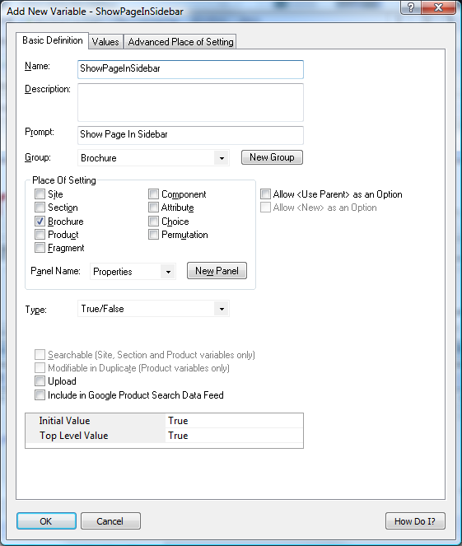
- Click 'OK' and close the library.
- Go to the 'Design' tab and in the preview pane click on one of the brochure pages in your list. You should now be looking at a layout called something like 'Simple Brochure Page Link' or ' Standard Brochure Page Link' etc.
- Highlight all the code in the layout and click the 'Insert Block' button:
- You should now be in the Condition Editor. Change the condition to:
<actinic:variable name="ShowPageInSidebar" /> == true
You can just copy and paste the code straight into the editor.
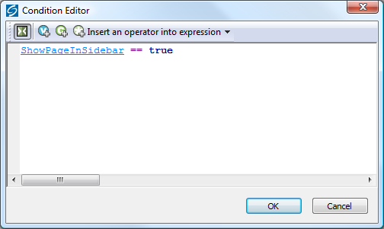
- Click 'OK' and then click 'Apply' to confirm your changes.
You can now go into the 'Properties' panel of any brochure page that you don't want in the list, and change 'Show Page In Sidebar' to 'False'.
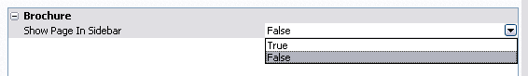

Including Brochure Pages in the Site Map
This technique will show you how to include a list of the brochure pages in your store into your site map page.
The first thing you need to do is create a brochure page link layout that is similar in style to the existing links in the site map.
- Go to 'Design | Library | Layouts' and expand the 'Brochure Page Links' group.
- Right-click on 'Text Brochure Page Link' and select 'New Layout'.
- Give it a name of 'Sitemap Brochure Page Link' and click 'OK'.
- Double-click on this layout and replace everything in it with the following code:
<a href="<actinic:variable name="BrochurePageURL" />">- <actinic:variable name="BrochureName" /></a>
- Click 'OK'.
Next you need to create a brochure page list layout to be inserted in the site map page.
- In the library, open the 'Brochure Page Link Lists' layout group.
- Right-click on 'Brochure Page Text Link List' and select 'New Layout'.
- Give it a name of 'Sitemap Brochure Page List' and click 'OK'.
- Double-click on this new list layout to edit it.
- Right-click on the layout selector that is there already and select 'Edit Appearance'.
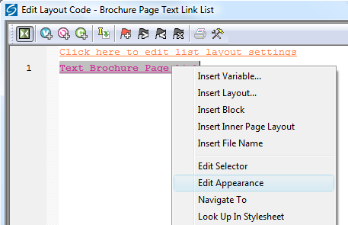
- Change the 'Use Fixed Layout' field to read 'Sitemap Brochure Page Link' and click 'OK'.
- Click the 'Edit List Layout Settings' button.
- Change to the 'Edit Rows and Columns' tab and replace each instance of '&nbsp;' in the grid with '<br />'.
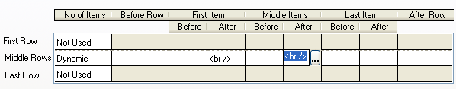
- Click 'OK' and then click 'OK' again to close the layout.
- Exit the Library.
You can now include this new list in the 'Sitemap Page Bulk Area' layout.
- In the 'Design' tab, use the 'Select Page Type' list to change the page to 'Site Map'.
- Click on one of the site map links in the preview.
- Click the 'Navigate to Parent Layout' button - - until you are in the 'Sitemap Page Bulk Area' layout.
- Put your cursor in line 2 and click the 'Insert Layout' button -
- Insert the 'BrochurePageList' layout selector with a fixed layout of 'Sitemap Brochure Page List'.
- Click 'Apply'.
Your brochure pages will now be listed in the sitemap.

Shopping Cart and Checkout

Viewing the Shopping Cart from Anywhere on the Internet
The page that shows a summary of the shopping cart details is actually displayed as a result of a call to an online Perl script in the cgi-bin directory.
Go to your online website and click the 'view cart' button on the navigation bar. Even with nothing in your shopping cart, the address of the page in the 'Address' bar of your browser will be something like:
http://your.URL/cgi-bin/ca000001.pl?ACTION=SHOWCART
This link will work when the call has come from inside the 'acatalog' folder online, but it might not work from outside. If it doesn't, you will need to add an 'ACTINIC_REFERRER=' parameter that tells the browser where your 'acatalog' folder is. This is the 'Catalog URL' value, which can be seen in 'Web | Network Setup'.
If your Catalog URL is 'http://your.URL/acatalog/' then the call to the shopping cart becomes:
http://your.URL/cgi-bin/ca000001.pl?ACTION=SHOWCART&ACTINIC_REFERRER=http://your.URL/acatalog/

Adding to Cart from Anywhere on the Internet
The following URL shows you the format to follow to add a product to the cart from anywhere on the Internet.
http://your.URL/cgi-bin/ca000001.pl?SID=3&PAGE=PRODUCT&Q_7=5
The SID parameter should be the section ID of the section where the product can be found. You can figure out the exact SID by inserting the 'SectionID' variable somewhere in your store pages and see what it becomes in the previewed page.
The Q_ parameter informs the script about the product reference and the quantity. The product reference is the (CGI encoded) string prefixed by Q_ while the quantity is the parameter value (prod ref is 7, qty is 5 in the above example).
If you are adding from outside the 'acatalog' folder, then ensure you add
ACTINIC_REFERRER=http://your.URL/acatalog/
onto the end of the URL.
Obviously this works only for products where components, attributes, date or other info prompts are not used. However these more complex products can also be added to the cart on similar way but more parameters are required (check the HTML source of your product page for hidden input parameters to see what else required in these cases).
The result of this script call may vary depending on the "Shopping mode" setting of the section where the product is located. E.g. if your product is located in a section where "Quantity on Product Page" shopping mode is used then using this link the product will be added to the cart and a bounce page will drop you back to the last used shop page, but if the shopping mode is "Quantity in Shopping Cart" then the cart will be displayed clicking on the link.
Note that this solution is not supported by SellerDeck therefore you should use this at your own risk.

Inserting Links to Save and Retrieve Shopping Carts
There are two variables available to include in your store designs, which will allow customers to save and retrieve their shopping carts whilst they are shopping.
The variable to save the current shopping cart is SaveCartUrl and the variable to restore a saved shopping cart is RestoreCartUrl.
You can include them in code such as:
<a href="<actinic:variable name="SaveCartUrl" />">Save Your Shopping Cart</a>

<a href="<actinic:variable name="RestoreCartUrl" />">Restore A Saved Shopping Cart</a>

Displaying a Message that Counts Down to Free Shipping
If you have set up your store to offer free shipping for orders that are over a certain value, you can use the following script in your layouts to include a message that tells people how much more they have to spend to qualify for free shipping.
<script language="javascript" type="text/javascript">
function de(prc) {
var data, endata;
data = new String(prc);
data = data.split("&#32;");
endata = cut(data[0]);
return endata;
}
function cut(dpt) {
stng = dpt.replace("&#163;","");
stang = stng.replace("&#46;",".");
stang = stang.replace("&#44;","");
return stang; }
var left;
price = de(getCartItem(1));
if (price >= 100) {
document.write("You have qualified for free shipping!");
}
else {
left = (100 - price).toFixed(2);
document.write("You need to spend £"+left+" to obtain free shipping!");
}
</script>
The '100' represents £100.00 (or $100.00 – depending on what currency you are using). You should change this to match the value set in Business Settings | Shipping and Handling | Global Free Over.
Disclaimer: This code was provided by a SellerDeck user via the SellerDeck Community (http://community.sellerdeck.com/) and so can't be supported by the SellerDeck Technical Support team.

Multiple Currency Conversion
By default, SellerDeck cannot support multiple currency conversion. However, it is possible to embed the Universal Currency Converter™ (produced by Xenon Laboratories Inc) within your Shopping Cart and your Checkout. The Universal Currency Converter™ can appear as either an embedded frame or as a floating window. It will take the value from the Shopping Cart and present you with a range of currencies to convert the value into. The Universal Currency Converter™ is updated in real time to give you all the accuracy you will need.
In order to incorporate the Universal Currency Converter™ into your catalogue:
Select 'Shopping Cart' from the 'Select Page Type' drop down list on the 'Design' tab.
Click on the 'Shopping Cart' title above the grid to open the layout called 'View Cart Page Shopping Cart Grid'. Scroll down to the bottom of this layout until you find:
</Actinic:XMLTEMPLATE>
Just above this line, enter the following:
<iframe src="http://www.xe.com/pca/input.php?Amount=<actinic:variable name="Total" />&From=GBP&ToSelect=USD" width="620" height="200" name="Currency" frameborder="0" scrolling="no"></iframe>
Change the currency values in red if required.

Going Straight to the Checkout after Adding to Cart
This solution will take customers straight to the checkout after adding product to the cart from a page with a shopping mode of 'Quantity on Product Page' with a single add to cart button per page. This is set in the ‘Page Settings' panel of the section.
To begin, you need to create a new user-definable variable called 'GoDirectToCheckout' which you can use to control which sections will take the customer directly to the checkout after adding to cart.
- Go to 'Design | Library | Variables'.
- Right-click on the 'Section' group and select 'New Variable'.
- Give it a name of 'GoDirectToCheckout'.
- Give it a prompt of 'Take Customer Directly To Checkout?'.
- Under 'Place Of Setting' select 'Section'.
- De-select 'Allow <Use Parent> as an Option'.
- Under 'Type' select 'True/False'.
- Set 'Initial Value' and 'Top Level Value' both to 'False'.
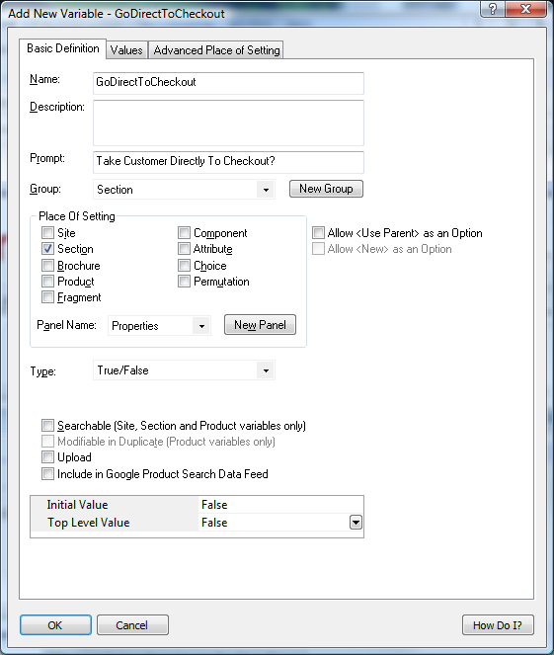
- Click 'OK' and close the library.
You are now ready to include the code in your design.
- Set up a section with a 'Shopping Mode' of 'Single Add To Cart Button' where you want to take customers directly to the checkout after adding to cart.
- Change to the 'Design' tab.
- Click on the single add to cart button in the design.
In the layout code for the single 'add to cart' button, copy and paste the following code:
<actinic:block if="%3cactinic%3avariable%20name%3d%22GoDirectToCheckout%22%20%2f%3e%20%3d%3d%20true">
<input type="hidden" name="ACTION" value="<actinic:variable name="CheckoutButton" />">
<input type="hidden" name="CHECKOUTURL" value="<actinic:variable name="OrderLinkText" />" target="_self">
</actinic:block>
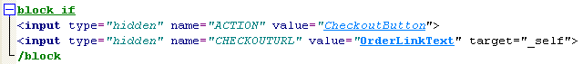
Now for any section where you want to take your customers directly to the shopping cart after adding to cart, go to the 'Properties' panel of the section and set 'Take Customer Directly To The Checkout?' to 'True'.
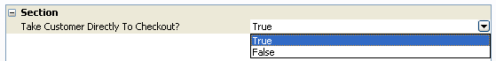

Making ‘Hide Cart Details’ the Default in the Checkout
The following steps will change the default setting for the show / hide cart details button in the checkout, so that the cart details are hidden and only the total order value is shown unless the shopper clicks the ‘show cart details’ button. NB this change negates the effect of the one above.
- Select ‘Library’ from the ‘Design’ menu and select the ‘Layouts’ tab.
- Scroll down and expand the ‘Shopping Cart Table’ section, and double-click the ‘Checkout Shopping Cart Grid’ layout to open it.
- Scroll down and find the </div> tag on the last line but one of the layout, and insert a new blank line immediately above it.
- Paste the following code into the new line:
<script type="text/javascript">
SetShoppingCartVisibility();
</script>
- Click ‘OK’ and then ‘Close’.
- ‘Publish to Web’ to upload the change.

Stopping People from Checking Out with Less Than 2 Items
This code will prevent customers from checking out unless they have at least two items in their shopping cart.
Go to the 'Design' tab and select 'Checkout Page 0' from the 'Select Page Type' drop-down list.
Click on the 'Next>' button in the design.
Replace the code in the 'Checkout Next Button' layout with the following:
<script language="JavaScript">
<!--
/************************************************************/
*
* getCartItem - Gets the SellerDeck Cart Value & No of Items
*
*************************************************************/
//CART_CONTENT = Cookie name
//1 = TOTAL_VALUE
//3 = CART_COUNT
function getCartItem(index)
{
var act_cart= getCookie("CART_CONTENT")
temp =(act_cart != null) ? temp=act_cart.split("\t"):0;
return (temp.length > 0) ? temp[index] : 0;
}
// -->
</script>
<input type=SUBMIT name=ACTION value="<actinic:variable encoding="html" name="NextButton" />" class="highlight-button" onclick="if (getCartItem(3) >= 2) {return true;} else {alert('Minimum order is 2 items');return false;}">
It will look like this:
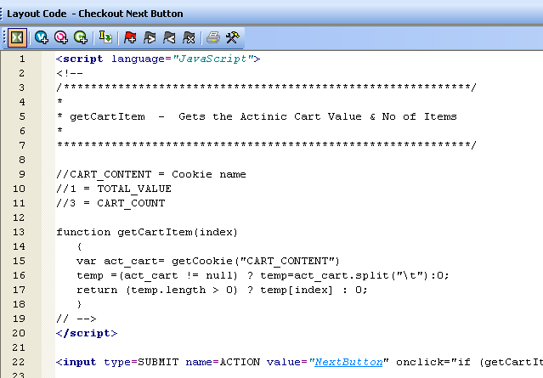
Where it says
if (getCartItem(3) >= 2)
the '2' can be replaced with another minimum quantity.

Offering Payment Methods to Customers in Different Formats
In SellerDeck, you can access all the HTML used within the checkout. Most of it is accessible via the 'Design' tab (Checkout Page 0/1/2 and Receipt). However, some key elements are within 'Design | Text'. The most important of these is the drop-down list used to offer payment methods to your customers.
To find the relevant section of Design | Text:
- Go to 'Design | Text', click 'Go to' and go to prompt Phase: -1 and ID: 1951.
You will highlight the following section:
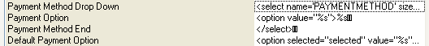
The highlighted line, and the three lines below it, contains the HTML used to build the payment-method drop-down list in the checkout. To change it to something else (in this case a list of radio buttons) you will need to do the following:
- In the first line, delete
<select name="PAYMENTMETHOD" size="1" id="idPAYMENTMETHOD" onchange="SetCreditCardFieldsVisibility();">
- In the second line, replace <option value="%s">%s with
<input type="radio" name="PAYMENTMETHOD" value="%s" onclick="SetCreditCardFieldsVisibility();">%s<br>
- In the third line, delete </select>
- In the fourth line replace <option selected="selected" value="%s">%s with
<input type="radio" name="PAYMENTMETHOD" value="%s" checked="checked" onclick="SetCreditCardFieldsVisibility();">%s<br>

The finished result will look something like the following:
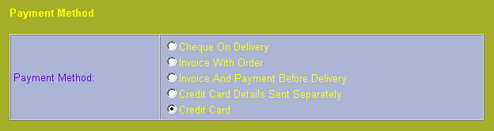

Adding a Giftwrap Option to the Checkout
This trick will add a 'gift wrapping' product to your store, and include a link to that product in the shopping cart, so people can add it to their order.
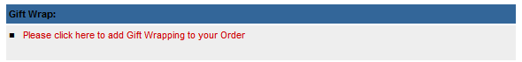
To begin, you need to create the giftwrapping product in your store. Create the product in an appropriate location (e.g. a new section called 'Gift Wrapping') and use the following settings:
Setting | Value
Product Reference | giftwrap
Other Info (Prompts panel) | Please enter a message to go with the gift:
Minimum Quantity (Details panel) | 1
Maximum Quantity (Details panel) | 1
Exclude from Froogle Data Feed (Details panel) | Selected
Exclude from Shipping Band Calculation (Details panel) | Selected
Include in Automatic Lists (Marketing panel) | All de-selected
If you are automatically generating product reference numbers, you will not be able to enter a product reference of 'giftwrap'. You'll just need to make a note of the product reference assigned to the product.
Next, you need to create a new layout for the shopping cart. To do this:
- Go to 'Design | Library | Layouts'.
- Expand the 'Checkout Area' group.
- Right-click within the group and select 'New Layout'.
- Give it a name of 'Giftwrap' and click 'OK'.
- Double-click on the layout to edit it and copy and paste the following code into the layout:
<!-- Gift Wrap list begin-->
<table cellspacing="2" cellpadding="3" border="0" width="<actinic:variable name="ACTSTDWIDTH" />">
<tr>
<th align="left" class="cartheading"><strong>Gift Wrap:</strong></th>
</tr>
<tr>
<td class="cart">
<ul>
<li>
<a href="<actinic:variable name="SearchCGIURL" />?PRODREF=giftwrap&amp;NOLOGIN=1<actinic:block if="%3cactinic%3avariable%20name%3d%22HiddenFields%22%20%2f%3e%20%21%3d%20%22%22">&amp;SHOP=<Actinic:Variable Name="HiddenFields"/></actinic:block>"> Please click here to add Gift Wrapping to your Order</a>
</li>
</ul>
</td>
</tr>
</table>
<!-- Gift Wrap list end-->
Change PRODREF=giftwrap so "giftwrap" is the product reference of the giftwrap product.
Click 'OK' to save the changes to the layout.
Finally, you need to include the giftwrap layout into shopping cart layout.
The easiest way to do this is go to the 'Shopping Cart Table' group in the library and editing 'View Cart Page Shopping Cart Grid'.
Add the following code in where required.
<actinic:variable name="CheckoutArea" value="Giftwrap" />
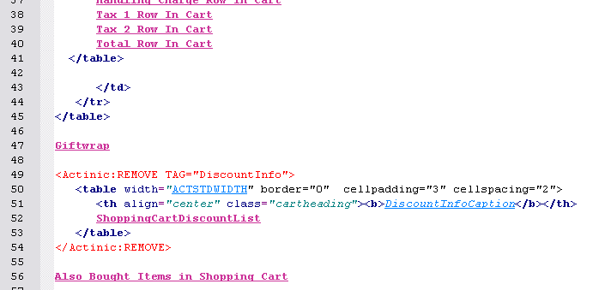
It may take a few goes before you are happy with the placement, but you can check the results in the previw panel in the 'Design' tab.

Turning a Text Field into a Check Box
This is a neat trick that will turn any text field in the checkout into a check box. This will extend the ability of your SellerDeck store to take different types of information, and the responses will still look meaningful in the printed reports.
This example is based on the 'User Definable' field in the 'Invoice Address' part of the checkout.
- Go to 'Design | Text | Web Site (cont) | Invoice Address' and select the 'Show' box next to the 'Invoice User Defined' field.
- Click 'OK'.
- Next change 'Checkout Page 0' in the 'Select Page Type' field in the 'Design' tab.
- Click on the 'User Definable' text (or whatever you have changed it to).
- Locate the following line:
- This is the code for the user defined field, and by default it is a text field. Change the above code to read:
<input type="checkbox" name="INVOICEUSERDEFINED" value="CHECKED" <Actinic:Variable Name="InvoiceUserDefined"/>>
This will turn the text field into a check box. This will stay checked if a customer leaves the invoice address page and then re-enters it for any reason. The value that will appear in the order processing reports to indicate whether the customer ticked the box is the word 'CHECKED'.

Automatically Capitalising Customer Input
Customers will not always enter their name and address information with capital letters online. This then means you will often have to manually edit the details once you have receive the order into SellerDeck.
This is a JavaScript function that will apply correct capitalisation to the details customers enter in your checkout as they type them.
First of all, you need to go to the 'Design' tab and select 'Checkout Page 0' from the 'Select Page Type' drop down list. Then locate the overall page layout and insert the following function into the <head> section, just above the </head> tag.
<script language=JavaScript>
<!--
function capitalizeWords(string) {
var tmpStr, tmpChar, preString, postString, strlen;
tmpStr = string.toLowerCase();
stringLen = tmpStr.length;
if (stringLen > 0)
{
for (i = 0; i < stringLen; i++)
{
if (i == 0)
{
tmpChar = tmpStr.substring(0,1).toUpperCase();
postString = tmpStr.substring(1,stringLen);
tmpStr = tmpChar + postString;
}
else
{
tmpChar = tmpStr.substring(i,i+1);
if (tmpChar == " " && i < (stringLen-1))
{
tmpChar = tmpStr.substring(i+1,i+2).toUpperCase();
preString = tmpStr.substring(0,i+1);
postString = tmpStr.substring(i+2,stringLen);
tmpStr = preString + tmpChar + postString;
}
}
}
}
return tmpStr;
}
// -->
</script>
Once you have done that, you can click on any fields in the page that you want capitalised, and just add in the call to the function. For example, replace:
<input type="text" name="INVOICEADDRESS1" size="30" maxlength="200" value="<actinic:variable name="InvoiceAddress1" selectable="false" />" tabindex="NETQUOTEVAR:TABINDEXINVOICEADDRESS1" />
with
<input type="text" name="INVOICEADDRESS1" size="30" maxlength="200" value="<actinic:variable name="InvoiceAddress1" selectable="false" />" tabindex="NETQUOTEVAR:TABINDEXINVOICEADDRESS1" onchange="this.value = capitalizeWords(this.value)" />
i.e. add the following into any <input> tag where you want the contents capitalised:
onchange="this.value = capitalizeWords(this.value)"
Disclaimer: This code was provided by a SellerDeck user via the SellerDeck Community (http://community.sellerdeck.com/) and so can't be supported by the SellerDeck Technical Support team.

Supporting an Affiliate Program with SellerDeck Ecommerce
It is possible to add markup to the SellerDeck's receipt page in order to support an affiliate program. The markup is generally specified by the affiliate program, but a typical example would be:
<IMG SRC="https://www.server.com/log.cgi?amount=[order-amount-here]&orderid=[order-id-here]">
Translating this into a SellerDeck ready line, you would get:
<IMG SRC="https://www.server.com/log.cgi?amount=NumericOrderTotal&orderid= TheOrderNumber">
The variables available to an affiliate program of this nature are:
TheOrderNumber - order number.
FormattedOrderTotalHTML - the order total formatted in the appropriate currency and encoded for HTML display
e.g. &#163;55&#46;57
FormattedOrderTotalCGI - the order total formatted in the appropriate currency and encoded for CGI
e.g. %a355%2e57
ActinicOrderTotal - the order total formatted in the SellerDeck internal format (integer number in currency base unit)
e.g. 5557
NumericOrderTotal - the order total partially formatted in the appropriate currency. This value include decimal and thousand separators, but leaves off the currency symbol.
e.g. 55.57
NumericOrderTotalCGI - the order total partially formatted in the appropriate currency and encoded for CGI. This value include decimal and thousand separators, but leaves off the currency symbol.
e.g. 55%2e57
TextOrderTotal – The order total with currency symbols and a decimal point, with no encoding.
e.g. £55.57

Creating a 'When To Deliver' Drop Down List
It could be that you would like your customers to tell you how quickly they would like their products delivered to them – whether they want the items as soon as possible, or whether they don't want them for one week, two weeks etc.
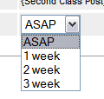
To do this, you can change the 'Shipping User Definable' text field in the checkout to a drop-down list. This is done as follows:
Go to 'Design | Library | Layouts' and expand the 'Checkout Prompt' group. Towards the bottom you will find 'Shipping User Definable Prompt'.
Double click on this layout to open it for editing.
Replace
<input type="text" name="SHIPUSERDEFINED" size="20" maxlength="255" value="<Actinic:Variable Name="ShipUserDefined"/>" />
with something like...
<select name="SHIPUSERDEFINED">
<option value="ASAP" selected>ASAP</option>
<option value="1 week">1 week</option>
<option value="2 weeks">2 weeks</option>
<option value="3 weeks">3 weeks</option>
</select>
You will also need to go to 'Design | Text | Web Site (cont) | Shipping and Tax' and change the 'Shipping User Definable Prompt' to something appropriate.

Specifying a Delivery Cut-Off Time for Orders
This section will show you how you could add a warning to your site that tells people whether their order will be sent the same day.
Simply place the following code into your product layout where you want the message to appear:
<script language=JavaScript>
now = new Date();
if ( now.getUTCHours() >= 16 ) document.write('<span style="color:red;">Warning text here</span>');
</script>
In the above example, the cut-off time is 4pm - 16.00. If you want a different time, change the '16' to another number on the 24 hour clock.
You can also put this code into the overall page layout for the store.
Disclaimer: This code was provided by a SellerDeck user via the SellerDeck Community (http://community.sellerdeck.com/) and so can't be supported by the SellerDeck Technical Support team.

Emptying The Cart When People Leave The Checkout
This JavaScript function will empty your customer's shopping cart when they click the 'Cancel' button on the checkout. It is useful as sometimes it is confusing for customers if they still have items in their shopping cart, when they think they have cancelled the transaction.
To begin, place the following JavaScript functions in the <head> area of the overall page layout that is being used in the checkout. You can verify this in the 'Checkout Pages Layout' field in 'Settings | Site Options | Layouts'.
Add it in just above the closing </head> tag.

<script language="Javascript" type="text/javascript">
function createCookie(name,value,days) {
if (days)
{
var date = new Date();
date.setTime(date.getTime()+(days*24*60*60*1000));
var expires = "; expires="+date.toGMTString();
}
else var expires = "";
document.cookie = name+"="+value+expires+"; path=/";
}
function CancelOrder() {
if (confirm('This will clear your order and address details completely.\nClick "View Cart" to change your order.\nDo you wish to proceed?') == true)
{
createCookie("ACTINIC_CART","",-2);
createCookie("CART_CONTENT","",-2);
createCookie("CART_COUNT","",-2);
createCookie("CART_TOTAL","",-2);
createCookie("ACTINIC_BUSINESS","",-2);
createCookie("ACTINIC_REFERRER","",-2);
window.location.href = 'http://www.YOURSITE.com/RETURN-PAGE';
}
}
</script>

Replace 'http://www.YOURSITE.com/RETURN-PAGE' with the location of a page you want to take customers to.
Then go to 'Design | Library | Layouts' and locate the 'Checkout Button' group. Within it, locate 'Checkout Cancel Button' and double-click on it to open it.
Replace the code in the layout with the following:
<input type="button" name="ACTION" value="<actinic:variable encoding="html" name="CancelButton" />" class="normal-button" onclick="CancelOrder();" />

Customer Accounts

Hiding Elements from Retail Customers, but Showing Them to ALL Registered Customers
If you have a design element in your site that you only want to show to registered customers, and hide from retail customers, then you need place the following tags before the code:
<Actinic:NOTINB2B><!--</Actinic:NOTINB2B>
…and put these after the code:
<Actinic:NOTINB2B>--></Actinic:NOTINB2B>
This will mean that the HTML comment marks will only appear for unregistered customers, and hence the content will be hidden from them.
Please note that in order for this to work, you need to ensure that 'Compact HTML/CGI' is de-selected in 'Design | Design Options'.

Preventing Unregistered Customers from Entering Certain Sections in your Store
It is possible to have sections that only customers within certain customer groups will see online. To do this, you need to create a new section link template with a very specific format.
Go to 'Design | Library | Layouts' and locate the 'Section Links' group.
Right-click on any of the layouts there and select 'New Layout'. Call it 'Section Link for Registered Customers Only'.
Now double-click on this layout to edit it, and copy and paste the following code into it, in place of any existing code:
<Actinic:SHOWFORPRICESCHEDULE Schedules="2" HTML="<a href=<actinic:variable name="SectionPageName"/>><actinic:variable name="SectionName"/></a>"/>
You can then select this layout within the 'Section Link Layout' field in the 'Layout' panel of any section that you want to be hidden.
You have to change the code in this template depending on which customer groups you want the section link to be visible within. The Schedules="2" value needs to be the ID of your desired customer group. You can find this from the 'Price Schedules' table in the 'ActinicCatalog.mdb' database.
Note: This section really needs to be at the end of a list of sections, Otherwise unregistered customers will have a gap appearing where the link should be.

Bouncing Unregistered Customers Out of Sections
If you wish to prevent unregistered customers from being able to view specific store pages, then you will need to include a simple JavaScript function into the overall page layout for those sections.
- Go into the 'Layout' panel of the section that you want to restrict to only registered customers.
- Locate the 'Overall Page Layout' field and make a mental note of the name of the current overall page layout.
- Click in the 'Overall Page Layout' field and select '<New>' from the bottom of the list.
- In the 'Based On' field, select the overall page layout that is currently being used by the section.
- In the 'Name' field enter 'Registered Customers Only'.
- Click 'OK' and then click 'Apply' to make this section use the new layout.
- Now change to the 'Design' tab and select the overall page layout.
- Locate the following command in the headers of the template:
<meta http-equiv="Content-Type" content="text/html; charset=iso-8859-1">
- Just underneath this, copy and paste the following into the template:
<Actinic:NOTINB2B>
<meta http-equiv="Refresh" content="0; url=NoEntry.html">
</Actinic:NOTINB2B>
<script language="javascript1.1">
function actNotRegistered(){
//<Actinic:NOTINB2B>
location.replace ('NoEntry.html');
//</Actinic:NOTINB2B>
}
</script>
Note: replace page.html with whatever page you want unregistered customers to be bounced to.
- Next, locate the <body> tag further down in the layout:
- Change the 'onload' part to read:

Whatever sections you don't want unregistered customers going into, specify this new layout in the 'Overall Page Layout' field. This should now automatically take customers back to the designated page if they try and go to a page in your store that you do not want them to.
Naturally, you are going to want to have some explanation in the section description of the section to point out that certain sections are for trade customers only.

Miscellaneous

Adding New Terms and Conditions
If you leave any of the boxes in 'Business Settings | Terms and Conditions' empty then the corresponding heading (e.g. 'Remittance Terms') will not appear in the HTML. However, if you wish to add your own Terms and Conditions entry you can fill in your text in an unused panel and then simply change the appearance of the title in the HTML.
To do this, go to 'Design | Text' and search for the heading you want to change.

Using a Text Field for Searchable Properties
Searchable properties allow you set up fields where customers can search on the values entered for the 'user-definable variables' in your store.
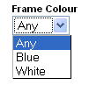
Instructions for doing this are in the main help in 'Online Store Features | Searching On Product Properties'.
By default, searchable property values are shown as a list for customers to select from online. However, it is possible to amend this to be a free text input box where customers can enter the value they want to search on.
To do this:
- First you need to set up a working searchable property as described in the help.
- When adding your property to the 'Searchable Properties' grid, use a 'HTML Representation' of something like 'List with Multiple Selection' i.e. one you won't use for anything else.
- Where it says 'Combining Results' at the bottom select 'OR'
- Now go to 'Design | Library' and go to the 'Searchable Property Value Lists' group.
- Edit the 'List with Multiple Selection' layout
- Replace the layout selector that's in there with '&nbsp;' (SellerDeck seems to need to have something in there)
- Click the orange 'Click here to edit list layout settings text'
- Delete everything in the 'End of List' field
- Replace the content of the 'Start of List' field with:
<input type name="<Actinic:Variable Name="SearchPropControlName"/>" value="" />
- Click 'OK'
This will replace the list of values with a single empty text box. The box will not support partial matches though (unlike the standard search box).

Providing Extended Search Results
For earlier version sites upgraded to SellerDeck 2013 or later
In versions prior to SellerDeck 2013, text search results were sorted by Product Reference and only included products that matched every word searched for. So for example, a search for ‘diamond rings’ would find a ‘solitaire diamond ring’ but not a ‘gold ring’ or a ‘diamond necklace’. This ensured that all results were directly relevant to the search. But it could often result in no results being returned.
SellerDeck 2013 added an improved text search facility which defaults to sorting results by Relevance instead of by Product Reference. In new sites it searches using an ‘OR’ operator instead of ‘AND’. This includes products similar to but not exactly matching the search, but normally shows exact matches first.
If you have a site upgraded from an earlier version, you can modify the search layout to behave in the same way.
- First identify the layout used for your text search box. If you know what this is you can open it in the Library. If not, click in the search box in the Design tab Page Preview to select it:
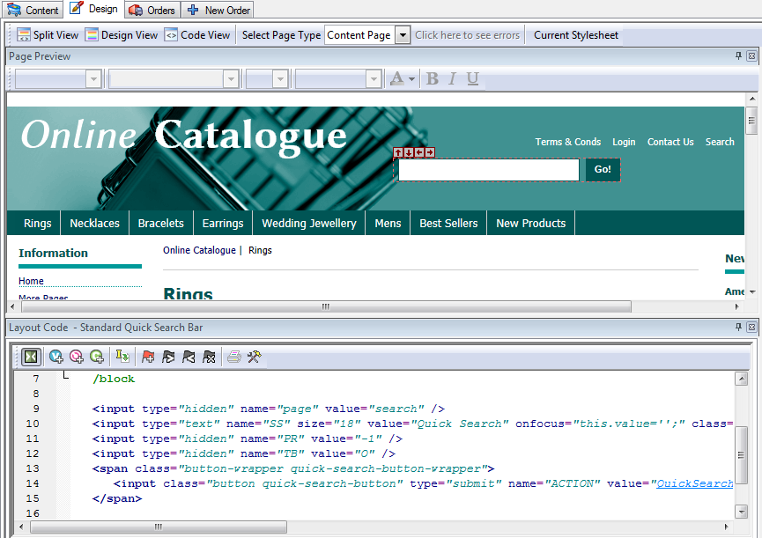
- Now identify the line of code that looks like this:
- Change the 'O' to and 'A' and click 'Apply'.
- Upload your site and try a few searches to see the difference.

Section C - Perl Script Changes

Products

Making the Other Info Box Optional
This prompt can be made optional by editing one of the perl scripts.
Locate the file ActinicOrder.pm in the site folder.
Edit the file with a text editor such as Notepad
Search for "sub InfoValidate", you should see…
if (length $sInfo == 0)
{
$sMessage .= ACTINIC::GetPhrase(-1, 55, "<B>$sPrompt</B>") . "<P>\n";
}
elsif (length $sInfo > 1000)

Comment out the first 4 lines (using #) and change the last line from 'elsif' to 'if' so that the code reads:
#if (length $sInfo == 0)
# {
# $sMessage .= ACTINIC::GetPhrase(-1, 55, "<B>$sPrompt</B>") . "<P>\n";
# }
if (length $sInfo > 1000)
Save and exit.
Update the site.
SellerDeck is not able to provide any detailed support for script changes made. If you find that there is a problem, an original copy of the script can be found within the 'Original' folder in your installation. Copy this into your site folder.

Having a larger box for the 'Other Info' Prompt
By default, customers only have a single line to provide an answer for the 'Other Info' question online. It is possible to edit the product layout and the 'Design | Text' area to provide a 'text area' box instead of a single line
First of all, you just need to edit the 'Other Info' prompt that appears as part of your product layout on the store pages (if you are using a shopping mode of 'Quantity on Product Page').
To do this:
- Select your product layout in the 'Design' tab and locate the following line:
- Replace this line with the following code:
<textarea name="O_<Actinic:Variable Name="ProductID"/>" rows="5" cols="40" maxlength="1000" value="" /></textarea>
You now need to edit the code for the other info prompt that appears in the shopping cart. To do this:
- Go to 'Design | Text'
- Click 'Go To' and in the ID field enter '2161'.
- It should highlight a line that says find a line that says:
%s<input type="text" name="%s" size="%d" maxlength="%d" value="%s" %s />
- Change the prompt to read:
%s<textarea name="%s" rows="5" cols="40" %d maxlength="%d">%s</textarea>
- Click 'OK' to save your changes.
- Now go into your 'Site1' folder and locate a file called 'ActinicOrder.pm'. Open it in Notepad.
- Search for '2161', you should see...
$sHTML = ACTINIC::GetPhrase(-1, 2161, "", $sIndex, 35, 1000, $sValue, $sStyle);
- Comment out this line by preceding it with a #.
- Insert the following immediately after the above line...
$sHTML = ACTINIC::GetPhrase(-1, 2161);
$sHTML =~ s/%d/%s/;
$sValue =~ s/%0a//ig; # we seem to need to remove some Line Feeds here
$sHTML = sprintf( $sHTML, "", $sIndex, $sStyle, 1000, $sValue);
- Save the file.
- Now go into your 'Site1' folder and locate a file called 'OrderScript.pl'. Open it in Notepad.
- Look for:-
if (length $$pProduct{'OTHER_INFO_PROMPT'} > 0)
{
MailOrderLine( "",
$$pProduct{'OTHER_INFO_PROMPT'} . "\r\n " . $CurrentItem{'INFO'},
- Change to:-
if (length $$pProduct{'OTHER_INFO_PROMPT'} > 0)
{
my $PatchIt = $CurrentItem{'INFO'};
$PatchIt =~ s/%0a/\r\n /ig;
MailOrderLine( "",
$$pProduct{'OTHER_INFO_PROMPT'} . "\r\n " . $PatchIt,
- Save the file and then upload your SellerDeck store.
SellerDeck is not able to provide any detailed support for script changes made. If you find that there is a problem, an original copy of the script can be found within the 'Original' folder in your installation. Copy this into your site folder.

Having Two Other Info Prompts
It is possible to split the 'Other Info' field in the shopping cart and on the confirmation page into two different fields. This allows your customers to provide much more detailed information with a product. Furthermore, it is possible to only have the extra field created just for specific products, based on the product reference of the product.
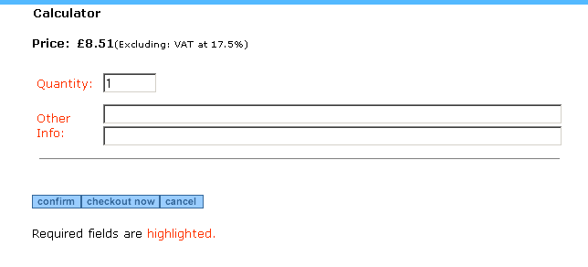

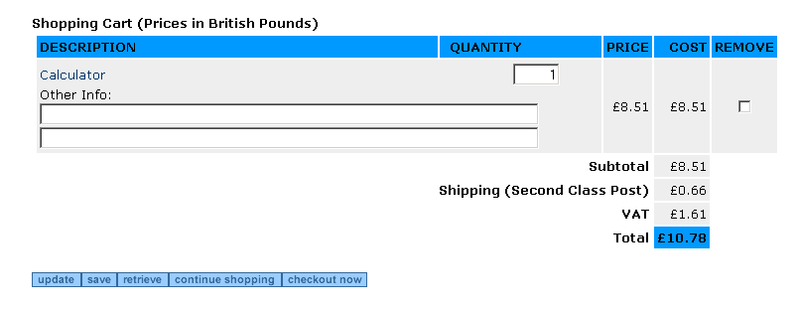
In order to do this, you need to open the file called 'ActinicOrder.pm'. When you have the file open, do a search for
sub InfoHTMLGenerate
This will bring you into a subroutine within ActinicOrder.pm that controls this functionality.
Look for the following code under where it says 'CUSTOMISATION BEGIN' code:
if ($sProdref eq "5")
{
my @aValues = split /\|\|\|/, $sValue;
if ($bStatic)
{
$sHTML = join "<BR>", @aValues;
}
else
{
$sHTML = "<INPUT TYPE=TEXT SIZE=\"80\" NAME=\"O_1_$nIndex\" VALUE=\"" . $aValues[0] . "\"><BR>";
$sHTML .= "<INPUT TYPE=TEXT SIZE=\"80\" NAME=\"O_2_$nIndex\" VALUE=\"" . $aValues[1] . "\">";
}
}
Note the word wrap that has occurred on the 11th and 12th line in the code above. These should be long lines without line breaks.
You will see that this code is all preceded with hashes '#'. These comment out the lines and prevent them from being active. In order to make the lines active, remove the '#'s.
Change the if ($sProdref eq "5") line to reflect the product reference of the product that you want to use the extra fields. For instance, if you wanted the extra field on a product with a reference of 'b16' then change the line to read
if ($sProdref eq "b16").
You then need to go down to 'sub InfoGetValue' and remove the '#'s from the custom code there, again changing the if ($sProdref eq "5") line as necessary.
Finally, if you want any specific validation done on the entries in the two fields, you need to go down to 'sub InfoValidate' and uncomment and adjust the code in there. The sample code there will flash up a warning message if the number of characters in either field does not exceed '5'.
Once you have made the required changes you can save the file and upload your store.
Disclaimer: This code was provided by a SellerDeck user via the SellerDeck Community (http://community.sellerdeck.com/) and so can't be supported by the SellerDeck Technical Support team. If you find that there is a problem, an original copy of the script can be found within the 'Original' folder in your installation. Copy this into your site folder.

Search

Omitting Certain Products From Search Results
This is a change to the SearchScript.pl Perl script which will mean that any products that end in 'x' will not be shown in the search results. Note that the search results sequence numbers will show a missing result.
Open SearchScript.pl within a text editor such as Notepad and locate the following line:
for ($nCount = $nMin; $nCount < $nMax; $nCount++) # process the range of product references in the results set
Immediately after this line add the 2 lines:
{ # patch
if ( $$rarrResults[$nCount] !~ /x$/ ) # hide products that have reference ending in x
Then a little way below this, look for the pair of lines
$sHTML .= ACTINIC::ParseXML($sResultMarkup); # parse the XML
}
Immediately after this pair of lines add the single line
} # patch
Then save the file and upload to test it.
With grateful thanks to Norman Rouxel for this solution.
Disclaimer: This code was provided by a SellerDeck user via the SellerDeck Community (http://community.sellerdeck.com/) and so can't be supported by the SellerDeck Technical Support team. If you find that there is a problem, an original copy of the script can be found within the 'Original' folder in your installation. Copy this into your site folder.

Turning the Search Results into a Buyable List of Products
This is a substantial change to SellerDeck, which allows the Search Results to look like a normal list of products, complete with cart button, etc.
It works by creating a small text file for each product which is incorporated into the search results. If you have thousands of products make sure your server can handle that number of extra files.
It's designed for sites using 'Quantity on Product Page' and it won't work with 'Single Add To Cart' pages.
This code is too big to detail in the Advanced User Guide, so you need to go to the 'SellerDeck Community' where it was originally posted.
Browse to http://community.sellerdeck.com/ and search for 'Search Results Hack'. Or just go straight to http://community.sellerdeck.com/showthread.php?t=31559
The instructions are in post #8 and #9 on this thread.
Warning – this is a highly advanced change that requires detailed knowledge of SellerDeck and of web servers. No support is available for this other than asking questions on the thread. Please read through all the other replies to the thread before posting as some people have already hit a few pit-falls with this solution.

Editing the Search Page HTML
'search.html' is now a totally complete, fully functional HTML page that can be opened in any visual HTML editor such as 'Dreamweaver'.
When you open up this file for editing, please take note of the following:
The <form></form> tags of the search form are located right at the top and bottom of the main area of the page. Therefore if you are going to create multiple search forms on the same page, you will have to duplicate and relocate the <form…> and </form> tags to surround each separate HTML form.
You will need to ensure that any <input type="hidden"> elements are included correctly in each search form.
You could begin by rearranging the HTML to create an independent search form to look something like this:

<p>What director are you looking for?</p>
<form method="get" action="http://your.URL/cgi-bin/ss000001.pl">
<input type="hidden" name="RANDOM" value="NETQUOTEVAR:RANDOM" />
<input type="hidden" name="PAGE" value="SEARCH" />
<select size="1" name="S_Director1_0">
<option value="Baz Luhrmann" selected>Baz Luhrmann
...
...
<option value="Stephen Spielberg">Stephen Spielberg
</select>
<input type=SUBMIT name=ACTION value="Search">
</form>
Notice that two hidden input fields are required to get the Perl to treat the form correctly.

Editing the 'customsearch.fil' Files
This online search will not work yet as we still need to create a 'customsearch.fil' file just for this form to use.
When you open up customsearch.fil in Wordpad, you get something like this:

1
Price!PR
Text!SS!TB
And
Text Property!S_Director1_0
And
Text Property!S_Artist1_1
And

(In Notepad, the line breaks will appear as black blobs)
This file tells the online search which values to look for in the catalogue and how the results are to be combined with each other.
A breakdown of this file is as follows:

Value | Line | Explanation
1 | Line 1 | Indicates format of file. Always begin the file with this line
Price!PR | Line 2 | This means that the search will be looking at the price fields of the products. This line will only be here if you are doing price-based searching.
And | Lines 4 , 6 & 8 | Indicates how the different search fields are to be combined with each other (the intersection). Set by choosing either 'AND' or 'OR' in the Searchable Properties tab.  Note that the 'And' or 'Or' refers to how the preceding line of code is to be combined with the other search fields.
Text!SS!TB | Line 3 | This means that the search will be scanning short and full descriptions for any keywords. 'SS' is the name of the keyword text field whilst 'TB' is the name of the 'combine keywords using' radio buttons.
Text Property!Whatever | Lines 5 & 7 | The first part of this command refers to the type of data you are searching on. This can be one of the following:  - Price  - Text (keyword search only)  - Text Property  - Integer  - Date  The second part ('Whatever') refers to the name of the form object.

To edit the above 'customsearch.fil' file to work with an online form that is only looking for 'Directors', you will need to change it to the following:

1
Text Property!S_Director1_0

And then save it as something like 'customsearch2.fil'. The file name must be of the form 'customsearch#.fil'. Ensure there are no blank lines at the bottom of the file.
In order to get your new search form to look for this 'customsearch#.fil' file you need to add a line of code to the search tool of the following form:

<input type=HIDDEN name="SN" VALUE="#">

Where '#' is the number used in the 'customsearch#.fil' file.
If you did save the file as 'customsearch2.fil', the HTML form code in the search page will now look like the following:

<p>What director are you looking for?</p>
<form method="get" action="http://your.URL/cgi-bin/ss000001.pl">
<input type="hidden" name="RANDOM" value="NETQUOTEVAR:RANDOM" />
<input type=HIDDEN name="SN" VALUE="2">
<input type="hidden" name="PAGE" value="SEARCH" />
<select size="1" name="S_Director1_0">
<option value="Baz Luhrmann" selected>Baz Luhrmann
...
...
<option value="Stephen Spielberg">Stephen Spielberg
</select>
<input type=SUBMIT name=ACTION value="Search">
</form>
In order to have SellerDeck to upload this new file, you will need to add it into the list in 'Design | Additional Files'.
This technique can be expanded to create multiple search pages, each one with a different search tool on it. Remember to add any additional search pages to the 'Design | Additional Files' list in order for them to be uploaded. Note that SellerDeck will not automatically link to any custom written search pages so you will have to write your own HTML to include these.

Joining Search Terms Together in Different Ways
You can also edit the 'customsearch.fil' file to join the search terms together in more complex ways. For instance, in the case of a catalogue of films, you may wish people to choose either the director or the star of the movie they want, and then choose what genre (Thriller, Comedy etc.) of film they are interested in. E.g. "Find all action films starring Harrison Ford or directed by Steven Spielberg."
If you set up 'Director', 'Star' and 'Genre' as custom properties and set up the 'Searchable Properties' tab to search on them, the 'customsearch.fil' file generated would look something like the following:
1
Text!SS!TB
Text Property!S_Director1_0
And
Text Property!S_Star1_1
And
Text Property!S_Genre1_2
And
This file would still search on keywords, and would only find films that contain the director AND the star AND the genre chosen. You could make the 'Director' and 'Star' fields both optional (to allow people to search on either) but you could not search on the director OR the star at the same time, and then look for the genre.
However, you can do this by changing 'customsearch.fil' to something like the following:
1
Text Property!S_Director1_0
Text Property!S_Star1_1
Or
Text Property!S_Genre1_2
And
This code removes the references to the keyword search (allowing you to remove the keyword search box from the search page) and changes how the search properties are joined together. Online, the search would act on this file in the following way:
- It would firstly see line 2 and find all the films of the chosen director (e.g. Steven Spielberg). It makes a list of them and stores them this list in its memory
- It then would read line 3 and find all the films starring the chosen star (e.g. Harrison Ford) and adds this list to the director list and holds it in its memory.
- The 'Or' in line 4 tells the search to combine both lists into one. If it was an 'And' then the search at this point would disregard all films starring Harrison Ford that were not directed by Steven Spielberg (and vice versa)
- The search reads line 5 now and finds all the films of the chosen genre (e.g. Action), makes a list of them and stores them in its memory.
- The 'And' in line 6 means that it will firstly compare the genre list with the director and star list, keeping the products that match. It disregards all the products that do not fulfil either criteria.
- The products that match the required criteria are then displayed in the results page.
Remember that the 'And' or 'Or' command refers to how the preceding line is to be combined with the results gathered so far.

Matching Plurals in the Search
Sometimes if you have the word 'apples' in your product description, you want people to be able to find that product if they search for the word 'apple' (without the 's'). This little addition to the Perl script will take care of that.
Open 'SearchScript.pl' (from within your site directory) in Notepad or a similar editor.
Find the line:
# Combine any multiple-white-spaces into single space
Place the following lines just above that line:
$$psSearchString =~ s/es$//io;
$$psSearchString =~ s/s$//io;
$$psSearchString =~ s/es\b//io;
$$psSearchString =~ s/s\b//io;
This solution was provided by a customer on the SellerDeck Community (http://community.sellerdeck.com/), and can't be supported by the SellerDeck Technical Support team. If you find that there is a problem, an original copy of the script can be found within the 'Original' folder in your installation. Copy this into your site folder.

Keeping a Log of Search Terms Used at the Site
You can enable search term monitoring by editing ActinicConstants.pm and removing the comment (the '#') from the line:
#$::SEARCH_WORD_LOG_FILE = "search.log";
Setting any non empty file name to $::SEARCH_WORD_LOG_FILE will result a log file. E.g.
$::SEARCH_WORD_LOG_FILE = "searchword.log";
… will create a file called 'searchword.log' in the acatalog directory on the web server.
The log file contains the following information:
Date, Remote host, Customer ID, Buyer ID, Search words, Hits
These values are comma separated. E.g. entering word "Desk" on the search page as unregistered customer will result the following line in the log file:
2015/01/16 14:45, 86.2.101.116, 0, 0, "diamond", 3
If more than one search word is entered then the words are separated by spaces. E.g.
2015/01/16 14:47, 86.2.101.116, 2, 3, "diamond ring", 5
Note: the "2, 3" means that this search was made by a registered customer where the customer ID is 2 and the buyer ID is 3.

Understanding Relevance
The concept of Relevance is widely used in online search functionality, and was introduced in SellerDeck 2013 along with the ability to change the sort order of search results.
In Settings | Search And Filtering Settings | Options you can choose which fields are to be indexed in relation to your products. Each time a word is found in an indexed field for any given product, it increases the Relevance of the product to searches containing that word.
Words in some fields contribute more to the Relevance score than others. For example, a word appearing in a product Short Description has a higher weighting than the same word appearing in the Long Description.
If a word appears twice in a field, the weighting for that field is multiplied by two. By default, further occurrences are not counted.
The weightings for each field are summed to give the overall Relevance of the product to the word. For technical reasons the maximum possible score is 4095. The higher the Relevance score of any product to any word, the earlier the product will appear in search results for that word.

Contact Us Form

Adding Extra Fields to the 'Contact Us' Form
To create new fields in the 'Contact Us' form you need to:
- Go to the 'Design' tab in the 'Select Page Type' drop-down list select 'Contact Us'.
- Click on one of the prompts on the page (e.g. 'Message') to select the 'Contact Us Bulk Area' layout.
- Add a new row where you want the field to display using the following
code:
<tr>
<td>&nbsp;</td>
<td>My New Field Name:</td>
<td><input type="text" name="MyNewField" size="50" maxsize="125" value="" /></td>
</tr>
- If the field is to be required then change the field prompt to look
like:
<td><span class="actrequiredcolor">My New Field Name:</span>*</td>
- Save and close the file
You now need to edit the Perl script that controls the message sending.
- Open 'Windows Explorer' and browse to your site folder (usually called 'Site1'). It's probably in 'My Documents\SellerDeck v11\Sites'
- Open 'MailForm.pl' in a text editor such as Notepad.
- Search for: 'sub SendMailToMerchant'
- You should see the following line:
# Receive parameters from input hash
#
my ($sEmailRecpt, $sSubject, $sTextMailBody, $sName, $sMessage, $sHTML);
- Add in $sMyNewField, so it looks something like
# Receive parameters from input hash
#
my ($sEmailRecpt, $sSubject, $sTextMailBody, $sName, $sMessage, $sMyNewField, $sHTML);
- You need to create a variable for each extra field that you want to
display so after :
$sSubject = $::g_InputHash{'Subject'};
add a similar line for each field, for example:
$sMyNewField = $::g_InputHash{'MyNewField'};
- Then search for: '# Construct the mail text and send it to the merchant'
- You need to add a line for each field after:
$sTextMailBody .= ACTINIC::GetPhrase(-1, 2373) . "\r\n" . $sMessage . "\r\n\r\n";
for example:
$sTextMailBody .= "MyNewFieldName:" . $sMyNewField . "\r\n";
- Then directly after these new fields you should see:
my @Response = ACTINIC::SendMail($::g_sSmtpServer,
$$::g_pSetupBlob{EMAIL}, $sSubject, $sTextMailBody, $sEmailRecpt);
- You need to add in your new variables so they are sent with the email, for example:
my @Response = ACTINIC::SendMail($::g_sSmtpServer,
$$::g_pSetupBlob{EMAIL}, $sSubject, $sTextMailBody, $sEmailRecpt, $sMyNewField);
- If you want to make your new field to be required then you need to search for:
if ($sEmailRecpt eq "")
{
$sError .= ACTINIC::GetRequiredMessage(-1, 2371);
}
- Copy this code and paste it directly after it and change the relevant
parts, i.e.:
if ($sMyNewField eq "")
{
$sError .= "<b>'My New Field'</b> is required<br>";
}
- Save and close the file and update your site.
SellerDeck is not able to provide any detailed support for script changes made. If you find that there is a problem, an original copy of the script can be found within the 'Original' folder in your installation. Copy this into your site folder.

Creating a Newsletter Subscription Form
It is possible to use the above technique to turn your 'Contact Us' form into a 'Subscribe To Newsletter' form. To do this, first of all you need to edit the 'Contact Us Bulk Area' layout to look like as follows.
This will add two new fields into the form - 'Surname' and 'Subscribe'. It will also change the 'Message' field to a 'Country' field.

<form method="post" action="<Actinic:Variable Name="SendMailPageURL"/>">
<input type="hidden" name="RANDOM" value="<actinic:variable name='Random'/>" />

<actinic:block if="%3cactinic%3avariable%20name%3d%22IsHostMode%22%20%2f%3e">
<!-- Hidden field when in trial mode -->
<input type="hidden" name="SHOP" value="<Actinic:Variable Name="HiddenFields"/>" />
</actinic:block>

<actinic:variable Name="ValidationError"/>
<input type="hidden" name="Subject" value="Newsletter" />
<table cellpadding="3" cellspacing="0">
<tr>
<td width="15">&nbsp;</td>
<td colspan="2">
<strong><Actinic:Variable Name="MailFormHeader"/></strong><br />
<br />
</td>
</tr>
<tr>
<td>&nbsp;</td>
<td>
Forename
</td>
<td>
<input type="text" name="Name" size="50" value="<Actinic:Variable Name="MailFormNameValue"/>" />
</td>
</tr>
<tr>
<td>&nbsp;</td>
<td>
Surname
</td>
<td>
<input type="text" name="Surname" size="50" value="" />
</td>
</tr>
<tr>
<td>&nbsp;</td>
<td>

</td>
<td>
Subscribe: <input type="radio" checked="checked" name="Subscribe" value="yes" /><br />
Unsubscribe: <input type="radio" name="Subscribe" value="no" />
</td>
</tr>
<tr>
<td>&nbsp;</td>
<td>
<span class="actrequired"><Actinic:Variable Name="MailFormEmail"/> *</span>
</td>
<td>
<input type="text" name="EmailAddress" size="50" value="<Actinic:Variable Name="MailFormEmailValue"/>" />
</td>
</tr>
<tr>
<td valign="top">&nbsp;</td>
<td valign="top">
Country:
</td>
<td>
<input type="text" size="50" name="Message" value="<Actinic:Variable Name="MailFormMessageValue"/>" />
</td>
</tr>
<tr>
<td valign="top">&nbsp;</td>
<td valign="top">&nbsp;</td>
<td>
<input type="submit" name="ACTION" value="<Actinic:Variable Name="MailFormSendButton"/>" />
</td>
</tr>
<tr>
<td valign="top">&nbsp;</td>
<td colspan="2" valign="top">
<Actinic:Variable Name="RequiredFields"/> <span class="actrequired"><Actinic:Variable Name="Highlighted"/></span>.
</td>
</tr>
</table>

</form>
Next, you need to go into 'Design | Text' and go to Phase: -1, ID: 2370 and change the prompt there to 'First Name' (from Name). Then go down to ID: 2373 and change the prompt from 'Message' to 'Country'.
Finally, you need to edit the 'MailForm.pl' file as described above to add $sSurname and $sSubscribe to the list of values supported by the Perl. e.g.
# Receive parameters from input hash
#
my ($sEmailRecpt, $sSubject, $sTextMailBody, $sName, $sSubscribe, $sSurname, $sMessage, $sHTML);
and
$sSubscribe = $::g_InputHash{'Subscribe'};
$sSurname = $::g_InputHash{'Surname'};
SellerDeck is not able to provide any detailed support for script changes made. If you find that there is a problem, an original copy of the script can be found within the 'Original' folder in your installation. Copy this into your site folder.

Shopping Cart

Removing Product Hyperlinks from the Shopping Cart
This technique will remove the link to the product that appears around product names in the shopping cart.
Locate 'ActinicOrder.pm' within the 'Site1' (or equivalent) folder. Open it in Notepad (or a similar text editor).
Search for $sProdLinkFormat, you should see...
my $sProdLinkFormat = "<a href=\"$::g_sSearchScript?PRODREF=%s&NOLOGIN=1$sShop\">%s</A>";
replace this line with...
my $sProdLinkFormat = " <!-- %s -->%s";
Save your changes and upload to see the results.
SellerDeck is not able to provide any detailed support for script changes made. If you find that there is a problem, an original copy of the script can be found within the 'Original' folder in your installation. Copy this into your site folder.

Using Dual Currency Pricing in the Store Pages But Not in the Cart
If you are showing prices in two currencies, but only want the prices in the shopping cart (and checkout) to show one currency, then you can fix this with a one line change in 'ActinicOrder.pm'. Locate this file in your 'Site1' (or equivalent) folder and open it in Notepad. Look for the line...
if($$::g_pSetupBlob{'PRICES_DISPLAYED'} && $$::g_pSetupBlob{'ALT_CURRENCY_PRICES'})
and change it to
if($::FALSE && $$::g_pSetupBlob{'PRICES_DISPLAYED'} && $$::g_pSetupBlob{'ALT_CURRENCY_PRICES'})
SellerDeck is not able to provide any detailed support for script changes made. If you find that there is a problem, an original copy of the script can be found within the 'Original' folder in your installation. Copy this into your site folder.

Changing the Destination of the 'Continue Shopping' Button
This section will show you how to change the URL for ‘Continue Shopping’ on the ‘View Cart’ page.
Locate 'CartManager.pl' within your 'Site1' folder and open it in 'Notepad' for editing.
Locate
sub ContinueShopping
A few lines down you will see:
my $sURL = $::Session->GetLastShopPage();
Comment out this line and add a new line so that it reads...
# my $sURL = $::Session->GetLastShopPage();
my $sURL = "TargetPage";
Where 'TargetPage' is the path to the page to be displayed, eg ‘/index.html’ or ‘/acatalog/Cameras.html’.
Then save the file and upload the store.
SellerDeck is not able to provide any detailed support for script changes made. If you find that there is a problem, an original copy of the script can be found within the 'Original' folder in your installation. Copy this into your site folder.

Removing the Bounce Page when Adding to Cart
When you use a shopping mode of 'Quantity on Product Page', the standard behaviour is when a customer clicks the add to cart button, SellerDeck shows a bounce page with the updated shopping cart details, and then takes the customer back to the store page.
However, the bouncing cart page has the potential to confuse some customers and it might potentially be unneccessary, particularly if you have implemented a cart summary in your page layout template that shows the updated cart totals anyway.

This method causes the bounce page to be suppressed, but the product will still be added to the cart, and all errors (e.g. exceeding maximum quantities) will still appear correctly.
This requires a modification of 'ShoppingCart.pl' (which SellerDeck uses to build 'ca00000n.pl')
Locate 'ShoppingCart.pl' in your SellerDeck site folder, and edit with Notepad or a code editor eg Dreamweaver.
Goto line 1122:
@Response = ReturnToLastPage($nBounceDelay, ACTINIC::GetPhrase(-1, 1962) . $sCartHTML . ACTINIC::GetPhrase(-1, 1970) . ACTINIC::GetPhrase(-1, 2051), $sPageTitle); # bounce back in the broswer
And replace with:
@Response = ReturnToLastPage(0,""); # immediate bounce back in the browser without page display
Note: you must ensure that 'Bounce Page Delay' (in 'Design | Design Options' is set to something other than '0'.
This will not affect the behaviour of the 'Quantity on Confirmation Page', or 'Quantity in Shopping Cart' shopping modes.
SellerDeck is not able to provide any detailed support for script changes made. If you find that there is a problem, an original copy of the script can be found within the 'Original' folder in your installation. Copy this into your site folder.

Checkout

Using Images for the Checkout Buttons
You can use images for the 'Next', 'Back' and 'Cancel' buttons in the checkout. This requires a little Perl customisation, so please carry out the steps in this exercise with care.
To begin, use the 'Select Page Type' drop-down in the 'Design Tab' to change to the 'Checkout Page 1' page. Scroll down until you find the three grey 'Next', 'Back' and 'Cancel' buttons.
Click on the '<Back' button and replace
<input type="submit" name="ACTION" id="idBtnPrev" value="BackButton" class="normal-button" />
with
<input type="image" name="ACTION_BACK" id="idBtnPrev" value="<actinic:variable encoding="html" name="BackButton" />" src="back.gif" />
Next, click on the 'Cancel' button and replace
<input type="submit" name="ACTION" value"CancelButton" class="normal-button"/>
with
<input type="image" name="ACTION_CANCEL" value="<actinic:variable encoding="html" name="CancelButton" />" src="cancel.gif"/>
Next, click on the 'Next' button and replace
<input type="submit" name="ACTION" id="idBtnNext" value="NextButton" class="highlight-button"
with
<input type="image" name="ACTION_NEXT" id="idBtnNext" value="<actinic:variable encoding="html" name="NextButton" />" src="next.gif"
Next, use the 'Select Page Type' drop-down in the 'Design Tab' to change to the 'Checkout Page 2' page. Scroll down until you find the grey 'Confirm Order' button. Click on it and replace
<input type="submit" name="ACTION_CONFIRM" id="idBtnConfirm" value="ConfirmOrderButton" />" class="highlight-button"
with
<input type="image" name="ACTION_CONFIRM" id="idBtnConfirm" value="<actinic:variable name="ConfirmButton" />" src="confirm.gif"
This is all assuming 'back.gif' is the image you want to use for the back button, 'cancel.gif' is the image you want to use for the cancel button, 'next.gif' is the image you want to use for the next button and ‘confirm.gif’ is the image you want to use for the ‘Confirm Order’ button. These images need to already be in your 'Site1' (or equivalent) folder.
Finally, locate 'OrderScript.pl' within your 'Site1' (or equivalent) folder with Notepad and find the following code:
@Response = ReadAndParseBlobs(); # read the catalog blobs
($Status, $Message) = @Response; # parse the response
if ($Status != $::SUCCESS)
{
ACTINIC::ReportError($Message, ACTINIC::GetPath());
}
Underneath it, copy and paste the following code:

if (!exists $::g_InputHash{'ACTION'})
{
if (defined $::g_InputHash{'ACTION_NEXT.x'})
{
$::g_InputHash{'ACTION'} = ACTINIC::GetPhrase(-1, 502);
}
elsif (defined $::g_InputHash{'ACTION_BACK.x'})
{
$::g_InputHash{'ACTION'} = ACTINIC::GetPhrase(-1, 503);
}
elsif (defined $::g_InputHash{'ACTION_CANCEL.x'})
{
$::g_InputHash{'ACTION'} = ACTINIC::GetPhrase(-1, 505);
}
elsif (defined $::g_InputHash{'ACTION_CONFIRM.x'})
{
$::g_InputHash{'ACTION_CONFIRM'} = ACTINIC::GetPhrase(-1, 2602);
}
}
Now upload to see your new button images. If it does not work, there is an untouched OrderScript.pl within the 'Original' folder in your SellerDeck installation, which you can copy into your 'Site1' (or equivalent) folder.

Changing the Order of the Shipping Methods
The script ShippingTemplate.pl (in the 'ShipControl' subfolder within your site folder) determines the sequence of the shipping classes shown in the checkout.
The script supports 4 sorting sequences, by cost (ascending or descending) and by description (ascending or descending). The default is to sort by cost ascending.
To change the sequence:
- Locate the file 'ShippingTemplate.pl' in the ShipControl folder below the site folder.
- Open the file in Notepad.
- Search for ‘CUSTOMISE: Sort’
- Here you will find the four options, the last three are commented out with a ‘#’ at the start of the line’
- Insert a ‘#’ at the start of the line of the currently enabled sort option and remove the ‘#’ from the start of the line of the sort option that you wish to enable.
- Save and Exit
- Update the site.
Important: If you enable either the ascending or descending alphabetical sort then you will need to replace ‘<=>’ with ‘cmp’.
SellerDeck is not able to provide any detailed support for script changes made. If you find that there is a problem, an original copy of the script can be found within the 'Original' folder in your installation. Copy this into your site folder.

Displaying Shipping Options as Radio Buttons
This change will replace the shipping class drop-down list in the checkout, with a set of radio buttons.
You will need to edit 'ShippingTemplate.pl', which you will find within your 'ShipControl' folder. Open the file in Notepad or an equivalent text editor.
Look for this line
$sSelectHTML = "<SELECT ID='lstClass' NAME='ShippingClass'>\n";
Change it to
# $sSelectHTML = "<SELECT ID='lstClass' NAME='ShippingClass'>\n";
Next, look for this line
$sSelectHTML .= "</SELECT>\n";
and replace it with
# $sSelectHTML .= "</SELECT>\n";
Next, look for
'SELECTED ':
and replace it with
'checked="checked" ':
Finally, look for
$sSelectHTML .= sprintf("<OPTION %s Value='%s'>%s\n",
and replace it with
$sSelectHTML .= sprintf("<input type=\"radio\" name=\"ShippingClass\" %s value=\"%s\">%s<br />\n",
SellerDeck is not able to provide any detailed support for script changes made. If you find that there is a problem, an original copy of the script can be found within the 'Original' folder in your installation. Copy this into your site folder.

Changing the Checkout ‘Salutation’ Field Into a Combo Box
To provide a drop down with options for the ‘Salutation’ (Mr, Mrs, Miss etc), you need to change a layout and make some small changes to one of the SellerDeck scripts:
- Select ‘Library’ from the ‘Design’ menu and click the ‘Layout’ tab.
- Scroll down to the ‘Checkout Prompt’ group and click the [+] icon to open it.
- Double-click the ‘Both Addresses Salutation’ layout.
- Find the following line:
<input type="text" name="INVOICESALUTATION" size="4" maxlength="15" value="<Actinic:Variable Name="InvoiceSalutation"/>" tabindex="NETQUOTEVAR:TABINDEXINVOICESALUTATION"/>
And replace it with the following code:
<Actinic:INVOICESALUTATION>
<select name="INVOICESALUTATION" style="width:50px;">
<option value=""></option>
<option value="Mr">Mr</option>
<option value="Mrs">Mrs</option>
<option value="Ms">Ms</option>
</select>
</Actinic:INVOICESALUTATION>
- To include other options, simply add extra <option> lines, eg:
<option value="Dr">Dr</option>
- Find the following line:
<actinic:block if="%3cactinic%3avariable%20name%3d%22DeliverPrompt000Visible%22%20%2f%3e"><input type="text" name="DELIVERSALUTATION" size="4" maxlength="15" value="<Actinic:Variable Name="DeliverSalutation"/>" tabindex="NETQUOTEVAR:TABINDEXDELIVERSALUTATION"/></actinic:block>
And replace it with the following code:
<actinic:block if="%3cactinic%3avariable%20name%3d%22DeliverPrompt000Visible%22%20%2f%3e"><Actinic:DELIVERSALUTATION>
<select name="DELIVERSALUTATION" style="width:50px;">
<option value=""></option>
<option value="Mr">Mr</option>
<option value="Mrs">Mrs</option>
<option value="Ms">Ms</option>
</select>
</Actinic:DELIVERSALUTATION></actinic:block>
- Go to the Site folder, find the file ActinicPXML.pm and open it in Notepad
- Search for the first occurrence of DELIVERRESIDENTIAL, you should see:
DELIVERRESIDENTIAL => sub { $self->DeliverResidentialTagHandler(@_)},
- Immediateley after the line with that code, insert the following 2 lines...
INVOICESALUTATION => sub { $self->InvoiceSalutationTagHandler(@_)},
DELIVERSALUTATION => sub { $self->DeliverSalutationTagHandler(@_)},
- Go to the end of the file. The last non-blank line is just 1; Immediately before this line insert the following code:
sub InvoiceSalutationTagHandler
{
my $Self = shift;
my ($sTag, $rsInsideText, $ParameterHash, $sId, $sFullTag) = @_;

if (ref $rsInsideText)
{
$$rsInsideText =~ s/<option\s+(value="$::g_BillContact{'SALUTATION'}")/<option selected $1/is;
}
return '';
}
sub DeliverSalutationTagHandler
{
my $Self = shift;
my ($sTag, $rsInsideText, $ParameterHash, $sId, $sFullTag) = @_;

if (ref $rsInsideText)
{
$$rsInsideText =~ s/<option\s+(value="$::g_ShipContact{'SALUTATION'}")/<option selected $1/is;
}
return '';
}
- If you have not already done so, enable the ‘Invoice Salutation’ and ‘Delivery Salutation’ fields by ticking their check boxes in: Design Text | Web Site (cont) tab | Invoice Address and Delivery Address sub-tabs (Phase 0 ID 0 and Phase 1 ID 0 respectively).
- Save the file and upload your site.

Customer Accounts

Taking the Customer to Brochure Home Page after Login
By default, when a customer logs in they are taken back to the page they logged in from. This solution will take your customers to the brochure home page instead.
You need to go to your site folder (usually 'Site1') and edit 'AccountsScript.pl' in Notepad.
Search in the file for ACTINIC::CAccLogin();
Immediately above this, add the following lines:
if( $::g_InputHash{USER} and $::g_InputHash{HASH} )
{
$::g_InputHash{PRODUCTPAGE} = $$::g_pSetupBlob{'BROCHURE_MAIN_PAGE'}; $sProdRef = "";
}
Save and close the file and then upload to see the results.
SellerDeck is not able to provide any detailed support for script changes made. If you find that there is a problem, an original copy of the script can be found within the 'Original' folder in your installation. Copy this into your site folder.

Suppressing the 'Re-Enter Password' Page
This will remove the 'Confirm Password' page that appears at the end of the checkout for any customers who have logged in with a username and password.
Locate the OrderScript.pl file and open it in a text editor such as Notepad or Dreamweaver.
Search for 'sub DisplayPage'
Underneath this, look for the following lines:
while ($nKeyCount == 0 &&
$nPageNumber >= 0)
{
my $sTempCookie;

Just after these lines, insert the following code into the file:
my $ePaymentMethod= ActinicOrder::PaymentStringToEnum($::g_PaymentInfo{'METHOD'});
if ($ACTINIC::B2B->Get('UserDigest') && # if a user is logged in and
($ePaymentMethod == $::PAYMENT_ON_ACCOUNT || # the payment method is pay on account or
$ePaymentMethod == $::PAYMENT_INVOICE) && ($nPageNumber == 3)) {
$nPageNumber += $nInc;
}

Just to be sure it is on the right place, the lines after the inserted lines must look like the following:
($status, $sMessage, $pVarTable, $pDeleteDelimiters, $pKeepDelimiters, $pSelectTable, $sTempCookie) =
ProcessPage($nPageNumber);
# process the current page

Save and close the file and upload your site.
SellerDeck is not able to provide any detailed support for script changes made. If you find that there is a problem, an original copy of the script can be found within the 'Original' folder in your installation. Copy this into your site folder.

Orders

Making the SellerDeck Order Number Shorter
Currently, order numbers are made up the customer initials, then the postcode, then a sequential number – totalling 14 characters.
If you want this to be shorter, use the following technique.
In this example we will replace the first part of the order number with two letters ('SD') and then only have 5 characters for the sequential number, rather than 8.
Locate the file 'OrderScript.pl' within your site folder and open it using 'Notepad' or a similar text editor.
Search for '0000000'. You should find the following line:
$::s_sOrderNumber = $sInitials . $sPostCode . substr($$::g_pSetupBlob{CGI_ID}, -1) . substr("0000000" . $nCounter, -7);
Change the line to:
$::s_sOrderNumber = "SD" . substr($$::g_pSetupBlob{CGI_ID}, -1) . substr("0000" . $nCounter, -4);
Change "SD" as required.
SellerDeck is not able to provide any detailed support for script changes made. If you find that there is a problem, an original copy of the script can be found within the 'Original' folder in your installation. Copy this into your site folder.

Changing the Time on the Orders
This section will show you how to change the time that shows on the customer receipt email, and the date that the orders get created.
SellerDeck uses GMT for the date on the orders. In order to change this, you need to edit the Perl scripts in several places.

First you need to edit the 'Order Date' function.
Within your site directory, find 'ACTINIC.pm' and open it in a text editor
Find…
sub GetActinicDate
…and then find the following line in this function:
($sec, $min, $hour, $mday, $mon, $year, $wday, $yday, $isdst) = gmtime(time);
Then adjust the time as required by adding (or subtracting) seconds from the 'time' value. E.g. if you want the time to be displayed as a GMT-5 time then the above line should be modified as
($sec, $min, $hour, $mday, $mon, $year, $wday, $yday, $isdst) = gmtime(time - 5 * 60 * 60);
If you save your changes and upload your site then all orders will be downloaded by using the adjusted times.

The next step is to change the time on the customer confirmation email.
Locate 'OrderScript.pl' within your site directory and open it in Notepad.
Find…
sub GenerateCustomerMail
… where the same line as above can be found.
Just apply the same changes here and save the file. Please note that there is a line just a few lines below which contains the string 'GMT'. This should also be modified to reflect your real time zone.
In other words the line
$sDate = $sDatePrompt . sprintf(" %2.2d:%2.2d GMT", $hour, $min);
should be modified to use your time zone. E.g.
$sDate = $sDatePrompt . sprintf(" %2.2d:%2.2d PST", $hour, $min);
The receipt page already uses the server's local time. If it is not appropriate then this can also be modified by editing 'sub DisplayReceiptPhase' in OrderScript.pl. Just find the line:
($sec, $min, $hour, $mday, $mon, $year, $wday, $yday, $isdst) = localtime(time);
and modify as appropriate. The suggestion is to change this to the same as the one in 'GetActinicDate'.
SellerDeck is not able to provide any detailed support for script changes made. If you find that there is a problem, an original copy of the script can be found within the 'Original' folder in your installation. Copy this into your site folder.

Using The Referrer Perl Script
An extra Perl file (normally called rs000001.pl – depending on your script ID) is available in the installer and is automatically uploaded to your web site. It is a way of tracking which sites customers have come through in order to reach your site. It works by creating a text string as a cookie in the customer's browser if they click on a specific type of hyperlink. If the customer places an order, the text string is then included with the order.
The main uses of this are as follows:
- If you have several links on different websites that point to the same store, you can see how much business comes from each of those links by assigning a different text string to each link.
- If you have several links pointing to your catalogue from different parts of your website, you can see which part of your website is the most popular route for people to go down before arriving at your store by assigning a different text string to each link.
Once an order is downloaded the text string from the cookie appears in a field called sUserDefinedGeneral in the 'Order' table in 'ActinicCatalog.mdb'. By changing the User Definable 3 prompt in 'Design | Text | Web Site (cont) | General Information', to 'Referrer' (but NOT showing it), you can make the text string generated by referrer.pl appear on the Transaction Logs (in the format 'Referrer: <Text String>').

Correct Format for the Call to The Referrer Script
Presuming the following settings:
URL of your cgi-bin folder | http:// www.myserver.com/cgi-bin/
URL of acatalog directory | http:// www.myserver.com/acatalog/
CGI-Script ID | 1
Path from cgi-bin to the acatalog folder | ../htdocs/acatalog
Page you want people to land on | Section_Page.html
Text string to indicate where people have come from | 123
The call to referrer.pl would be as follows:
http://www.myserver.com/cgi-bin/rs000001.pl?SOURCE=123&DESTINATION=Section%5fPage%2ehtml&PATH=%2e%2e%2fhtdocs%2facatalog&BASEURL=http%3a%2f%2fwww%2emyserver%2ecom%2facatalog%2f
There are four values you pass to the referrer script:
SOURCE= The text string to indicate where people have come from.
DESTINATION= The page in your 'acatalog' folder you want people to land on
PATH= The path from your cgi-bin folder to your 'acatalog' folder
BASEURL= The URL of your acatalog directory
The values can be anything as long as they follow the x-www-form-urlencoded standard (%XX where XX is the hex code for the special character like spaces, & , ?, etc.). The text string is limited to 255 characters.
For example, http://www.myserver.com/acatalog/ will appear as: http%3a%2f%2fwww%2emyserver%2ecom%2facatalog%2f
/ becomes %2f
. becomes %2e
_ becomes %5f
: becomes %3a
- becomes %2d

NB this script is not compatible with using PayPal as a Payment Method.

Emails

Adding Extra Fields into the Customer Email

General Information Fields
This technique will allow you to put the customer's answer to the question you ask with the 'How did you find our site?', 'What was your reason for buying' and 'User Definable 3' questions into the receipt email that is sent to the customer. These prompts can be edited in 'Design | Text | Web Site (cont) | General Information'.
Please note that this technique will require you to edit the Perl scripts that are used to run the online checkout. SellerDeck cannot provide support for any programming changes made. If it goes wrong, please revert back to the original 'OrderScript.pl' script, which is found in your 'Original' directory.
Edit OrderScript.pl in 'Notepad'.
Search for 'CUSTOMER_NAME' you will see...
$ACTINIC::B2B->SetXML('CUSTOMER_NAME',$sName);
After this line, insert the following...
#
# GeneralInfo
#
$ACTINIC::B2B->SetXML('HOWFOUND', $::g_GeneralInfo{'HOWFOUND'});
$ACTINIC::B2B->SetXML('WHYBUY', $::g_GeneralInfo{'WHYBUY'});
$ACTINIC::B2B->SetXML('GENUSERDEF', $::g_GeneralInfo{'USERDEFINED'});
Save and exit.
You will now be able to use the following tags in the 'Customer Email' layout (available in the 'Select Page Type' drop down list in the 'Design' tab):
<Actinic:HOWFOUND/>
<Actinic:WHYBUY/>
<Actinic:GENUSERDEF/>

Purchase Order Number
This section will show you how to place your customers' purchase order number into the email they are sent.
Open 'OrderScript.pl' within your site folder in Notepad.
Find the line:
$ACTINIC::B2B->SetXML('CUSTOMER_NAME',$sName);
You will find this in the sub 'GenerateCustomerMail' function.
Once you have found this line, add the following code underneath:
$ACTINIC::B2B->SetXML('PURCHASEORDERNUMBER', $::g_PaymentInfo{'PONO'});
Once you have made this change, you will be able to use the tag <Actinic:PURCHASEORDERNUMBER/> in the 'Customer Email' layout.

Shipping Method
This will show you how to include the customer’s selected shipping class as a variable in the online receipt.
Open ‘OrderScript.pl’ on Notepad and search for “read the template”.
It will jump to the following lines:
#
# Read the template
#
Just above this, enter the following lines:
#
# Add shipping info
#
$ACTINIC::B2B->SetXML('ShippingClass', $::s_Ship_sShippingDescription);
You can then enter <Actinic:ShippingClass/> into the 'Customer Email' layout wherever you want the shipping method to appear.

Order Number
To quote the current order number in an email, insert the following variable:
<actinic:variable name="OrderNumber" />

Payment Method
This technique will show the Payment Method in the email that gets sent out when the customer places an order
Edit 'OrderScript.pl' in your site folder (take a backup first)
Search for:
#
# Read the template
#
Insert the following directly before the above:
#
# Add payment info
#
my $sPaymentDescription = $::g_pPaymentList->{$::g_PaymentInfo{METHOD}}->{PROMPT};
$ACTINIC::B2B->SetXML('PaymentMethod', $sPaymentDescription);
Close and save the file
You can then add the following into your customer email template:
Payment Method: <Actinic:PaymentMethod/>

Section D – Other Tricks

Importing

Creating a Design Import File
A 'Design Import' file is a hierarchical file that just contains layout code (and variables/layout selectors etc.). It is a quick way of passing on design code from one copy of SellerDeck to another.
To generate a design import file, carry out a Partial Site Design snapshot export (Design | Deploy Partial Site Design) containing the layouts you want in the import file.
Then in the site folder will be a file called Act_DesignExport.txt, which is a hierarchical export file of all the design objects contained in the snapshot.

Reports

Adding Your Own Reports into SellerDeck's Built-in List
First, you need to save your custom report in the SellerDeck installation directory.
Next, you need to edit the file called ‘Reports.ini’, which can be found within the site working folder (normally ‘Sites\Site1’). Edit the code at the bottom to look something like the following:
[Reports]
TransactionsSummaryByReferrer="Transaction Summary by Referrer"

[TransactionsSummaryByReferrer]
ReportName=ME_TransByRefV6.rpt
FromDate="Select &From:"
ToDate="Select &To:"
TestedDate="orders.date ordered"
PromptID=4
PromptPhase=1
SelectionFormula=
ExtraConditions="{Orders.bOrderIsDeleted} = false and {Orders.nPaymentStatus} <> 8 and {Orders.nPaymentStatus}>0"

Explained :
[Reports] : A section that lists the user defined reports and references a section giving the report details.
[TransactionsSummaryByReferrer]: the section for this report
ReportName: the file name of the report, must be in the main catalog directory
FromDate: the prompt for the from date
ToDate: the prompt for the to date
TestedDate: the crystal format date field to test
PromptID: prompt id for report string
PromptPhase: prompt phase for report string
SelectionFormula selection formula for the report
ExtraConditions extra where clause conditions

Unfortunately, you can't add a report to work with the currently selected catalog items or orders.

Mailing Lists
'Marketing | Mailing Lists' allows you to filter your customer data by specific criteria to generate mailing lists. Here are some advanced tips for filtering customer data for SellerDeck Business users:

List All Customers Who Have Bought Product X But Not Product Y
Within the tree in the 'Select Products' tab, select your product X products – i.e. the products that your desired customers have bought.
Within the 'Product Search' tab, select 'Exclude matching products' and then enter the product reference of product Y (the products that your desired customers haven't bought) into the 'Reference' field.
You can now set up your 'Main' tab to search for particular date ranges and click 'Preview list' to check what customers have been selected.

Printing Packing Labels For Today's New Orders
Within the 'Main' tab, set the date fields to only contain today's date. You might also want to set the 'Order Status' to 'Complete'.
Go to the 'Options' tab and under 'Unique Field' select 'Order Number'.
Now go to the 'Preview' tab and click the 'Print' button. Under 'Type' select 'Label Sheets' and then select how many labels per sheet you want to use. Click 'Preview' to check your data.

Uploading

Uploading Without FTP Access

SellerDeck uploads its files via FTP. If a user is not able to have FTP access to his or her cgi-bin directory, it is possible to work around this by having the user manually generate the files that are normally transmitted to the website via FTP. The rest of the site can then be transmitted via HTTP. These can then be passed onto the ISP to be installed on the web site by the ISP.
In order to manually generate the files required, the user must carry out the following:
- Start SellerDeck
- Set all the Network Preferences (found at Web | Network Setup) except the FTP details. (Refer to the main help file if required.)
- Go to 'Advanced | Generate Scripts'. Follow the directions to install the files that are normally FTPed to your web site..
To update your web site installation,
Transfer the CGI scripts to the CGI-BIN on your web server:
nq000001.pl
ms000001.pl
ca000001.pl
os000001.pl
bb000001.pl
ss000001.pl
sh000001.pl
md000001.pl
al000001.pm
ad000001.pm
as000001.pm
di000001.pm
ae000001.pm
ao000001.pm

Create the SellerDeck web site directory ('acatalog')
If the web server is a UNIX server, be sure to set the proper executable permissions on the CGI scripts. The CGI scripts can be found in your site folder (usually called 'Site1'). The applet archives and loose classes can be found in C:\Program Files\SellerDeck v11\.
Once the files are in place, the user needs to use the 'Web | Update Website' menu option to complete the upload process.
If the user changes their network preferences or selects the 'Web | Refresh Website' menu option, SellerDeck will regenerate all of the "base" files and it will appear to SellerDeck that these files need to be uploaded, even if the vendor did a "manual" install immediately before the refresh. This is not a serious problem and it can be worked around. The correct operation should be as follows:
- Change some network settings or prepare for a refresh.
- Select the 'Web | Generate Scripts' menu option.
- Manually install the base files at the web site if they have changed at all.
- Select either the 'Web | Update Website' menu option or the 'Web | Refresh Website' menu option.
- A warning will be shown, explaining that the base files need to be uploaded. Click the OK button.
- Let the upload complete.
- Select the 'Web | Generate Scripts' menu option. Again but don't transfer any files to the web site.
- Further uploads will complete without the warning from step e.

Using SellerDeck with a Firewall
SellerDeck is composed of two parts:
- An application that runs on a PC that is the part that the merchant operates. This is the 'PC client'
- Online components (written in Perl) that run on a web server.
If there is a firewall between the PC client and the web server, the following must be allowed:
- HTTP
- FTP
- HTTPS (when security has been set to "SSL")
SellerDeck uses the standard ports 80 for HTTP, 21 for FTP.
Also, SMTP communications take place between the web server and the selected SMTP server. The SMTP server will usually be on the same physical server, but if communication is via a firewall it must allow SMTP. Obviously, the SMTP server must be allowed to send emails to the general Internet.
Customers will use a browser to buy from the online shop. If there is a firewall between the browser and the web server, the following must be allowed:
- HTTP
- HTTPS (when security has been set to "SSL")
SellerDeck uses the standard port 80 for HTTP.

Section E – Web Servers

SellerDeck Hosting Requirements

Specifications Required for SellerDeck to Run
SellerDeck installs on a website by sending certain files to the website via FTP. The SellerDeck scripts do not have very complex requirements: all the user needs is a web hosting account that allows them to run CGI scripts written in Perl.
The specific requirements for SellerDeck to run successfully are as follows:
- A UNIX or Windows NT system running a web server.
- The web server must support POSTs and GETs to CGI scripts implemented in Perl
- Perl 5.004 or greater must be installed on the server
- The user must have access to a cgi-bin directory (or any directory that allows them to execute CGI scripts).
- The user must have access to a web server document directory (a directory from which the web server distributes files). This directory is referred to as the web root directory.
- The CGI scripts must have access to the web root directory (the directory from #5).
- The effective user ID of the CGI scripts when they are executed via the web browser must have read and write access to the web root directory (from #5).
- The user ID of the web server must have read access to the web root directory (from #5) and read/execute access to the cgi-bin directory (from #4).
- The server must execute the CGI scripts in the directory in which they are installed. (There has never been a problem with UNIX servers or third party NT web servers violating this requirement, but Microsoft's IIS breaks this rule unless the cgi-bin directories are located in a particular directory specified by IIS.)
- The user must have FTP access to the server, or they must be running in Freetrial* mode, or they must do manual installs**.
- If the user plans to FTP files to the server, their FTP account must be able to read, write, and delete files in the cgi-bin directory and the web root directory (from #5). They must also be able to create sub-directories in the catalog directory. Users on UNIX systems must also be able to change the file and directory permissions.
- If the user plans to run in Freetrial mode, they must have an account with an ISP that supports Freetrial.
- If the user plans to perform manual installs, they must have some method of transporting and installing the files on the web server.
- A SMTP server must be available to the CGI scripts if the user would like to be notified via email when new orders arrive.
- If the user plans to use SSL to secure the credit card details of their customers, the catalog files (files in the acatalog directory created within the acatalog directory from #5) must be accessible to the secure server.
* Freetrial is a version of SellerDeck which comes preconfigured to be hosted on a specific server. It does not require FTP as all the cgi and java files are already loaded on the server. It is used for SellerDeck's trial hosting.
** A Manual Install is the process by which the cgi and java files, that are normally transmitted to the website via FTP, are generated on the desktop computer. The files can then be transmitted to the website via another method. This is normally used when a user does not have FTP access to their site.

Web Space Required by SellerDeck
A formula for estimating the amount of space you will need at the web site for your catalogue is as follows:

if p = number of products in the store
and s = number of sections you are planning on using
then
Size of store (in MB) = (0.85p + 15.55s)/1000 + 0.8

The above is based on the Business theme, with compacted HTML and an average of 30 words per full description. This figure includes the Perl and Java etc. but does not include images (which can often form the bulk of the space taken up on a website.)
Disclaimer: These figures are based only on rough estimates and should be accepted as such.

Permissions required by SellerDeck Ecommerce

UNIX Servers
If the customer is running in normal mode, the minimum permissions required are:
'cgi-bin' directory
- 755
'acatalog' directory
- The FTP user ID must have full permissions (7)
- The effective user ID of the CGI scripts must have read/write permission
- The effective user ID of the Web server must have read permissions. Depending on the set up, the permissions could be 700, 760, 764, 746, or 706. 700 and 760 are probably the most common.
If you encounter problems with permissions when trying to upload your store for the first time, try setting the permissions on the effective user ID of the web server to '777'. Once your store is uploaded, progressively tighten up the permissions on the web server to one of the settings recommended above, or until your store no longer functions.

NT Servers
See Section G , below.

Miscellaneous

SellerDeck's Online Components
The components that SellerDeck uploads to the Internet are detailed below.

Directory | Files | Extension
/cgi-bin | Perl Files | .pl
/acatalog | Web Pages | .html
 | Images specified within the application | .gif / .jpg
 | Shipping/tax/login/search config. files | .fil
 | Binary files accessed by Perl when adding a product to the shopping cart etc. | .cat
 | Unique order number generation files | .num
 | E-mail templates | .txt
 | 'encrypt' files containing encryption key data | .cab / .zip
DD | Digital download files | any

Section F: Installing a Standalone Demo on a PC
These instructions will allow you to turn your PC into a web server, in order to be able to upload a SellerDeck store for testing/demonstration purposes - without connecting to the Internet.
Note: This will only work for a user on a PC with Administrative rights.

Downloading The Required Components
There are three components that are required are:
- Perl Interpreter - to execute the SellerDeck Perl scripts
- Web Server - so you can connect to folders on your PC with an http address
- FTP Server - so you can log into folders on your PC via FTP, with a username and password
Here is where you can get hold of these three components (instructions are correct as of 06/02/04):

Perl Interpreter
Application: | ActivePerl
Preferred Version: | 5.8.8.817 (or higher)
URL: | http://www.activestate.com/
Directions: | In the top menus, go to ‘Languages | ActivePerl Family’ and then click ‘Download’. Then click on 'ActivePerl'  You will need to register with your name, email address and company name before you download.  Download the Windows MSI package.

Web Server
Application: | Apache HTTP Server
Preferred Version: | 2.2.3
URL: | http://httpd.apache.org/
Directions: | Click on the 'Download > From a Mirror' link at the left hand side.  Scroll down to where it says 'Apache 2.2.3 is the best available version' and under it, click the link where it says 'Win32 Binary (MSI Installer)'. Note that the best available version may be higher than 2.2.3 The file will be called something like 'apache_2.2.3-win32-x86-no_ssl.msi'.

FTP Server
Application: | War FTP Daemon
Version: | 1.82
URL: | http://www.warftp.org/
Directions: | Click on the 'Download' link.  Scroll right to the bottom of the page to where it says 'War FTP Daemon 1.80 (Current)'  Ignore where it talks about beta versions, and just click the 'warftpd-1.82-00-RC2-i386.exe' link to download the file.

Installation Instructions

ActivePerl
Run 'ActivePerl-*.*.*.*.msi' (different versions have different filenames in place of the asterisks). A successful installation can be achieved by going with all the default settings in the installer (although you can click 'Browse' when required to install on a drive other than C:\).
Note: You need to restart the computer before Perl will work properly.

Apache HTTP Server
Run 'apache_2.0.59-win32-x86-no_ssl.exe' (or whatever version you have downloaded).
During installation, set both the 'server name' and 'web site name' to 'localhost'. For the administrator email, just put 'anyone@localhost'.
IMPORTANT: The default installation directory should be changed to C:\Apache2 (rather than C:\Program Files\Apache Group). Naturally, you can install on D:\ rather than C:\ if required.
If you are using Windows NT/2000/XP then Apache will start right away after installation. There is a 'Service Manager' icon appearing in the system tray next to the clock that you can use to monitor Apache.

War FTP Daemon
Run 'warftpd-1.82-00-RC2-i386.exe'. It will extract the installation files to a temporary folder, and you can click 'INSTALL' to install the application.
You can just accept the default installation directory (or change it to install on D:\ rather than C:\ if required).
A configuration wizard will then start. Select that you want a 'New Installation' and then just accept the next three defaults.
IMPORTANT: When the install wizard asks you to enter a 'root file system', the click the browse '…' button and browse to 'C:\Apache2\htdocs'. Click 'Next >' when ready.
Accept the next default and then enter a 'SYSADMIN' password for the FTP Manager. Remember to make a note of the password you enter, as you will need it when you first start the server. Click 'Next>'.
Don't worry about entering an email address, and then click 'Next>' twice until you see a green 'Go!' and you are ready to start the installation.
War FTP Daemon will then configure itself and start. You can access it at any time by clicking the yellow triangle in the system tray (next to the clock).

Configuration

Apache
Under the 'C:\Apache2\htdocs' directory create a directory called 'cgi-bin'.
Then, open 'C:\Apache2\conf\httpd.conf' in Notepad and make the following changes:
Locate the line:
ScriptAlias /cgi-bin/ "C:/Apache2/cgi-bin/"
Just search for 'cgi-bin' to find the required line.
Change it to read:
ScriptAlias /cgi-bin/ "C:/Apache2/htdocs/cgi-bin/"
A few lines later you will need to change:
<Directory "C:/Apache2/cgi-bin">
To read:
<Directory "C:/Apache2/htdocs/cgi-bin">
Naturally, substitute D:\ for C:\ if required.
Now close the file and save it.
Please note that any changes made to httpd.conf will not be implemented until Apache has been started/restarted.
If you are using Windows NT/2000/XP then Apache will already be running so you need to go to the 'Apache Service Manager' icon in the system tray (next to the clock) to restart it.

War-FTP Configuration
Open the War FTP Manager by double-clicking on the yellow icon in the system tray. You may need to log in.
Click the 'UserManager' icon on the toolbar (by clicking the folder icon with the face on it).
Click on 'System' (in the top-left). Then in the right hand panel, activate FTP Login access by double-clicking on 'FTP Login Access' in the box in the middle of the right-hand panel.
Next, select the 'FTP' tab (at the bottom) and click on the '+' next to 'Security'. Then click on 'File Access'. Some file paths will appear in a list at the top of the panel.
Click on the top file path that reads 'C:\Apache2\htdocs'.
In the check boxes underneath, make sure the following are selected:
Recursive, Free, Create, Remove, List (DIR), Read, Write, Delete
This is shown below:
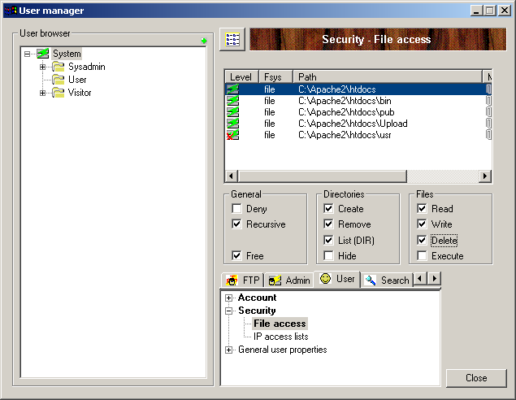
Next, right click in the list of file paths and select 'New'.
Enter 'C:\Apache2\htdocs\cgi-bin' (without the quotes) in the 'Path' field. Then, select the 'Freeze the mount point' box and in the 'Mount Point' field, enter '/cgi-bin'.
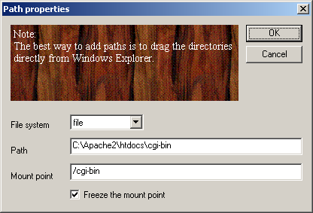
Click 'OK'. Then in the boxes underneath select:
Read, Write, Delete, Execute
This is shown below:
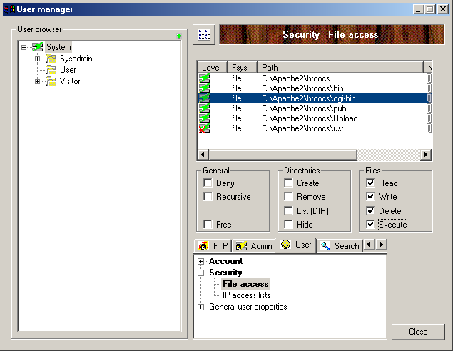
Next, go back to the left-hand panel and click the '+' next to 'System'. Then right-click on 'User' and select 'Add User'.
Enter a username of 'demo' and click 'OK'. Then enter a password (and confirm it) and click 'OK'.
Click 'Close' and then close the War FTP Manager.

SellerDeck Network Settings
Start SellerDeck and go to 'Web | Network Setup'. If it says 'SellerDeck Host Mode' at the top then click 'Convert' and 'Yes'. Enter the following details in the fields provided.

Server details:
Catalog URL: | http://localhost/acatalog/
CGI-BIN URL: | http://localhost/cgi-bin/
Codebase: | ./
Path from CGI-BIN to Catalog Directory: | ../acatalog
Common Settings
Script ID Number: | 1
Extension: | .pl
Mail (SMTP) Host: | [leave blank]
Web Site URL: | http://localhost/
Path to Perl: | C:\Perl\bin\perl.exe (or D:\Perl\bin\perl.exe)
FTP Details:
Server Host: | localhost
Username: | demo (or username created in War-FTP)
Password: | Whatever was setup in War-FTP
Path to CGI-BIN: | cgi-bin/

Testing if it Works
Go to SellerDeck and go to 'Web | Refresh Website'. This will upload all the necessary files. Once it has completed, you should now be able to browse to your home page:
http://localhost/acatalog/

Troubleshooting

Check That Perl Is Installed
To check that Perl is installed on your PC, in a command window type:
C:\>perl –v
Sample output from a command window check that Perl is installed and will run:
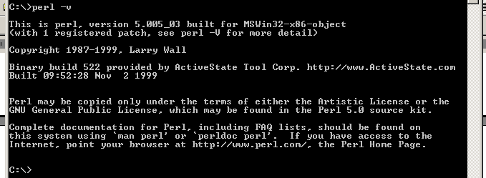
Also in the command window check the path to Perl by typing:
C:\>path
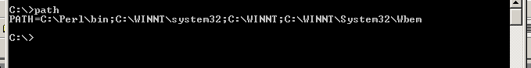
The correct path is: C:\Perl\bin, as above.

Check Apache
Open up a browser and browse to http://localhost/ and the Apache Welcome page should appear. The page should read "It HAS Worked! The Apache Web Server is Installed on this Web Site!". If it does not appear, check your installation of Apache by repeating the steps listed earlier in this document.

Check War-ftpd
Open up War-ftpd and check the permissions settings are identical to the screen shots earlier in this document.

Access Denied Errors
If you are getting 'Access Denied' Errors on upload, then check the boxes in War-FTP are ticked correctly, as described earlier in this document, and also check that War-FTPd is online.

Check Perl Scripts
To check that the path to the perl scripts is correct, and that they will run, in the browser, browse to http://localhost/cgi-bin/nq000001.pl. If a page with nothing but the words 'Script Error' (in red) appear then the upload has been successful.

Manual Check of War-ftpd
To check that War-ftpd is working and is providing access to the cgi-bin directory, make sure War-ftpd is online, and then in a Command Window type:
ftp localhost
Then connect as your demo user, entering your password when prompted. Next enter the following commands:
cd cgi-bin
dir
If it shows you a list of files, then the permissions are set correctly.

Perl Association
To check the association of the Perl file extension (.pl) in Windows NT the following registry key needs to be checked:
LocalMachine\SYSTEM\CurrentControlSet\Services\W3SVC\Parameters\Script Map
The association should look like the following:
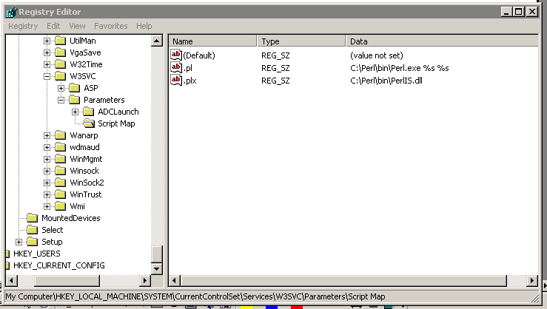
The association should be:
Name Type Data
.pl REG_SZ C:\Perl\bin\Perl.exe %s %s
Note: The "s" of %s %s are both lowercase.

Section G: IIS5 Server Setup

Host Headers
Host headers are a mechanism where more than one domain name can be hosted from a single IP Address.
Use the IIS MMC to create a host header name for each web site to be hosted on the IP Address.
The host header name has to be registered with the appropriate name resolution system.
If the computer is on an intranet (a private LAN that uses Internet technology), register it with the intranet's name resolution system, such as the Windows Internet Name Service (WINS).
If the computer is on the Internet, register the host header name with the Domain Name System (DNS), which is administered by InterNic.
If you are using a name that is not a registered DNS name you can add to the systems hosts file, found at:
C:\WINNT\System32\drivers\etc\hosts
Note: This mechanism only works for the system(s) with the host header entry in their hosts file.

Vocabulary

Term | Definition
DNS | Domain Name System is a method for resolving IP addresses to/from host names. DNS root servers are owned and maintained by the InterNIC for the Internet.
Virtual directory alias | A virtual directory alias is a name that clients use when referring to your virtual directory. For example, in the address http://www. sellerdeck.com/cgi-bin, cgi-bin is a virtual directory.
Virtual Web site | A virtual Web site provides the appearance that two or more sites are different, even though they exist on the same Internet server.

Setup of Catalog Web Site
Open the IIS MMC and expand the pane view of the server structure.
Right click on the server and select 'New | Web Site':
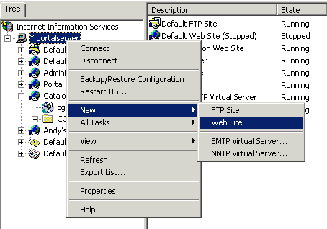
The Web Site Creation Wizard appears:
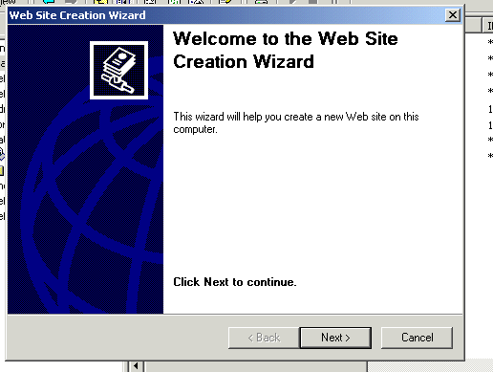
Click the Next> button.
Enter the Description of the Web Site:
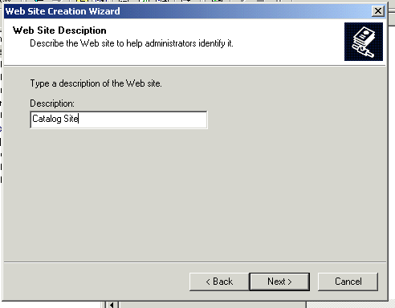
Click the Next> button.
Select the IP Address to use for this Web Site from the drop-down list. Change the Port Number if a port other than 80 is to be used. If Host Headers are to be used, enter the Host Header for this site:
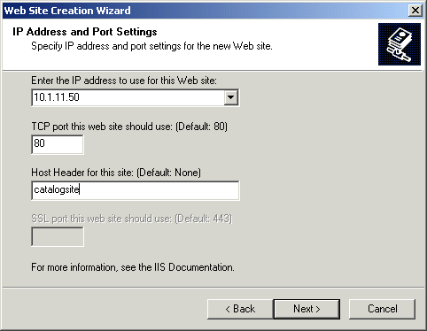
Click the Next> button.
Click on the Browse… button and browse to the Home Directory to be used for this Web Site:
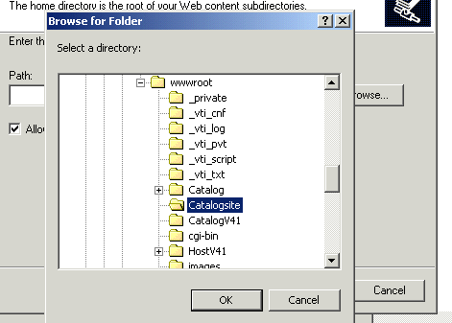
Click the OK button.
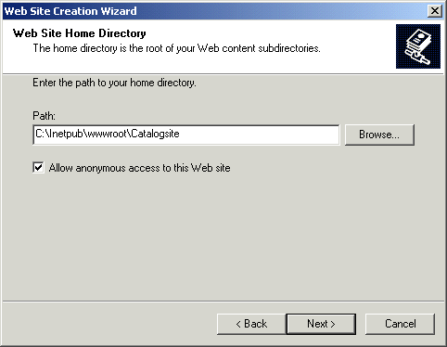
Click the Next> button.
Select the following permissions:
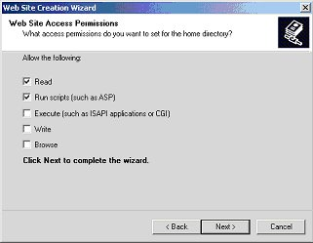
Click the Next> button.
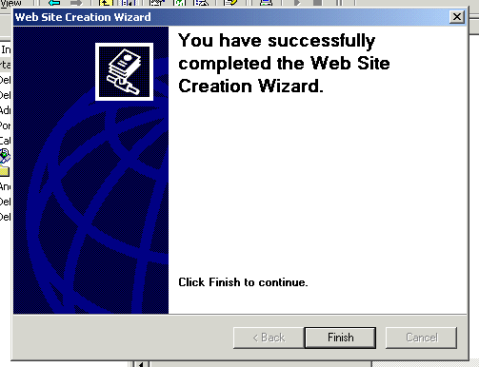
Click the Finish button.

CGI-BIN Directory
The cgi-bin directory has to exist on two levels:
- The physical level – actually on the hard disk.
- The Virtual level – within IIS.

CGI-BIN Physical Directory Creation
A cgi-bin directory has to be created before it can be an IIS “Virtual Directory”.
Open up Windows Explorer and drill down to the Web Site “Home” directory:

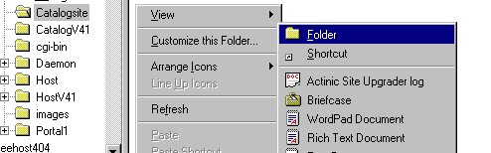
Right click on the directory and in the popup menu select: New | Folder
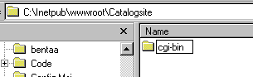
Enter cgi-bin as the directory name.

CGI-BIN Virtual Directory Creation
For Catalog to be able to access the perl script files on the host server, a cgi-bin (created in 3.1 above) must enabled as a Virtual Directory within IIS.
Before the cgi-bin Virtual Directory has been created, in the IIS MMC it appears as a normal folder:
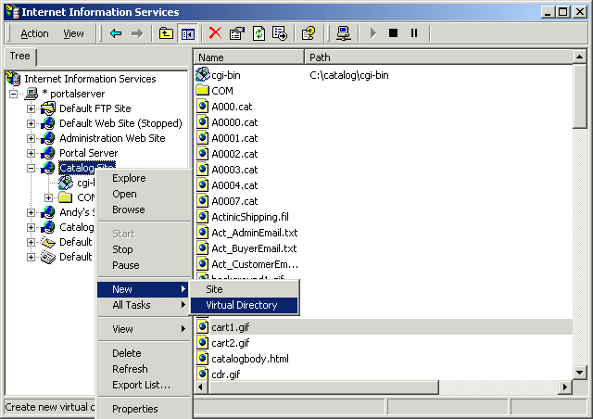
The Virtual Directory Creation Wizard appears:
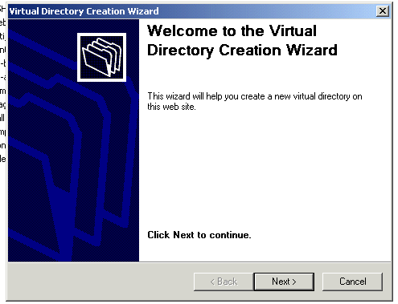
Click the Next> button.
Enter cgi-bin in the Virtual Directory Alias box:
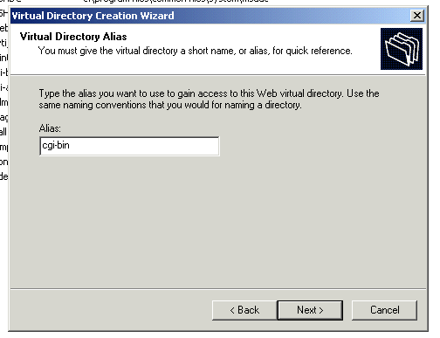
Then click the Next> button.
Browse to the cgi-bin directory, to be used in Web Site Content Directory via the Browse… button:
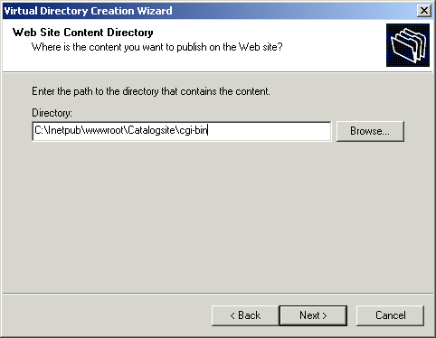
Then click the Next> button.
Check Read, Run Scripts and Execute in the Access Permissions:
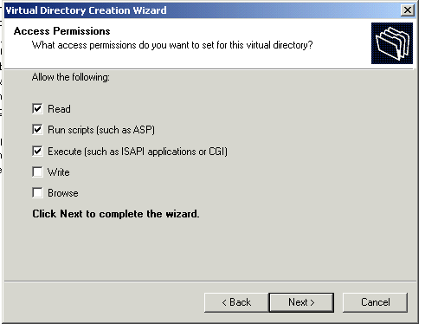
Then click the Next> button.
The "You have successfully completed the Virtual Directory Creation Wizard" window appears:
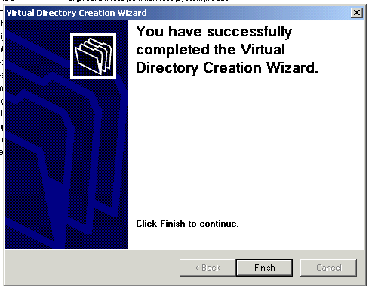
Click Finish button.
The icon on the cgi-bin should be created as the one pictured below:
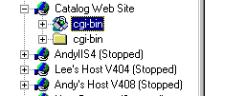
Note: The normal folder icon will most likely still be visible in the Web Site, doing a Refresh should remove the cgi-bin normal folder icon, and just leave the cgi-bin Virtual Directory.

cgi-bin IIS Check
In the IIS MMC expand the web site containing the cgi-bin directory and check the Properties settings:
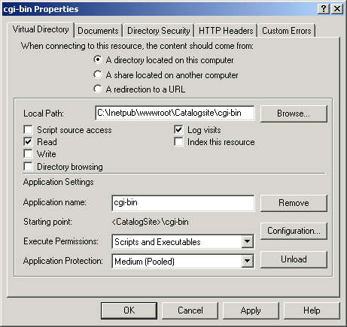
Check - A directory located on this computer.
Local Path: C:\Inetpub\wwwroot\Catalogsite\cgi-bin
Check - Read and log visits
Application name: cgi-bin
Execute Permissions: Scripts and Executables
Application Protection: Medium (Pooled)

cgi-bin Perl Association
Check the cgi-bin Perl association in IIS.
Right click on the cgi-bin virtual directory icon:
Select Properties | Configuration | Application Configuration
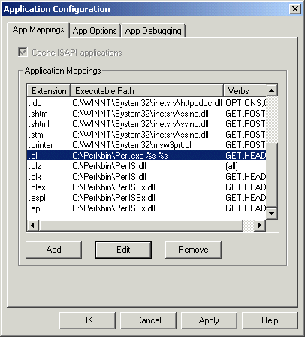
There should be only one entry for the Perl association and it should be:

Extension Executable Path
.pl C:\Perl\bin\Perl.exe %s %s

Note: the “s” of the %s %s are both lower case.
Verbs should be limited to: GET, HEAD and POST

NTFS Permissions

Catalog Home Directory
Open up Windows Explorer and drill down to the Catalog “Home directory” right click on it and select Properties:
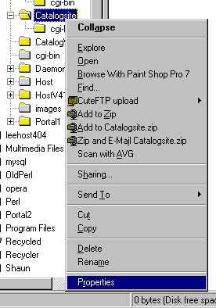
The Catalogsite Properties window is displayed.:
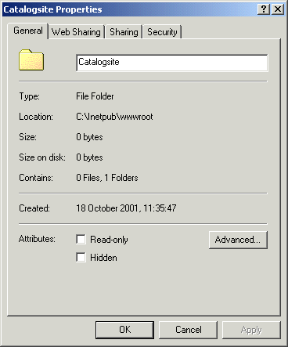
Select the Security tab:
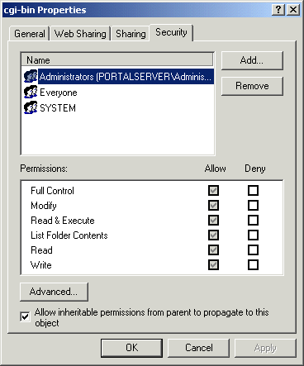
Highlight the Everyone User and click on the Remove button and remove the Everyone User.
Click on the Add… button.
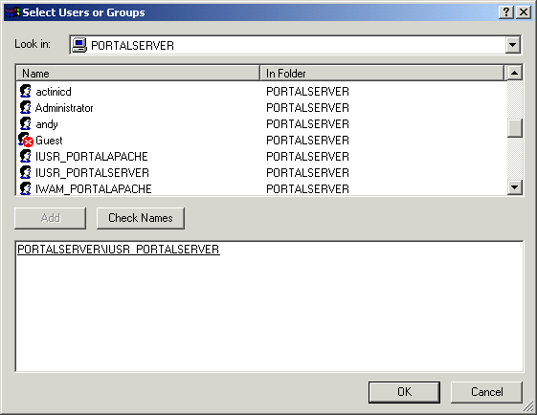
Scroll down to the IUSR_hostname (in this example IUSR_PORTALSERVER)
Click the Add button.
Select ftp User (in this example Shaun Sloan) and click the Add button.
Click OK.
The Catalog site directory permissions should look like:
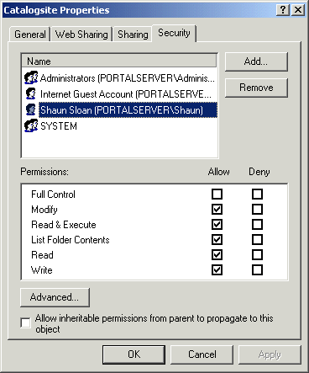
For the IUSR_hostname User (in this example IUSR_PORTALSERVER) the following permissions should be checked in the Allow column:
Modify
Read & Execute
List Folder Contents
Read
Write

For the ftp User (in this example Shaun Sloan) the following permissions should be checked in the Allow column:
Modify
Read & Execute
List Folder Contents
Read
Write
Click OK to exit the Catalogsite Properties window.

Acatalog Directory Permissions
The same permissions should be applied to the acatalog directory as the Catalog “Home directory”. Highlight the IUSR_hostname User and check the permissions:

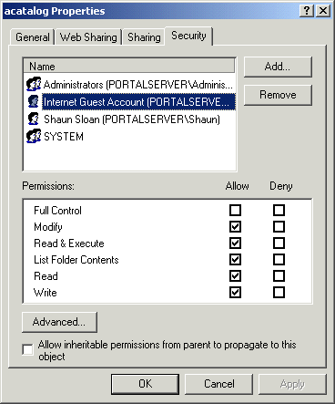
IUSR_hostname should have the following permissions checked in the Allow column:
Modify
Read & Execute
List Folder Contents
Read
Write

The ftp User (Shaun Sloan in this example) should have the following permissions checked in the Allow column:
Modify
Read & Execute
List Folder Contents
Read
Write

The Everyone User should have been removed.
Click OK button to exit.

CGI-BIN Directory Permissions
NTFS permissions for the cgi-bin directory have to also be set up.
Open up Windows Explorer and drill down to the cgi-bin directory, right click on it and select Properties:
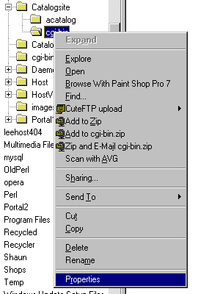
The cgi-bin Properties window is displayed:
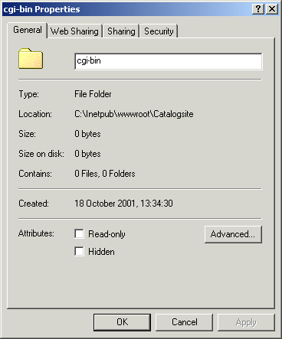
Select the Security tab:

Highlight the Everyone User:
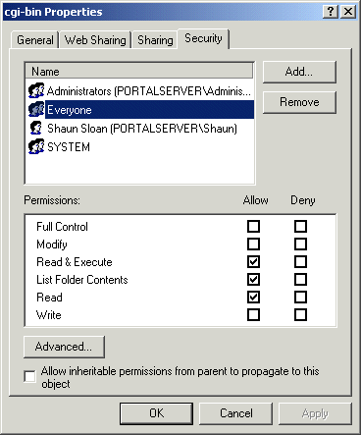

Check the following Allow Permissions:
Read & Execute
List Folder Contents
Read
Uncheck:
Allow inheritable permissions from parent to propagate to this object.

FTP User
Because the Everyone User permissions have been restricted it is necessary to give the user that will be used to ftp the files to the server write access to the cgi-bin directory.
Click on the Add button and select the appropriate user:
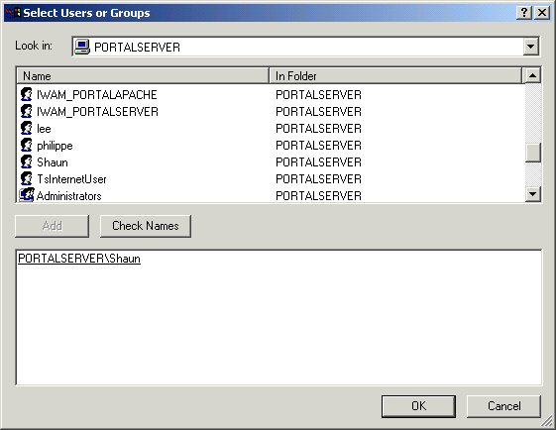
Click OK.
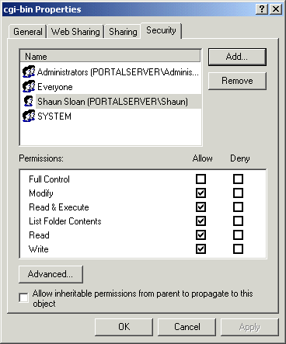
The following permissions should be checked for the ftp User:
Modify
Read & Execute
List Folder Contents
Read
Write

Click on Apply and then OK to exit cgi-bin Properties window.

Network Password Dialog-box
If an “Enter Network Password” dialog-box appears after clicking on the Add To Basket button:
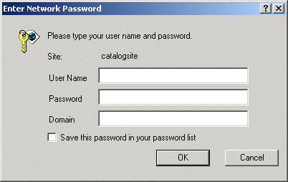
The Internet Guest Account does not have Read & Execute permissions on the cgi-bin directory.
Check the permissions are set as in section 7 above.

Web Sharing
Open up Explorer and drill down to the cgi-bin directory, right click on it and select Properties and select Web Sharing tab. If there are multiple Web Sites then the will be a drop down list associated with Share on:, select the Catalog Web Site associated with this cgi-bin.
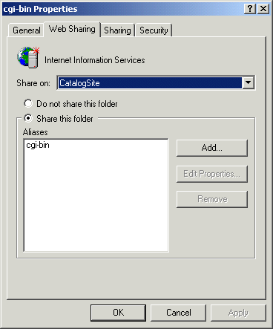
The settings should be as follows:
Checked - Share this folder
Aliases – cgi-bin
Then click the OK button.

FTP Settings
In the IIS MMC, select the Default FTP Site or FTP site associated with Catalog, right click and select Properties. Click on the Home Directory tab.
Check the settings are as below:

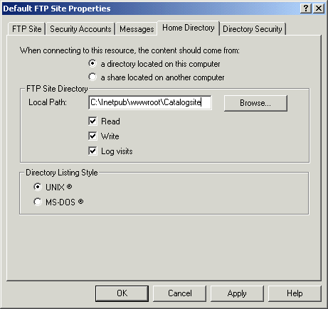

Click the OK button.

Perl Setup

Perl Association
To check the association of the Perl file extension (.pl) in Windows NT the following registry key needs to be checked:
LocalMachine\SYSTEM\CurrentControlSet\Services\W3SVC\Parameters\Script Map
The association should look like the following:

The association should be:
Name Type Data
.pl REG_SZ C:\Perl\bin\Perl.exe %s %s

Note: The “s” of %s %s are both lowercase.

Perl Checks
The following checks should be made to ensure that Perl is installed on the Server.
In a command window check that Perl is installed and will run:
C:\> perl –v
Output should look something like:
Also in the command window check the path to Perl:
C:\> path
The output should be something like:
Note: If the perl –v returns a message along the lines:
“‘perl –v’ is not recognised as an internal or external command, operable program or batch file.”
is displayed then perl is most likely not installed.
If Perl is not installed, it can be downloaded from the ActiveState web site:
http://www.activestate.com/Products/ActivePerl/Download.html

SellerDeck Network Settings
The Network settings should be as follows:
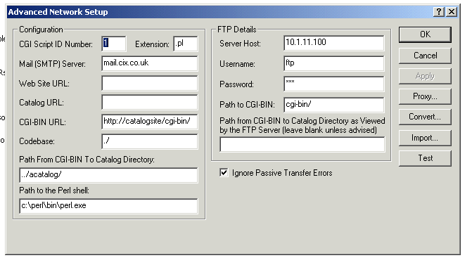

Defining The Home Page In IIS
The default home page in IIS is set to default.htm or default.asp, but SellerDeck uses index.html as the home page.
To add index.html open up the IIS MMC, right click on the Web Site and select Properties:
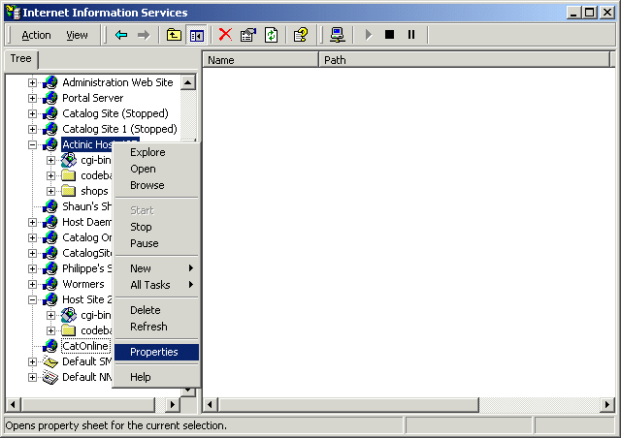
The Web Site Properties box appears:
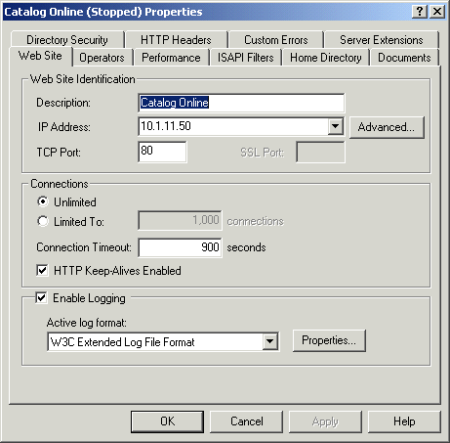
Select the Documents tab:
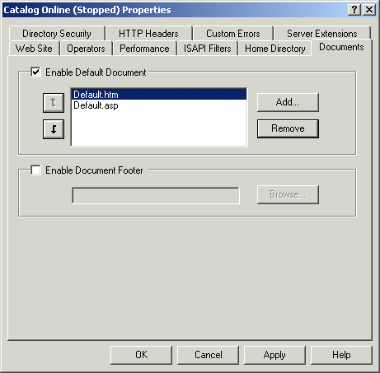
Click on the Add… button:
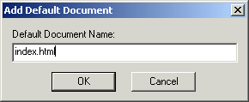
Enter index.html and click the OK button.
Using the button move index.html to the top of the list:
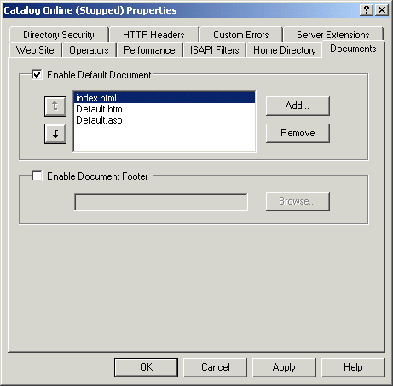
Click on the OK button.

Troubleshooting

cgi-bin Accessed Denied
There are occasions when access to the cgi-bin directory is denied after following the above guidelines.
It may become necessary to delete the cgi-bin virtual directory in IIS and then the cgi-bin directory in Windows Explorer, and then re-create both and reapply the necessary permissions

